Quality of Life Survey Report
  - October 2017

Executive Summary

The Graduate School in partnership with Graduate Student Life in The Stamp and in collaboration with the Graduate Student Government and Graduate Student Legal Aid Office, administered a 90 question survey to over 9800 graduate students during the period of May through June 2017. The purpose of the survey was to better understand multiple facets of the graduate student experience. This population was last surveyed in 2010 with a limited scope by the Office of Graduate Student Life.

The survey generated 2,017 responses of which 1,712 responses provided more than enough useable data for this exploratory study of graduate student life on campus. The graduate student sample for this exploratory analysis is representative of the demographic composition of the graduate student population on campus; thus, enabling assumptions about graduate student behavior and perceptions to be made. In terms of educational objective, survey respondents in PhD programs were slightly disproportionally higher than the actual student population. However, survey respondents were similar to the graduate population in terms of full-time/part-time status, international/domestic and race/ethnicity. In terms of primary school or college graduate populations, the percentage of business school respondents was low, the percentage of iSchool respondents was twice the actual population and the others were similar or slightly higher. We collected a large set of demographic data and responses to a broad range of survey questions which will provide a robust set of analyses.

The first section provides analyses about student engagement with the University and about individual interactions with students and faculty. The second set of analyses deal with the questions that looked at student interactions with and perceptions of the faculty and the department and how well students felt that the program prepared them academically and professionally. The latter is reported for the campus as a whole as well for each college.

Some key trends in the data include:

- Doctoral students consider financial support, opportunity to work with a specific faculty member and department reputation in their decision to enroll at Maryland while those seeking a master’s degree focus on the department, caliber of the university, location and financial support.
- Doctoral students are more engaged in campus activities (about 70% participate in departmental events) than Master’s level students. Also, they are more likely to engage in discussions regarding research strategies and personal issues with their peers. Reasons noted for not engaging were due to academic commitments, academic and other work load and not wanting to go alone.
- Very few students reported experiencing discrimination by other graduate students or experiencing tense or hostile interactions with other graduate students. About 90% of the students responded of not having the experience or only a “little” to both questions.
- Overall international students are more likely to recommend Maryland to others and Master’s level students are more likely to do so than doctoral students.
- Overall, students had a more favorable view of their departments and programs than they did of the University. The areas that doctoral students felt that programs provided the most support were in conducting and publishing research while they felt less supported in obtaining funding. Importantly, students felt programs helped them develop problem solving skills and verbal communication skills, but could provide more in the areas of leadership skills, organizational skills, and teamwork skills.

The report provides considerable detail at both the campus level and at the college level in terms of student interactions with students and faculty, engagement, and departmental support.

Contents
Description of the Report 5
Description of the Sample 5
Educational Objective 5
Current enrollment status 5
Advanced to candidacy 5
Is your program on campus? 5
Primary academic school or college 6
International students 6
Race/Ethnicity 6
Gender 7
Sexual Orientation 7
Marital Status 7
Disability 7
Veterans 7
Others Under Students’ Care 7
General Analyses 8
Before Arriving at the University of Maryland 8
Activities and Events 8
Interaction with Graduate Students 12
Programming and Services 15
Careers upon Graduation 18
Predictors of Recommendation and Belonging 19
General Feedback about the University 25
Supplemental College Questions 45
Agriculture and Natural Resources 54
Faculty 54
Department 56
Program Preparation 57
Architecture, Planning, and Preservation 59
Faculty 59
Department 60
Program Preparation 62
Arts and Humanities 63
Faculty 63
Department 65
Program Preparation 66
Behavioral and Social Sciences 67
Faculty 67
Department 69
Program Preparation 70
Business 71
Faculty 71
Department 72
Program Preparation 73
Computer, Mathematical, and Natural Sciences 75
Faculty 75
Department 77
Program Preparation 78
Education 80
Faculty 80
Department 82
Program Preparation 83
Engineering 85
Faculty 85
Department 87
Program Preparation 88
Information Studies 89
Faculty 89
Department 91
Program Preparation 92
Journalism 94
Faculty 94
Department 94
Program Preparation 94
Public Health 95
Faculty 95
Department 97
Program Preparation 98
Public Policy 100
Faculty 100
Department 101
Program Preparation 103
Appendix 104

Description of the Report
This report details the findings from the Quality of Life survey, administered by the 4G Network, comprised of the Graduate School, Graduate Student Life, Graduate Student Legal Aid Office, and the Graduate Student Government to all graduate students at the University of Maryland via an open link in spring 2017 in order to better understand the graduate student experience. Of the 2,017 responses received, 1,712 responses contained information used in the various final analyses.

Description of the Sample
Below is a description of the sample of students who responded to the survey. In many ways, they are similar to the larger graduate student body at the University of Maryland, which strengthens the case for generalizing the findings to the larger population.

Educational Objective
The 1699 respondents to the survey are similar in educational objectives to the greater University of Maryland graduate student population as shown below, although the ratio of master’s degree and Ph.D. students who responded to the survey is smaller and there is a smaller percentage of non-degree seeking students.
Educational Objective | Respondents | Graduate Student Population
Master’s degree | 845 (49.7%) | 5820 (54.8%)
Ph.D. | 783 (46.1%) | 4065 (38.3%)
Professional doctorate | 20 (1.2%) | 121 (1.1%)
Certificate | 22 (1.3%) | 160 (1.5%)
Non-degree seeking | 29 (1.7%) | 445 (4.2%)

Current enrollment status
Of the 1698 valid responses, 1303 (76.7%) are full time and 395 (23.3%) are less than full time. The sample who responded to the survey is very similar to the larger graduate student population as shown below.
Enrollment Status | Respondents | Graduate Student Population
Full-time | 1303 (76.7%) | 8094 (76.3%)
Less than full-time | 395 (23.3%) | 2517 (23.7%)

Advanced to candidacy
Of the 801 valid responses from doctoral students, 326 (19.0%) have advanced to candidacy and 475 (27.7%) have not.

Is your program on campus?
Of the 1697 valid responses, 1492 (87.9%) are on campus and 205 (12.1%) are not.

Primary academic school or college
Of the 1100 valid responses, the breakdown of respondents by school is below. There are far fewer respondents from the business school and more respondents from the arts and humanities, information studies, computer, mathematical, and natural sciences, and public health.
Academic College | Respondents | Graduate Student Population
A. James Clark School of Engineering | 233 (21.2%) | 2131 (20.0%)
College of Agriculture and Natural Resources | 35 (3.2%) | 350 (3.0%)
College of Arts and Humanities | 125 (11.4%) | 907 (8.0%)
College of Behavioral and Social Sciences | 120 (10.9%) | 978 (9.0%)
College of Computer, Mathematical, and Natural Sciences | 165 (15.0%) | 1349 (13.0%)
College of Education | 104 (9.5%) | 981 (9.0%)
College of Information Studies | 91 (8.3%) | 462 (4.0%)
Philip Merrill College of Journalism | 5 (0.5%) | 71 (<1.0%)
Robert H. Smith School of Business | 95 (8.6%) | 2034 (19.0%)
School of Architecture, Planning, and Preservation | 21 (1.9%) | 264 (2.0%)
School of Public Health | 66 (6.0%) | 329 (3.0%)
School of Public Policy | 40 (3.6%) | 300 (3.0%)

International students
Of the 1114 valid responses, 221 students provided name of their respective home countries. The most common are India (84; 38.0%), China (52; 23.5%), Canada (8, 3.6%), Iran (7, 3.2%), Taiwan (7, 3.2%), and Colombia (5, 2.3%). A larger percentage of respondents to the survey were international compared to the larger population.
Student Status | Respondents | Graduate Student Population
Domestic | 800 (71.8%) | 7044 (66.4%)
International | 289 (25.9%) | 3567 (33.6%)
Prefer not to say | 25 (2.2%)

Race/Ethnicity
Of the 817 valid responses, there were more White and Multi-racial respondents and fewer Hispanic students. Note: Those who indicated Hispanic and an additional race category were labeled as multi-racial rather than Hispanic, which is in line with the universities’ categories.
Race/Ethnicity | Respondents | Graduate Student Population
White | 555 (67.9%) | 4157 (39.2%)
African American/Black | 65 (8.0%) | 845 (8.0%)
Asian | 61 (7.5%) | 681 (6.4%)
American Indian/Alaska Native | 2 (0.2%) | 15 (0.1%)
Native Hawaiian or Other Pacific Islander | 0 (0.0%) | 3 (0.0%)
Hispanic | 17 (2.1%) | 425 (4.0%)
Two or More | 51 (6.2%) | 201 (1.9%)
Unknown | 65 (8.0%) | 717 (6.8%)

Gender
Of the 1116 valid responses, 447 are men (40.1%), 624 (56.0%) are women, 35 (3.1%) prefer not to say, 3 (0.3%) are agender, and 7 (0.6%) provided their own descriptions, including “queer”, “genderqueer”, “genderfluid” and “non-binary.” The university only provides percentages based on a binary definition of gender, where 5090 (48%) of the graduate student body is female and 5521 (52%) are male.
Of the 1103 valid responses, 13 (1.2%) identify as transgender.

Sexual Orientation
Of the 1102 valid responses, 856 (77.7%) identify as heterosexual, 90 (8.2%) prefer not to say, 64 (5.8%) identify as bisexual, 43 (3.9%) identify as gay, 9 (0.8%) identify as lesbian, 8 (0.7%) identify as questioning, and 32 (2.9%) noted that the above categories did not describe their sexual orientation and wrote in other categories including: “straight”, “queer”, “polysexual”, “pansexual”, “asexual”, and “fluid.”

Marital Status
Of the 1110 valid responses, 592 (53.3%) are single, 466 (42.0%) are partnered or married, and 52 (4.7%) prefer not to say.

Disability
Of the 1112 valid responses, 1004 (90.3%) do not have a disability, 59 (5.3%) have a disability, and 49 (4.4%) prefer not to say. The most common disabilities listed are mental health issues (e.g., depression, anxiety, bipolar, OCD): 9 people; learning disabilities (e.g., dyslexia, ADD, ADHD): 13 people; and hearing or vision impairments: 5 people.

Veterans
Of the 1110 valid responses, 38 (3.4%) said they are or were a member of the US Armed Forces, 23 (2.1%) said they would prefer not to say.

Others Under Students’ Care
Of the 1102 valid responses, 793 (71.96%) said they did not care for anyone else; 136 (12.34%) care for dependent children under the age of 10; 84 (7.62%) said they care for dependent adults; 46 (4.17%) cared for dependent children under the ages of 16; and 15 (1.36%) said they care for dependent children with special needs. Of the 24 (2.54%) who responded “Other” and wrote in their responses, 11 indicated that they care for pets, 6 indicated that they care for dependent children over the age of 16, and the remaining 7 respondents indicated that they care for other family members including: “spouse”, “non-dependent 86-yr-old mother”, “grandchildren under the age of 6” and “family.”

General Analyses

Before Arriving at the University of Maryland

What factors do students find important to consider before applying to a program?
Before applying, the PhD students that responded (N ≈ 780) felt that a good financial aid package, the opportunity to work with specific faculty members, and the reputation of the academic program/department were very important in making their decision to attend the University of Maryland.
The Master’s students that responded (N ≈ 840) felt the reputation of the academic program/department, caliber of the university, location, and financial aid package were very important in making their decision to attend.
While all of these factors are important, the differences are the PhD students’ focus on working with specific faculty members, which is not as large a concern for master’s degree students. Additionally, students applying for master’s degrees are more interested in the overall reputation of a university compared to doctoral applicants whose focus is more department/program related.

What factors do students find important to consider before arriving on campus?
Before arriving on campus, students felt that the most important factors were transportation to and from campus, finding housing, securing funding, and securing employment. The graphs below provide information about how students responded to each of the factors listed. Each factor shows the percentage of students who said that the factor was extremely important (pink), very important (light green), moderately important (blue), slightly important (dark green), or not at all important (yellow). Each bar adds up to 100% of the respondents.
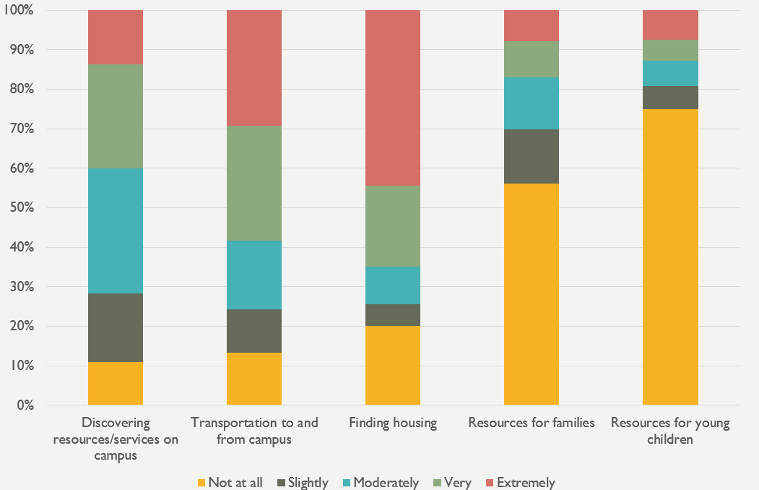 | 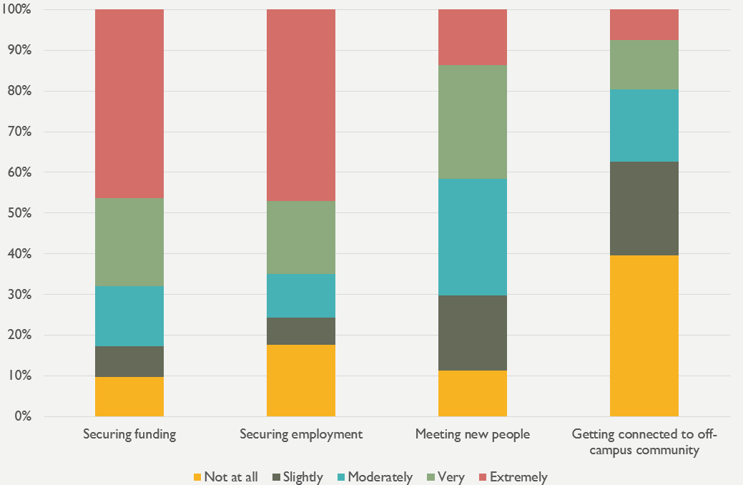

Activities and Events

Graduate Student participation and availability
The majority of students responding to the survey (N = 783 PhD students and 845 master’s degree students) participate in department specific events (69.9% of PhD students; 46.5% of master’s degree students). The other events that a large percentage of students participated in were the Graduate School orientation (45.2% of PhD students; 38.9% of master’s degree students) and career development workshops (25.3% of PhD students; 28.2% of master’s degree students). The list of activities/events, along with the percentage of students indicating participation is shown below.
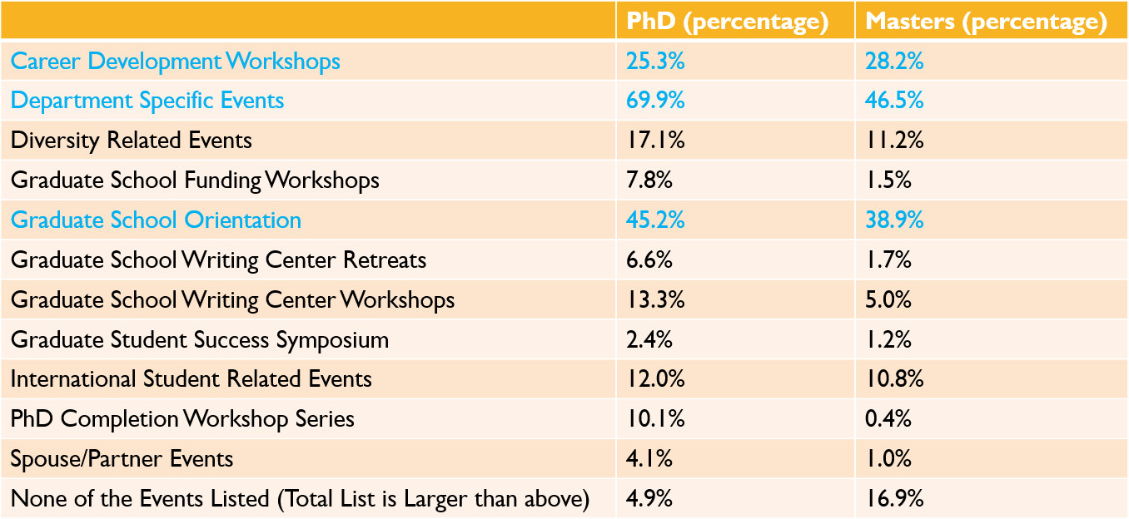
Students indicate that the biggest reasons for not attending events are scheduling conflicts with academic (47.6% PhD; 45.8% master’s degree) and work (41.8% PhD; 46.5% master’s degree) responsibilities, a lack of interest (39.3% PhD; 27.6% master’s degree), not wanting to go alone (35.6% PhD; 32.3% master’s degree), and not being informed of the event (28.4% PhD; 26.4% master’s degree).
Among the 153 responses of students who wrote in other factors that prevented them from attending or participating in events, the top 10 themes are listed in the table below:
Top 10 themes from student responses
1. | Location (39) | 6. | Schedule (13)
2. | Remote student (39) | 7. | Employment (9)
3. | Balance / not enough time (28) | 8. | Priorities (8)
4. | Commute (16) | 9. | Availability / access (6)
5. | Fit (14) | 10. | By choice (5)

Below are representative quotes from the top 5 themes:
Location & Commute (themes 1 & 4): A number of students are not able to attend / participate due to location & commute
“working in a lab off campus”
“Not held in my local area (DC). Would love to see programming for UMD doctoral students hosted in various parts of the DMV. ”
“Location (I live in Arlington, VA) ”
“Commute - live far from campus and mostly work on research from home - having completed all on-campus coursework.”
“Don't live near school, and traffic is horrible”
“actually walking to the events. Campus is huge, and if an event is far away, I won't go. ”
“I commute an hour to campus, so while I would like to attend more family events, it's not convenient for me to attend in College Park. ”
“I live and work over 50 miles away from campus”
“I do not live in Maryland and it is very inconvenient to drive to campus”
“I live in Baltimore and commute to campus”
“Cannot attend evening events due to long commute”

Remote student (theme 2): A number of remote students are not able to attend / participate
“Being an online student makes it more difficult to travel and be motivated to join.”
“At a different campus”
“Am not local - live in Alabama”
“I live about 3 hours away from campus, and distance learners are consistently left out.”
“Online student. No opportunity presented.”
“Different campus and not a lot of support or feelings of invitedness”
“Live in different state”
“I'm in Beijing Campus, so is not very convenient to participate in the events ”
“I do not attend school at the main campus.”
Balance & fit (themes 3 & 5): A number of students are not able to attend / participate due to lack of time and poor fit
“Are you kidding me? TIME TIME TIME”
“Academic workload”
“too much work to do”
“Very limited free time as a graduate student”
“I'm older than most students and don't have much in common with them”
“events seem geared toward direct undergrad to grad students, not returning/non-traditional students like me”
“Some of the events seem like they'll be too big - for example, GradPub seems super popular, but that also means it's SUPER CROWDED and this is not fun for me”
“programs are geared toward 20-somethings”
“There is just no time for most of these events. I'm supposed to be grading papers, running experiments, writing a dissertation, etc.”
“lack of time/ feeling overwhelmed”
“No free time”
“perceive it's not going to add much value for the limited amount of time I have”
“I wish there were more graduate student clubs like there are undergraduate student clubs, such as for community service, similar interests, etc. When I look up groups that sound interesting and fun, it's completely undergraduates and I would feel awkward/out of place being the only grad student there. I would prefer a club for grad students specifically. ”
A sense of not really belonging”

Since scheduling conflicts appeared to be the largest reason for lack of participation, students were asked during what breaks they were available and what days and time typically work best. Respondents, particularly PhD students, are available during all breaks, which may be a good time to hold events. Master’s degree students are most available during spring break, while PhD students are most available during summer break.
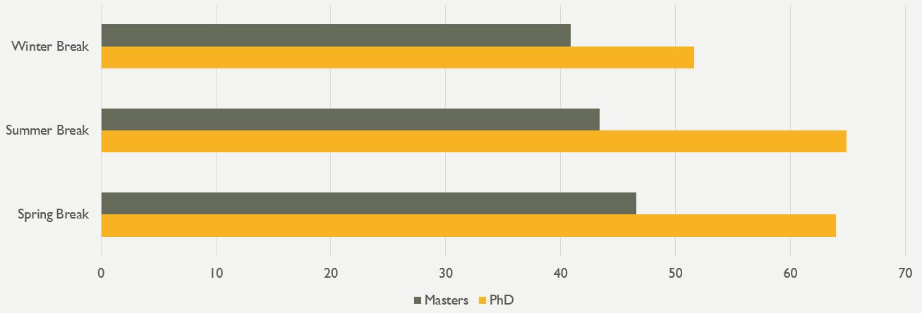
The days/times that students are most available are on weekdays from 5-7pm and 7pm-10pm, as well as weekends from 1pm-3pm.
The best ways for students to learn about activities and resources are through departmental emails, the Graduate Student Life E-Newsletter, and the Calendar of Events/UMD This Week email. The full list is provided below.
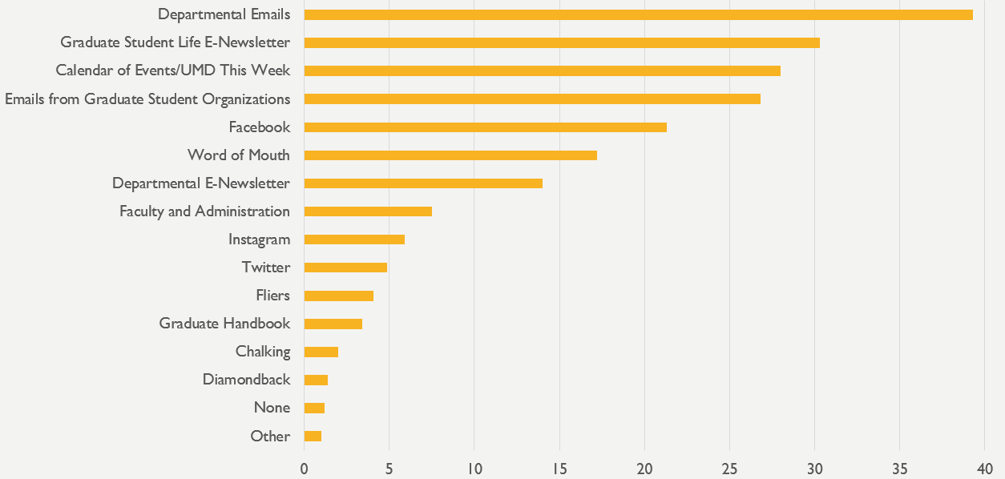

Students who wrote in “other” responses mentioned the following additional ways to learn about campus resources and activities: emails (especially those that one does not need to click to open something, where info is in email and sign-up is an easy link that automatically puts something on calendar), university website, an online calendar (that is updated regularly with accurate information), an app version of the calendar where all events are listed in one place, OrgSync, in-class mentions, brief animated video summaries, and others.
Some students indicated interest in remote programming options, particularly résumé building references and interview preparation tips in the form of online references. Other remote programming preferences include asynchronous webinars and videos with tutorials. Those who wrote in responses indicated interest in various formats of remote access programming, including: online advising, teleworking options, Saturday morning review sessions, free editing/proofreading for non-native speakers of English, online audio lectures, counseling sessions via skype, immediate IT help, Testudo at odd hours, weekly inspirational videos, and other online resources. Perhaps focus groups could shed light on what kind of content would be preferred if these resources were to be rolled out.
What kinds of graduate student organizations do you wish existed?
Of the 363 responses to this question, 71 responded “none” or “N/A.” Another 12 responded that the current mix of organizations was enough and they wished that they were better informed about what already existed. Of the remaining 280 responses that listed possible graduate student organizations, identity-based organizations were the most common, suggested by 52 respondents. These ranged from specific student types (e.g. online, satellite, older, professional, employed by the federal government, non-traditional, first-generation, etc.) to demographic categories (race/ethnicity, international, sexual orientation, disability, religion, etc.). Social organizations, the second most commonly mentioned, were suggested by 45 respondents. The third most commonly suggested organization type was athletic, suggested by 28 respondents. Other suggestions included organizations focused on arts/music, union/collective bargaining, career/networking, community service, academic interests, family, food, support, outdoor, writing, wellness, political, public speaking, technology, language, travel, and miscellaneous interests.

Interaction with Graduate Students

Interaction with other graduate students
Respondents were asked six questions about their interactions with other graduate students. Responses could range from “Not at all” to “A great deal”. The graphs below show a breakdown of responses based on educational objective and another breakdown of responses based on race/ethnicity.
Of those responding who also provided information about educational objective, 51% are obtaining their PhDs and 49% are obtaining their master’s degrees. With respect to race/ethnicity, those who responded are 54.9% White, 28.5% International, 6.5% Black/African American, 6.2% Asian, and 4% Hispanic.
A larger percentage of PhD students have discussed personal matters with other graduate students compared to those obtaining a master’s degree. This result is not surprising as PhD students typically have a smaller cohort and spend more years on campus compared to those in master’s degree programs. The majority of students, regardless of race/ethnicity, have at least indicated that they discuss personal matters with other graduate students on a moderate level. When looking at race/ethnicity breakdown, a higher percentage of Hispanic, White, and International students indicated engaging in discussion of personal matters more so than did Black/African American and Asian students. A graph of the results is below.
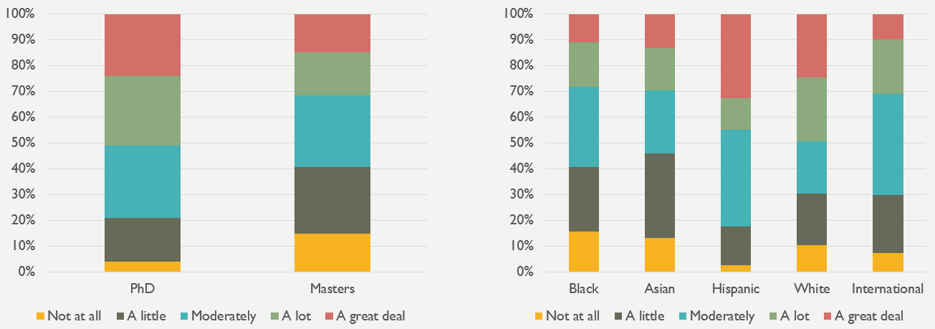
When asked how often the respondent discussed research strategies with other graduate students, the majority did so at least moderately. As with the previous question, a larger percentage of PhD students have discussed research strategies with other graduate students compared to those obtaining a master’s degree. Since PhD students are more likely to be engaging in research, this result is not surprising. When looking at race/ethnicity breakdown, a higher percentage of Hispanic and International students indicated engaging in discussion of research strategies more so than other groups. A graph of the results is below.
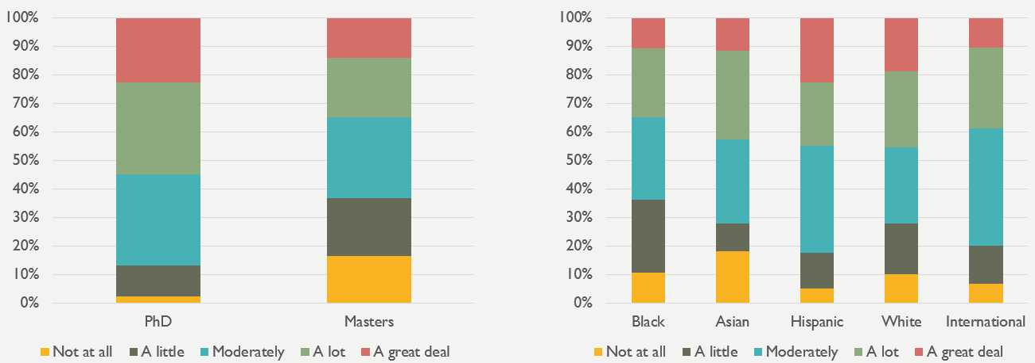
The majority of students who responded also indicated that they interact with graduate students outside of class. PhD respondents were again more likely to indicate a higher amount of interaction compared to master’s degree students. With respect to race/ethnicity, there was not a lot of difference, percentage wise, as to the frequency of interactions outside of class, as you can see in the graphs below.
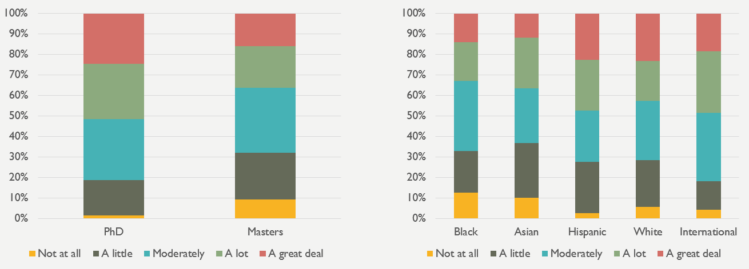
When asked how often the respondent participated in student groups or events with other graduate students, the majority of PhD students and a little over 40% of master’s degree students did so at least moderately. International students seemed to participate in student groups and events with graduate students more frequently than those from other racial/ethnic groups, while Asian American students indicated that they participate in the events with other graduate students less frequently. In focus groups, it will be important to obtain more information from students who responded with “A little” or “Not at all”. More specifically, the administrator of the focus groups should ask whether these respondents participate in student groups and events alone or if they choose not to participate in the events at all. More details can be seen in the graphs below.
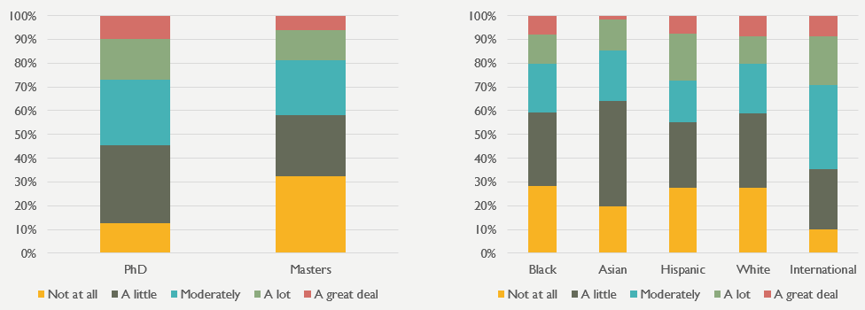
Fortunately, very few students report experiencing discrimination from other graduate students. About 92% of PhD students and 90% of master’s degree students report never having experienced discrimination from other graduate students or experiencing it “a little”. When breaking the responses down based on race/ethnicity, Hispanic, Black/African American students, Asian, and International students were more likely to report experiencing discrimination compared to White respondents. A small percentage of Asian American students indicated that they experience “a great deal” of discrimination from other graduate students. Focus groups should obtain examples of the types of discrimination that some students have faced in order to consider possible interventions to minimize these experiences. Details can be found in the graphs below.
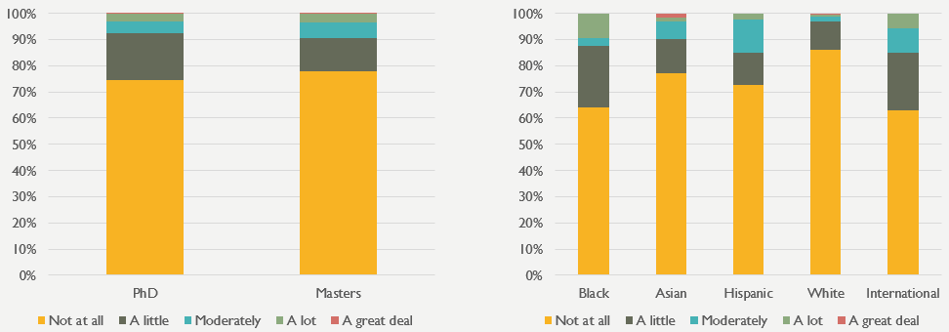
Very few students report experiencing tense or hostile interactions with other graduate students. About 90% of PhD students and 90% of master’s degree students report never having tense or hostile interactions with other graduate students or having these types of interactions “a little”. When breaking the responses down based on race/ethnicity, International and Black/African American students were more likely to report having had tense or hostile interactions with other graduate students compared to respondents from other groups. A small percentage of Asian American students indicated that they experience “a great deal” of tense or hostile interactions with other graduate students. Just as mentioned with respect to discrimination, focus groups should obtain examples of the types of tense or hostile interactions that some students have faced in order to consider possible interventions to minimize these experiences. More response information can be found in the graphs below.
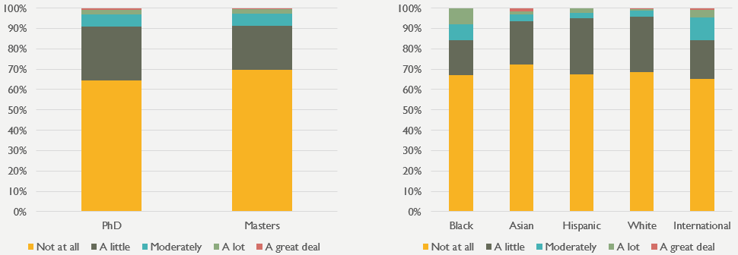

Programming and Services

What resources/programs do students feel are valuable?
Of the types of support provided by the Graduate School, students find Graduate School financial support and fellowships to be most valuable. Graduate School conference support and the tax assistance programs were also considered valuable.
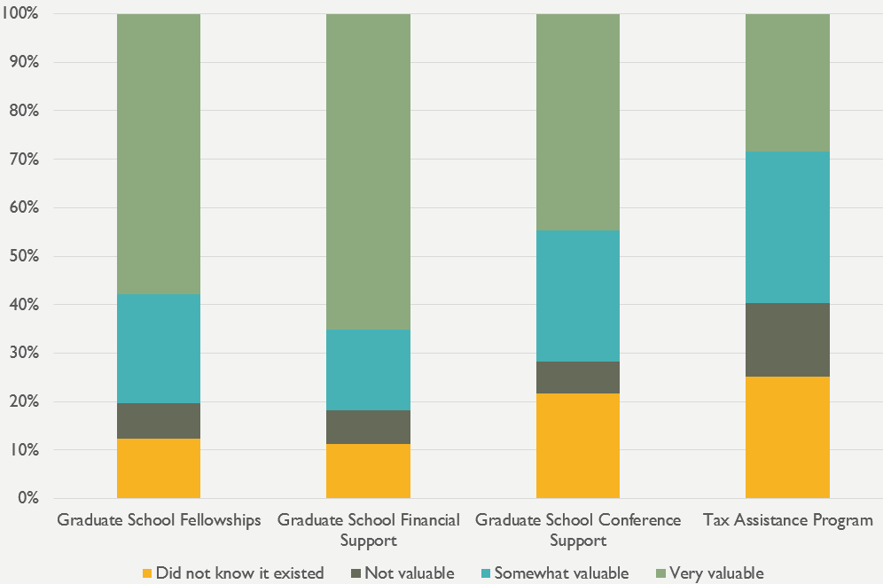
The graphs above and below provide information about how students responded to each of the resources and programs listed. Each bar shows the percentage of students who said that the resource/program was very valuable (light green), somewhat valuable (blue), not valuable (dark green), or a resource/program they did not know existed (yellow). Each bar adds up to 100% of the respondents.
Of the workshops listed, students find the career preparation workshops and career counseling to be very valuable, as well as the Graduate Writing Center.
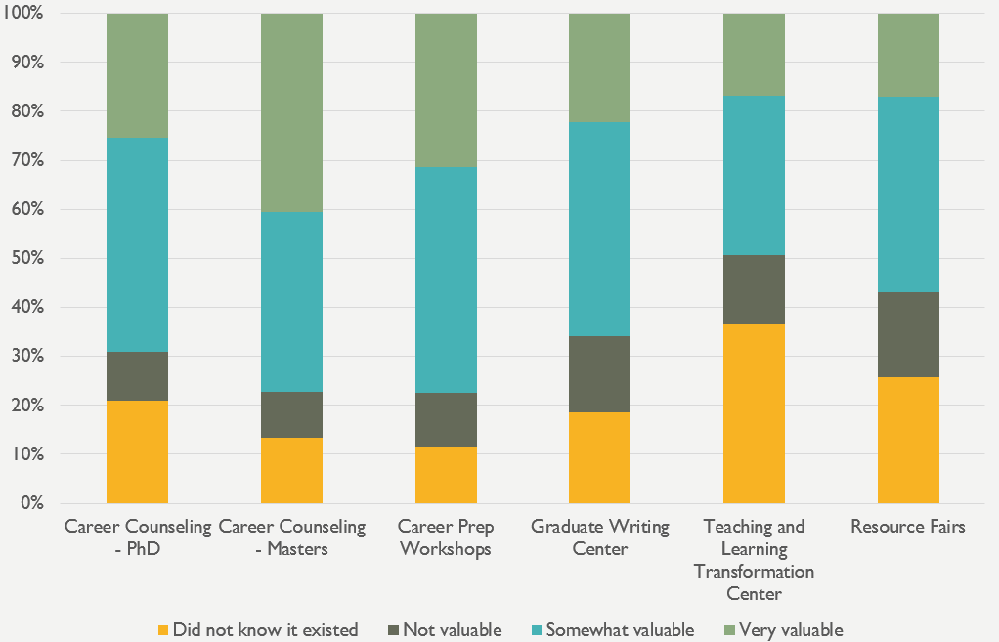
The program specific orientation was also considered as valuable to the graduate student respondents, as indicated in the last graph. While many students found the Graduate School orientation to be valuable to them, it was not as highly rated as the program specific orientation.

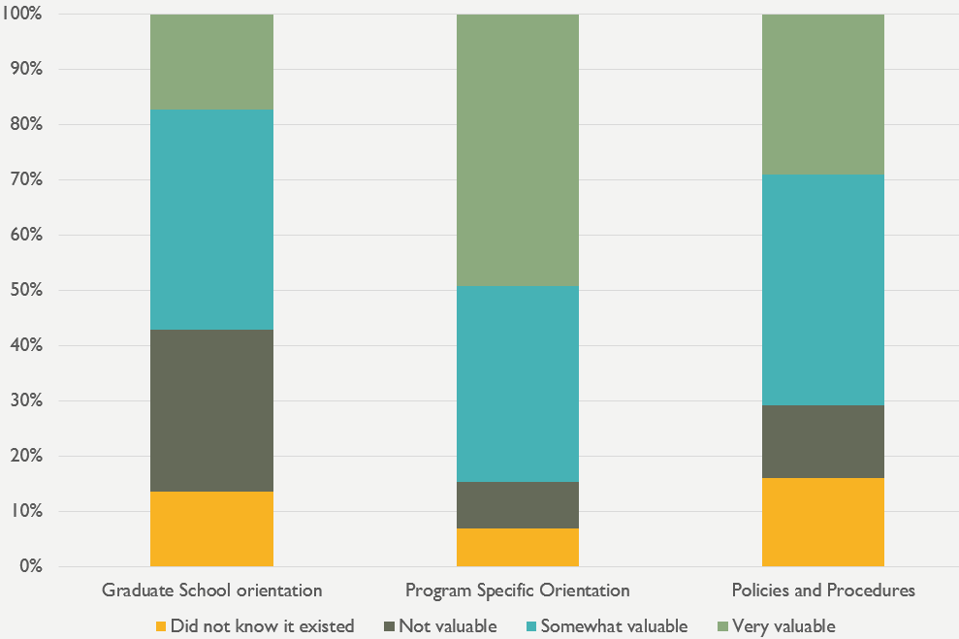
Since the Graduate School orientation began in 2013 and has been continually evolving, a breakdown by year was graphed to see if there were particular years when the orientation was considered more valuable. Interestingly, those who started in 2012 indicated that Graduate School orientation was valuable, despite there not being one. Perhaps these students mean that they wish that they had an orientation when they first started. Those who started in 2016 seemed to value the orientation more than during other years, with 2017, 2013, and 2014 following closely behind.
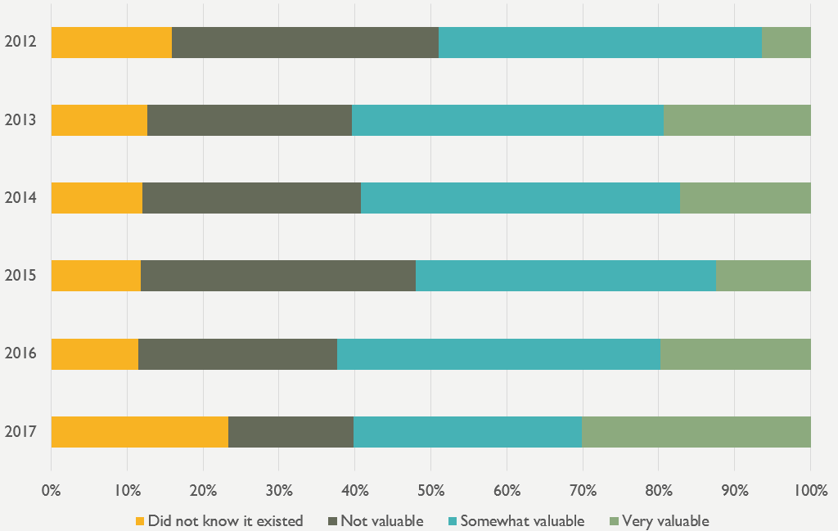

What professional development workshops are of interest to students?
Students were asked what types of professional development workshops they would be interested in attending. Results were split up based on educational objective and are shown in the graph below. Yellow represents PhD students and green represents master’s degree students. As evidenced from the graph, PhD students are most interested in Grant Writing Skills, Finding Outside Funding, and Job Search Workshops, while master’s degree students are most interested in Career Development Workshops, Job Search Workshops, and Communication Skills.

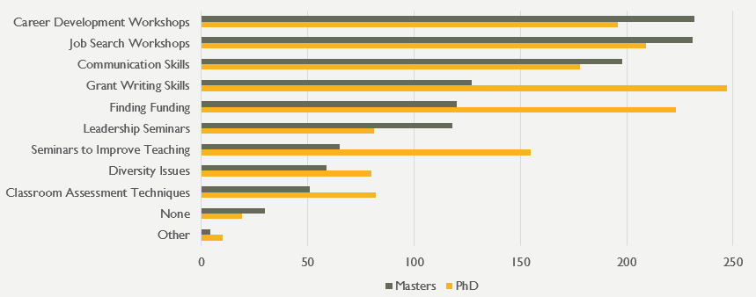
Students who wrote in “other” responses indicated a number of other professional development workshops that fall under six broad categories: career development, advising/mentoring, academic writing, public speaking, teaching, and financial literacy. Specific workshop topics are indicated in the table below:
Professional Development Workshops of Interest to Students (Other)
Career Development | - Publications/conferences, shadowing in the Field  - PhD program/professor search workshops  - Personal career coach  - Older professionals changing careers  - Navigating search for clinical externships and internships relevant to my field  - More of everything for career services!!  - Mock interview for PhD  - Finding and working with a classical music agent  - Connecting us with actual jobs/employers - put our resumes front and center to those who are hiring
Advising/mentoring | - Mentoring  - Faculty advisor rotation program
Academic writing | - Seminars on getting published in academic venues.  - Academic writing.
Public speaking | - Public speaking
Teaching | - How to teach in an academic setting
Financial literacy | - Understanding to how pay back college loans

Careers upon Graduation

What careers are students looking to pursue upon graduation?
Career interests varied by educational objective. The PhD students who responded are predominately interested in careers at R1 and R2 universities. Other doctoral students who responded are predominately interested in careers at R2 and R1 universities, as well, but self-employment was a popular third choice. Students obtaining master’s degrees are most interested in careers in business or working for a for-profit company. Students graduating with certificates are predominately interested in careers in the U. S. Federal government. Lastly, non-degree seeking students are predominately interested in careers in primary and secondary schools, as well as business and for-profit companies.
The results appear to align with the degrees and certificates offered by the various departments and programs on campus. A large number of doctoral students are interested in working in research universities in the future, while a large number of the master’s students are interested in working in the industries in which they are studying. It is not surprising that many of the students obtaining certificates are interested in working in the government because the University of Maryland awards certificates in fields like geospatial information systems, which are more commonly found positions within local, state, and Federal governments.
Keep in mind that there are some limitations to these data, particularly for those pursuing other doctoral degrees, certificates, and those that are non-degree seeking, as the number of respondents is quite small and may not be representative of the larger population.

What careers center activities are of interest to graduate students?
Students were provided with a list of career center activities and asked which of them were of interest to them. The top ten responses, in order, were Salary Negotiation, Alumni Networking, Effective Job Search Techniques, Cover Letter Workshop, Career Exploration Tools for PhDs, Résumé Workshop, Interviewing Workshop, Professional Headshots, Networking Tips, and Finding/Utilizing Mentors.
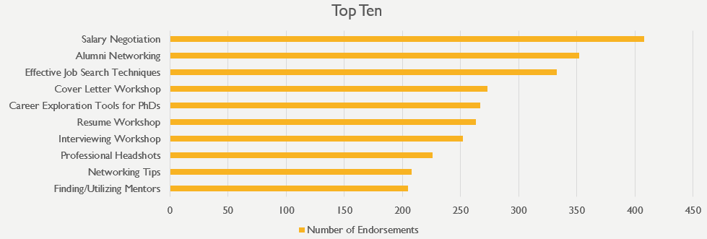

Predictors of Recommendation and Belonging

The Graduate Student Quality of Life survey asked questions regarding students’ feelings of belonging in the hopes of answering the following questions:
- What predicts graduate students’ reported likelihood to recommend the University of Maryland to other students?
- What predicts graduate students reported sense of Safety and Support, a Sense of Belonging subscale, on campus?
- What predicts graduate students reported sense of Connection, a Sense of Belonging subscale, on campus?

The analytical dataset included in this section of the report includes all students who responded to the survey and for whom there is data for the outcome variable and other variables included in the analysis. Due to the high number of incomplete responses, attempts to maximize all the data available were undertaken for this analysis. Rather than deleting all partial responses, if a respondent answered the outcome variable, in addition to at least one predictor variable, their responses are factored into the analysis. Therefore, respondents could skip an item being used as a predictor and still be included in the analytical sample.
This report summarizes these findings and includes detailed information regarding the strength and direction of the relationships between individual variables and the outcome variable in three tables. A summary of the significant predictors is presented below.
Findings
Outcome Variable: Would you recommend the University of Maryland to other students?
Four models were run to explore predictors of students’ likelihood to recommend UMD to other students. Model 4 was selected as the final model as this combination of variables was able to explain the most variance (i.e., best predicted) in students’ responses to this item. Model 4 was able to predict 24% of the variance, which is generally considered to be a low to moderate level of prediction.
Within Model 4, the following variables were significant predictors:
- International: Compared to non-international students, international students were more likely to indicate they would recommend UMD to other students (p = 0.011).
- Masters seeking: Respondents seeking a master’s degree (as compared to those seeking a PhD) were more likely to indicate they would recommend UMD to other students (p < 0.000).
- Satisfaction with Funding: Those who indicated they were more satisfied with their level of funding were more likely to indicate they would recommend attending UMD to other students (p < 0.000).
- Satisfaction with Career Planning: Those who indicated they were more satisfied with career planning were more likely to indicate they would recommend attending UMD to other students (p < 0.000).
- Experiences with Faculty – Mistreatment Subscale: Students with higher scores on the Mistreatment subscale were less likely to indicate they would recommend UMD to other students (p < 0.000).
- Experiences with Faculty – Student Centered Subscale: Students with higher scores on the Student Centered subscale were more likely to indicate they would recommend UMD to other students (p < 0.000).

A full list of the variables included in this analysis, as well as the outcomes for each model are included at the end of this report. It is likely there are other variables that would predict students’ likelihood to recommend UMD that were not included on the survey.
Also of interest to the data analysis team were the two subscales related to respondents’ sense of belonging on campus. Using a Principal Components Analysis, two subscales were created: 1) Support and Safety and 2) Connection. Two additional regressions were conducted to determine what predicts students’ responses to these two subscales.

Outcome Variable: Support and Safety Subscale
Again, four models were run to explore predictors of students’ sense of Support and Safety. Model 3 was selected as the final model as this combination of variables was able to explain the most variance (i.e., best predicted) in students’ responses to this item, while also being the most parsimonious. In other words, the additional variables added in model 4 did not make a measureable improvement on the model’s ability to predict students’ responses compared to model 3. Model 3 was able to predict 10% of the variance.
Within model 3, the following variables were significant predictors:
- Master’s students: Compared to PhD students, master’s students reported a higher sense of Support and Safety (p = 0.002).
- Other Educational Objective: Compared to PhD students, students with an educational objective other than a master’s degree (i.e., other doctorate, certificate, or non-degree seeking) reported a higher sense of Support and Safety (p < 0.000).
- Student Centered Subscale: The higher a student’s score on the Student Centered Faculty subscale, the higher the reported sense of Support and Safety (p = 0.001).

Outcome Variable: Connection Subscale
Again, four models were run to explore predictors of students’ scores on the Connection Subscale. Model 3 was selected as the final model as this combination of variables was able to explain the most variance (i.e., best predicted) in students’ responses to this item while also being the most parsimonious. In other words, the additional variables added in model 4 did not make a measureable improvement on the model’s ability to predict students’ responses compared to model 3. Model 3 was able to predict 11% of the variance.
Within model 3, the following variables were significant predictors:
- Master’s students: Compared to PhD students, master’s students reported higher scores on the Connection subscale (p < 0.000).
- Other Educational Objective: Compared to PhD students, students with an educational objective other than a master’s degree (i.e., other doctorate, certificate, or non-degree seeking) reported higher scores on the Connection subscale (p < 0.000).
- Student Centered Subscale: The higher students’ scores on the Student Centered Faculty subscale, the higher their sense of reported Connection (p < 0.000).
- Mistreatment Subscale: The higher a student’s score on the Mistreatment by Faculty subscale, the higher the Connection subscale score (p = 0.013).

The final predictor above is intriguing. Despite reporting being mistreated by faculty, those students with higher scores on this subscale report higher feelings of connection. While we do not know what causes a positive relationship between these two subscales, we may be able to identify potential explanations that could be investigated in a future study. The Connection subscale includes a question about whether students know where to go for assistance when experiencing issues on campus. For those students who feel that they have been mistreated by a faculty member, it is possible that they would have needed to explore these options more thoroughly than students who have not had this experience. Additionally, while there are 7 items included on the Mistreatment subscale, the mean is 2.2 and only 80 students had a mean score of 4.0 or higher. Since there are few students who report being mistreated by faculty, this limits the ability for this method to accurately capture the relationship between these variables. Lastly, it could be that this mistreatment facilitates connection with other graduate students experiencing similar interactions with faculty.
As with the recommendation analysis, it is likely there are other variables that would predict students’ sense of Connection, as well as Support and Safety, that were not included on the survey. The addition of two items examining the number of activities students reported attending did not improve the ability to predict students’ responses on either Sense of Belonging subscale. It may be that the total number of events hosted outside of the classroom that a student attends is a poor predictor, while a specific subset of activities or the time of year in which students attend these events may be a better predictor.
Action Items/Recommendations
- Future studies should use the findings from these regressions to further specify the predictors that may be useful for analysis. For example, questions about out of classroom engagement may be expanded to include additional information beyond the count of activities attended. For example, when in a student’s academic career these events are attended and how often they are attended (some events included occur more than once per year).
- Given that students who report higher levels of mistreatment by faculty are less likely to recommend the university to other students, further investigation may be warranted. For example, exploring which colleges and programs report higher levels of mistreatment may provide a starting place for conversations on how to address these practices and limit mistreatment of graduate students. Similarly, focus groups could be used to explore the apparent positive relationship between students who report being mistreated and their increased scores on the Connection subscale.
- Among all three analyses, master’s students were more likely than PhD students to indicate a higher level of agreement with the outcome variable/scale. Focus groups with PhD students to identify services or programs that may increase their sense of belonging or likelihood to recommend the university to others may prove fruitful.
- Given the length of the questionnaire, many respondents did not complete all of the items, which may have influenced these results (e.g., race/ethnicity data may not be available for everyone included in the analysis). Given the importance of these findings, care should be taken to restrict the number of items included on the survey during the next administration so that respondents complete all items.

More information about the subscales can be found below.

Subscales
Subscales were created using a principal components analysis with an oblique rotation. The items in each subscale are presented below along with Cronbach’s alpha, a measure of reliability.
Support and Safety (α = 0.854):
- I enjoy being a graduate student at the University of Maryland.
- I feel physically safe when I am on campus.
- I feel like the university is a place where I am valued.
- My graduate program/department is supportive of my success as a graduate student.
- The university is supportive of my success as a graduate student.
- I feel like the university is a place where my ideas are respected.
- The university fosters respect for cultural differences.
Connection (α = 0.623):
- If I have concerns about the university, I know where to go on campus.
- I interact with graduate students outside my field of study.
- I feel connected to the graduate student community at the University of Maryland.
Mistreatment (α = 0.876):
[Faculty]…
- Have tense/hostile interactions with me.
- Discriminate against me.
- Seem more concerned with furthering their own careers than with the well-being of the program as a whole.
- Allow personal disagreements with each other to negatively impact students.
- Appear to give most of the attention and resources to a select group of students.
- Use their position to request work/assistance in ways in which I am not comfortable saying no.
- Carefully guard results and new ideas from others in the field.
Student-Centered Subscale (α = 0.911):
[Faculty]…
- Help students grow as scholars.
- Value my professional interests.
- Discuss research strategies with me.
- Discuss career options with me.
- Include me in projects that align with my professional interests.
- Care about students.
- Interact with me outside of class.
- Discuss personal matters with me.
- Care about their scholarship.
- Are explicit in their expectations of students.

General Feedback about the University

Students were given an opportunity to provide general feedback on their university experience through a number of open-ended questions. Responses were coded by theme and representative quotes are presented in this section.
Please tell us in what ways you do not feel supported by the university, your department, or your program
A total of 209 students responded to this question, and a number of them expressed strong negative feelings. The top twenty themes that emerged are presented in the table below, and representative responses from the top 10 themes are also presented.
Top 20 themes from student responses
1. | Financial (58) | 11. | Coursework (16)
2. | Value of grad students (43) | 12. | Mental health/stress (16)
3. | Lack of support (40) | 13. | Academics (16)
4. | Program-specific (35) | 14. | Priorities (15)
5. | Lack of voice (32) | 15. | Culture (13)
6. | Advisors (20) | 16. | Administration (13)
7. | Communication (20) | 17. | Poor fit/mismatched expectations (12)
8. | Faculty (20) | 18. | Diversity (12)
9. | Career/networking (20) | 19. | Disturbing (11)
10. | Assistantship (17) | 20. | International students (10)

Theme #1: Financial. A number of students do not feel supported due to financial issues
“When I was first accepted to the program, I was told that it was "very easy to find funding, graduate assistantships etc." I accepted the offer (over other offers I might add). Once I accepted the offer, and I found out it WAS NOT so simple, and contacted the program about it, they basically said I was on my own. It was very frustrating.”
“The financial hardship of graduate students is not taken seriously by the university.”
“When admitted, I was told that I was guaranteed funding for at least 5 years. Instead, my advisor lost her funding just 3 months after I arrived. Ever since, I've accumulated ~$40,000 in debt as different faculty members have pawned me onto each other.”
“What can I say? Our President just cares about building new buildings. Is it really possible to survive with $1400 in DC area? Am i here to research or being TA/ do internships to survive? I was paid $1900 per month as TA in Arizona where I paid $300 for rent. Horrible situation. Big debt. Nobody cares.”
“The university pays our graduate assistants a ridiculously low wage for their work and in comparison to flagship campuses. The cost of living here is insanely high.”
“The assumption that all doctoral students are full-time and fully funded, with no serious provision for part-time study is problematic. This is especially true with regard to time to degree requirements being the same for single full-time students, and students with families and responsibilities requiring full-time employment off campus. The practical effect is to discourage older students, who may have much to contribute, but for whom a GTA stipend is insufficient.”
Theme #2: Value of graduate students. A number of students feel undervalued by the university, their department, or program
“My only interaction with "the university" has been paperwork making sure I meet deadlines and paying tuition- I have no sense that the university cares if I graduate or not.”
“My department and program are great. But I definitely don't feel supported by the university. Graduate student workers are basically slave laborers; we do all the grunt work and are the reason that many of the departments are able to function and yet we see very little respect or financial compensation.”
“In my specific field, I have very little interaction with the majority of the professors and staff in the building. Because of this, they have no idea who I am or what I am working on, and no vested interest in me or my projects.”
“I was used for years as cheap labor to get classes taught and work done. I found there to be jealousy, pettiness and non collegiality in my department”
“I feel very supported by my department and program. I feel that the university generally lacks concern for graduate students - in terms of stipends, benefits (e.g., health insurance), parking. I strongly think that graduate students are taken for granted at this university. Additionally, having been an undergraduate at UMD, there is a very clear distinction between the resources offered and advertised to graduate students. Many graduate students are unaware of the resources and activities available to them.”
“I feel like there is very little concern from anyone on how I am actually doing, they (both the university and my department) seem to be highly concerned with my career but not with my personal state of being. Including; depression, stress etc.”

Theme #3: Lack of support. A number of students also mentioned non-financial ways in which they felt unsupported
“I can hardly think of a way in which I do feel supported by the university, department, or program. The student groups are much more helpful. I know there a lot of programs and initiatives and whatnot designed to support grad students, but these events do not change the fact that faculty and administration (outside of the offices that host them) have little regard for graduate students. This is a cultural problem that hosting appreciation events will not address.”
“I do not feel like there is a supportive graduate student community. I have talked with others at some other universities and the Graduate students feel much more connected to one another.”
“I and others in my program have had difficulty navigating some the university bureaucracy which left me feeling unsupported. During my first semester I had accepted a GA position which ended up creating an issue with my student account and the Bursar's office. I received ineffective help from Financial Aid (who could take over a month to respond to e-mail) and my college's Graduate Student Services department. This issue, which started during the beginning of my first semester was pushed through almost to the beginning of the second semester, almost preventing me from continuing on. After this experience I did not feel like there was anyone I could ask for help regarding administrative problems or academic advisement.”
“I am working with a professor who was hired just after I started, so the group is very small and he has a very hands-off managing style, so it is hard to find people to help with my research questions, leading to delays in my advancement through the program. Department-wise, I feel like I was allowed to slip through the cracks while I was struggling to adjust to my advisor.”

Theme #4: Program-specific. A number of students provided program-specific feedback
“Program not fully developed.”
“[My] program is looked down upon and we are not given enough opportunities to get GAs or other on campus part time opportunities.”
“The department has been hesitating in upgrading the coursework to match the industry standards to increase employment. Besides, has irrelevant and obsolete courses that are mandatory.”
“A lot of times it seems like the instructors [in my program] care more about their research than actual teaching.”
“The administrative staff of the [specific school] has never been terribly helpful or supportive. The staff is not helpful, especially when it has come to advising (despite the numerous program changes over the past couple of years). This is in stark contrast to the wonderful, amazing and supportive staff in [another] department.”
“It is specific to my program and the professors not giving me the education and interaction I deserve.”
“As I explained before, my emails aren't responded to, there is a feeling that they do not care about us as students in our program, we are constantly disrespected in the way problems are dealt with and in the few responses received from professors where they were outright rude in response to valid questions about due dates and understanding assignments.”
“My problems with my graduate career lie solely with my department and not the university as a whole. The students of my particular advisor are all struggling but we feel that we cannot pursue assistance without damaging our careers.”

Theme #5: Lack of voice. A number of students expressed a sense that they lacked a voice when expressing feedback for improvement
“I have felt that my department is unresponsive to concerns that I and my fellow students have expressed time and again over the time I have been here, and even when we have taken surveys or taken our concerns to the College level almost nothing changes. This is particularly in regard to having transparent rules about course requirements, funding and TAship availability, and increased support toward reaching our program's requirements.”
“The university refuses to recognize graduate employees as employees, nor will they advocate for us with the Maryland Assembly. Despite reports of workplace abuses, poor quality of life, and inadequate funding, they will not work with us to improve the graduate student/employee experience. “
“I have voiced concerns with the program after every class. (7) and no action has been taken. Or at least not action that makes positive change.”
“The university makes no effort to make sure that student workers are paid a living wage or acknowledged as employees who deserve collective bargaining rights.”
“My department supports me as much as they can. This is where I feel the support ends. / The university and president's office clearly prioritizes STEM fields above all else, and we feel it. The graduate school seems ineffective at doing much more than organizing social events and asking students about how they feel. I can't even get a government form filled out properly by the bursar's office because they aren't aware what does and doesn't constitute "full time" for graduate students. / Needless to say I am quite tired of routinely getting asked for feedback and seeing no indication that anything is being done to improve graduate students' conditions.”
“My department/program is very supportive. The University administration, however, is tone deaf to concerns about graduate student labor issues.”
“Lack of financial and administrative support. In order to get things done, you need to complain loudly and frequently. Student concerns are not prioritized until we force them to be prioritized.”
“In general I have found that university might listen to graduate student complaints (about cost of living, about workload, about mental health needs, about difficulties working with belligerent or confrontational students, etc.) but nothing ever changes.”

Theme #6: Advisors. A number of students provided feedback on their frustrations about advisors
“Dealing with graduate advisor. lack of guidance and mentoring. Having to try to find resources and opportunities to be successful on my own.”
“I have persistently expressed interest in pursuing a PhD after my Masters but I'm being discouraged by a faculty member who is serving as my faculty advisor. My advisor also does not have the capability to properly advise students. I find myself heavily being supported by professors in other departments.”
“My academic advisor does not respond to emails and is extremely difficult to get in touch with. He has not been supportive or a mentor in any sense. My assistantship has been wonderful, however.”
“I had to find a way to change advisers and nobody helped or supported me, noting adviser was the chair of department. I couldn’t seek advice from anyone. / Even earlier when I had issues with adviser and went to the ombuds office, they were not helpful in giving me options or making sure I feel supported.”
“I was not assigned an advisor until my 3rd-4th semester in this program, and only after I sought guidance. Upon this advisor counseling, I discovered that I was not on the right track to finishing my degree when I wanted. I could have saved myself quite a bit of time and money had I received guidance from an academic advisor from the beginning of my program.”
“I get little feedback despite requesting it from my advisor on the process for proposal to advance to candidacy and I'm already six months behind what a preliminary estimate for advancement was. While it is good not to feel pressured, I feel lost that I don't know what is required of me and I know many other students who started the same time I did are all completing proposals over the next couple months and some have had coaching from their advisors for the oral examination portion.”

Theme #7: Communication. A number of students had concerns about program / university communication
“We are given very little information about how things work in the department and in decision making. There is a general lack of transparency. I was lied to by professors. I never received feedback from several professors. There are professors who do not return emails and make it very hard to meet with them in their office.”
“The University internal software systems do not communicate with each other, causing tons of hassle to get simple changes done. There are no central resources for assistantships or fellowships. Campus systems such as DOTS are outsourced and have no chain of command with which to file complaints about terrible service.”
“We rarely have access to accurate, timely information. There is more focus on the academic and networking needs of doctoral candidates. For lower-level doctoral students, the focus is more social. We never see or hear from department faculty regarding research opportunities; we mainly receive job listings and post-doc listings.”
“There is little guidance for me as a graduate student, so I know that I have to figure out the path forward myself. There are often requirements that change or are not mentioned in program materials, so it makes it difficult to plan out the path to a degree. The bureaucracy and red tape make it difficult to figure out what needs to be done each semester (even my advisors are often at a loss), and I am constantly baffled by the number of forms that need to be filled out. Everything seems poorly organized and there seems to be little thought given to the student experience and to guiding people through their education.”
“The people managing the administration in my program are completely unhelpful. Every time I walk into the office for questions, they look at me like I'm not supposed to be there. I guess I don't understand why they always look so confused by the fact that someone has a question.... And it's not just me. I saw another student in my cohort go in the office and no one says a word. You have to announce what you need for someone to be helpful. When I email them with a question, they seem to always pass me off to the next person. / / My program director is completely uninterested with what's going on with us. They told us we would "never have to pay for a single credit if we got a GAship," as they planned out the course schedule perfectly. Well...it was NOT. I will end up paying thousands.”

Theme #8: Faculty. A number of students did not feel supported due to concerns with faculty
“Lack of empathy from professors who later said they would never do the program we are in, verbal chastisement when we have concerns about workload, lack of follow through on promises”
“Most faculty has been very difficult to work with when I have run into issues. It is not like I am a bad student; I have a 3.91 GPA now. But still, they were not supportive with academic and non-academic struggles I had.”
“Certain faculty members funnel any opportunities to their own advisees, including GA positions, awards, jobs, etc. at the expense of the rest of the department. Faculty refuse to allow graduate students to take part in decision-making, despite the fact that we teach over half of the classes that we offer.”
“From the moment I arrived and received no departmental orientation, handbook, or instructions on what I should be doing, it already felt like I was not supported by my department. There are few professors who actually seem to care about the students, and all anyone seems to care about is pushing us through, regardless of any struggles students might be having. They gossip amongst themselves about students to the point that students sometimes are viewed negatively by certain faculty members even before they have interacted with them.”
“Basic considerations, such as the time commitments of graduate students are not often considered by faculty in my program. Such as determining when we will have a meeting, offering short notice and no consultation, without consideration for job or other requirements.”
“Across multiple departments and schools, it is clear that faculty do not enjoy teaching Master's courses, nor are they particularly interested in the quality of the courses, or even placement.“

Theme #9: Career/networking. A number of students do not feel supported as they plan for careers after their programs, within academia or outside academia
“They cannot even offer advice on how to apply for jobs as they have spent their careers in academia (and I sense some disdain for alt-ac careers from some faculty members, even though again, that's where most of us go after graduating).”
“The future success of graduate students is not taken seriously, and PhD students are not adequately prepared for jobs.”
“There are no resources on developing a professional career within academia. All such professional development at the department and graduate school level focus on careers outside of academia, which is very useless if you want to pursue a career in academia.”
“If you do not have academic career goals, almost no one seems to know anything to help you and in fact, they seem to selectively forget that you do not want to follow in their incredibly improbable footsteps. / While university (graduate school) level resources for career pursuits have been helpful, as far as I know, they only recently came into existence. It will be much more useful for students who are not as far along. “
“Some of the instructors are using VERY outdated material that is no longer relevant. Because these instructors teach required courses, we are effectively paying to learn things that will not benefit us in obtaining usable skills or gainful employment. It is a waste of my money and likely to change because the instructors feel secure in their jobs as the course is required.”
“The PhD program is training for jobs that largely do not exist. Of course, people find jobs elsewhere, but basically without any help from the program or university. / / Recently, the career center has had a series of workshops for non-academic paths which has been great, but honestly, everyone should be exploring/planning their career trajectory early on in graduate school. That way, a student can build a set of experiences that will help them determine where they want to end up and will make them exceptional candidates for it.”

Theme #10: Assistantship. A number of students felt unsupported as it relates to assistantships. Concerns included assistantship availability, funding, and workload
“Specifically, there are a lot more assistantships that are teaching-based but very few that are research-based and will result in posters or publications.”
“There are not many assistantship positions that fit what I do.”
“Without funding or a TA position available to me, I have had to get a real job and continue my studies as a part time student.”
“I lost my research funding three times, generally with only a few weeks of warning that my paychecks would stop. I was promised a GA when I was offered admission, but I was not savvy enough at the time to ask "how long." I know better now - it only lasted three years, and a few months after I advanced to candidacy my adviser ran out of money. I do not blame him, as this happens to scientists all the time, but I think he did a bad job communicating this with me.”
“I'm underpaid compared to my other friends around the country who are in worse schools, and their assistantship is less demanding.”
“Heavy work load for teaching assistantship”
“Funding shows how much a university cares for your well-being (i.e. ability to pay for food and housing). We're known as one of the universities with the worst funding for graduate students and yet we are a R1 school...Because I work an assistantship and my days are 12-14 hours long, I can't secure outside employment to help with income.”

Please tell us why you wouldn’t recommend University of Maryland to other students
A total of 279 students responded to this question, and a number of them expressed strong feelings about why they would not recommend the University. The top twenty themes that emerged are presented in the table below, and representative responses from the top 10 themes are also presented.
Top 20 themes from student responses
1. | Financial (75) | 11. | Career (17)
2. | Academics (56) | 12. | Community (16)
3. | Program/Department-specific (56) | 13. | Facilities (15)
4. | Balance / “it depends” (55) | 14. | Assistantship (15)
5. | Quality (42) | 15. | Student life (15)
6. | Lack of support (38) | 16. | Disorganization (14)
7. | Faculty (31) | 17. | Disturbing (14)
8. | Value of grad students (30) | 18. | Lack of voice (13)
9. | Location (22) | 19. | Positive feedback (13)
10. | Poor fit/mismatched expectations (22) | 20. | Diversity (12)

Theme #1: Financial. A number of respondents would not recommend UMD due to inadequate financial support
“My program doesn't give graduate students the level of financial support that they could get elsewhere.”
“Additionally the cost of living around the campus or even further out from campus are two to three times as high as comparable institutions and lacks quality housing for students nearby that would not drive your cost of attendance to greatly add to your debt from attending.”
“Tuition costs, financial aid availability, minimal resources and support services.”
“Unless you are able to negotiate future funding, summer funding, etc. before signing your contract, you are often left to search on your own with little money available (that is being requested by a huge amount of students).”
“The graduate stipend is far too low for the area, especially for international students as they cannot work off campus. In addition, to expect students to pay fees out of an already low stipend is unreasonable. Graduate students essentially subsidize a transport system and facilities more catered to undergraduates than themselves.”
“Graduate student experience is not enjoyable: The pay is far too low to live comfortably in the region (And to attract other good graduate students) and, as far as I can tell, absolutely nothing is being done about it aside from sending us "feedback surveys" every few months.”

Theme #2: Academics. A number of respondents would not recommend UMD due to its academic offerings
“My experience in my program has been lacking. I have not received the education and professor interaction that I was told I would. Too many core classes that I am uninterested in means that I am unable to focus my passions (which is the purpose of graduate school). I have not received feedback from professors that would help me improve my skills and learn. Some professors do not teach material so that is understandable, some are so unorganized that I do not get to complete assignments like my peers, and some are so busy that they cannot provide feedback on papers and projects.”
“Too large. The graduate classes are too large. No significant discussion. Professors do not want to teach.”
“Mainly the courses offered for my particular field of study are extremely lacking and the organization of my program is really poor.”
“Inconsistencies in course descriptions and actual class content.”
“I wouldn't recommend my program because there is a good chance you won't be able to take a class that you want to take.”
“I love UMD but I would never recommend my program because many of my classes are not being offered and it is holding me back from being able to graduate.”

Theme #3: Program/Department-specific. A number of respondents would not recommend UMD due to program- or department-specific concerns
“The program requires all students to take a first year of pre-selected "core" classes. For someone who has years of experience, these introductory gen-ed courses are an incredible waste of time and money.”
“The program doesn't really cater to very bright students, rather it's main focus is on teaching mediocre students. It also does not focus on helping students succeed in academia, rather there is an obsession with offering PhD students information on jobs outside of academia. It is like they assume their students will not succeed in academia, so they structure classes and research opportunities around this assumption.”
“Really just my program, due to bitter/angry feuding faculty.”
“The program is weak and UMD seems to be more worried about research, community service, and attracting new students than it is educating the students.”
“Particularly in the department, the graduate students aren't valued. Those at the highest levels of authority in the department openly dislike graduate students and are frequently unconcerned for our well being and academic success.”
“My program was not concerned with my success post graduation”
“I wouldn’t recommend my program because faculty are few, graduate student interaction is minimal, we don’t interact w faculty outside of our advisor...it’s very segregated.”

Theme #4: Balance/”it depends”. A number of students provided a more balanced response to this question

“It would depend on what the student was looking for. Caring, involved advisors? Probably not. If they wanted a top research program and UMD was ranked highly for that, then probably yes.”
“It would depend on the program and the person's values. If they want access to DC, then yes. If they want a supportive environment, probably no.”
“It really depends on the program, the person's background and interests, and so on.”
“It depends on what environment you are looking for - in terms of transportation, how close knit of a community there is and what types of campus support”
“I would want to know what program they were interested in, what size institution they were looking for, and what type of location they wanted. College Park in my experience has not been a great place to live, but I have appreciated the education received at UMD. I was looking for a large institution, but a small cohort of Master's students, so it was a good fit for me.”
“I think there are certain things UMD does well, and certain things it has to offer and others that it does not do well or does not offer to an incoming graduate student. Depending on what the student was looking for in a school, I might direct them elsewhere. For example, if they wanted a vibrant urban setting, I might direct them elsewhere. If they are considering a career in research for the federal government, I would highly recommend UMD.”

Theme #5: Quality. A number of students expressed that program / course / education quality were factors that made them not recommend UMD
“I have loved the university in general and I think it has many wonderful programs. However, I feel as though my particular program is on the decline and not the highest quality education for the money or the time.”
“I am not at all impressed by UMD from a scholastic or administrative aspect.”
“I have seen programs receive barely enough attention to claim accreditation (and yes I have experienced enough in the accrediting process to speak on this) resulting the students mentoring themselves.”
“The department is losing senior faculty and their faculty lines are not being replaced. Those that have been replaced are not competitive enough to attract top academics.”
“The university is fine, but the program is lacking in the number of classes offered and quality teachers. There has been a high turnover of teachers and some core classes have not been given for over a year.”
“The focus of the university should be more towards encouraging change in academic approach for the students by giving them a more practical sense of the textbook knowledge. It feels like my department is not even trying to improve its standing or to achieve excellence.”
“The course offerings at the department are quite stale; they're offering the same types of offerings they did about 15 years ago.”
“The classes were taught at a lower level than my undergraduate courses. Really disappointed in the quality of the education I received”

Theme #6: Lack of support. A number of students expressed that the lack of support would discourage them from recommending UMD

“Terrible graduate student support from my department”
“Relative to other institutions I had the chance to interact with, the environment is harsh, advisors are not friendly whatsoever. The dynamics of competitions among classmates reinforced by the department has led to several cases of anxiety and depression among us.”
“I don't feel like the university is on my side”
“There is no mentorship or established best practices for mentoring students. There are obvious favoritisms. The program does very little, if anything, to help students find jobs. There are professors who refuse to work with graduate students.”
“Much time wasted in classes, little advice provided to students during the PhD compared to many other schools. Grad school does not have a way of make sure advisors spend sufficient time with their students.”
“Lack of community; lack of support; I'm in a department that treats students horribly”
“Also, I have had a very hard time building a support system here, mostly due to my small research group, so I would recommend incoming students consider that.”
“I feel like it depends on what type of student you are, I feel a lot of people can slip through the cracks here. It doesn't seem like the university is fully invested in every department (and things like maintenance take forever and have been a detriment to our labs)”

Theme #7: Faculty. A number of students expressed that their concerns about faculty made them not recommend UMD

“The University of Maryland is not a very inviting environment. The professors seem to be too busy to deal with students, but that is only because the university is putting so much pressure on them to receive grants.”
“The infighting between professors is unprofessional.”
“The program is less organized than I was led to believe and the personal preferences and whims of the faculty have more control over a student's success than the student's actual work.”
“The professors we have been having in the Department have not been the best.”
“Professors are not updating their course syllabus and we are still studying the basics whereas if we see other universities, they have better curriculum for the same specialization.”
“Most of the faculty here do not seem to care outwardly at how distressed or mentally unhealthy their students are.”
“My professor is subtly sexist and uses his female students as "token assistants" when around female professionals. He is emotionally abusive to his students, continually threatening to kick them out of the program if they don't perform to his insane standards.”
“My program has systematically faced challenges with our faculty not receiving tenure, courses being cut, and not being considered a priority in the program.”
“It's been extremely frustrating to be in my program : professors are not doing their job. Grades are not entered for up to 9 weeks and emails are never responded to, which is unacceptable.”

Theme #8: Value of graduate students. A number of students would not recommend UMD due to feelings that the university does not value graduate students

“I would recommend people go elsewhere because we are paid badly, and treated as expendable by the university administration. Our valid complaints are overlooked and disregarded again and again.”
“I don't feel like the administration values its graduate students.”
“Graduate students don't seem to be valued as highly as activities that bring revenue to the University (such as sports). There were many, many stressful days of rearranging experiments or losing productivity because I was ordered to move my car from a parking space that I paid for so that DOTS could charge sports fans money to park in it.”
“Graduate Students are an afterthought. The resources aren't supported like they should be. Hard to create community.”
“Graduate student salary is very low. Terrible paternity leave policies for grad students. Much more interested in sports than paying our grad student teachers a living wage. Graduate students are often looked down upon by administration. No collective bargaining.”
“Grad students and their welfare don't seem like a priority for the University: / 1. The "limbo" (non-employee) status of grad assistants, with virtually no rights / 2. Shuttle routes and timetables are hit or miss despite the long hours we put in / 3. Regular rate hikes with little to no input from the student community (e.g., the new international student fee)”
“As this is a research 1 university, it does not always feel like the students are a high priority for the professors.”

Theme #9: Location. Campus location played a role in whether students would recommend UMD
“Living in the area is very expensive, yet there is nothing to do in College Park”
“Lack of affordable decent grad housing, few things to do in the immediate surrounding area”
“Just not my ideal environment--too city-like and not much of a "college town" atmosphere compared to the other schools I attended for my other degrees.”
“It's a horrible place to live. Has all of the negatives of a city and none of the positives. Expensive, high crime rate, no super markets, nothing to do on rt 1 besides eat. Being close to DC isn't enough to balance out the fact that College Park isn't DC and yet makes you pay like you are with little in return. At least DC is full of things to do besides eat.”
“Frustrated with the transportation options between campus and Baltimore, while DC is unaffordable and College Park is one of the more unappealing places to live I've been.”
“Because the location lacks internship/job opportunities.”
“An amount of funding is too small to live in college park. Prices are so high, especially rent fee.”
“Because of the location (college park)' housing problem (especially if you are an international student, the DMV area is really expensive- not a good option for a grad student.”

Theme #10: Poor fit/mismatched expectation. A number of students would not recommend UMD because their expectations were not met

“Reality failed to meet expectations.”
“People actively lied about my graduate program during recruitment.”
“Mistreatment by faculty, unresponsive staff/directors, preferential treatment given to other students based on their mentors, loss of opportunities that were promised before I decided to come to the program, lack of transparency, etc.”
“I don't think my school takes into consideration the fact that many of us are very much adult students, and adult responsibilities may affect things sometimes. (Taking care of parents/kids)”
“Ineffective presentation of campus activities, inadequately accessible program listings. Many things are hard to find out about or hard to get. There are multiple departments with multiple calendars with events often not being placed on them at all. Student activities are poorly organized. School amenities are not easy to find. IE: I just found out, at the end of my second semester, about the graduate lounge on the second floor at Hornbake, and I discovered the graduate lounge in the Stamp Student Union the week after finishing this semester's finals.”
“The course catalog on the website in no way matches what the school actually offers. Currently, many students are having trouble to even find 6 credits worth of courses for the coming fall semester. When applying, I read about all the possible courses I could take and all the things I could learn with such excitement, only to get here and realize that a majority of them will never even be offered. I feel like my decision to attend UMD was based on inaccurate information and that the image of the program that was presented to us is inherently false.”

Is there anything else that you’d like for us to know about your experience at the University of Maryland?
A total of 300 students responded to this question, which was the final question in the survey. The top twenty themes that emerged are presented in the table below, and representative responses from the top 10 themes are also presented.

Top 20 themes from student responses
1. | Positive feedback (74) | 11. | Programming (18)
2. | Financial issues/concerns/funding (45) | 12. | Student Life (17)
3. | Work-life balance (27) | 13. | Diversity (17)
4. | Community (26) | 14. | Survey feedback (16)
5. | Career (24) | 15. | Academics (14)
6. | Value of Grad Students (23) | 16. | Online students/issues/courses (14)
7. | Faculty (22) | 17. | Disturbing (13)
8. | Fees/Tuition (19) | 18. | Assistantship (12)
9. | Facilities/equipment (19) | 19. | International students (12)
10. | Communication (18) | 20. | Program- or Department-Specific (12)

Theme #1: Positive feedback. Many respondents expressed positive sentiments about their UMD experience, ranging from overall positive experience (“the school”; “the people”; “my peers / colleagues”; “overall experience”) to specific aspects such as:
Free coffee Thursday
The work Susan Martin with career advice for PhDs
Specific faculty members
Off-campus roommate finder website
The campus
My department / my program
School spirit
Service work through the department
Events for graduate students, e.g. Grad student awareness week
Mentorship and great opportunities
Cultural competence and diversity
Cutting-edge research & scholarship
Career fairs
Recwell system/program
The Graduate School and other organizations helping new students transition to University life
Being able to participate as an online / satellite student
Support from UMD staff, TA, and departmental admin staff
Diversity, welcoming for international students
University ranking / reputation
On-campus student groups
Field trips to NYC / Philly
Many resources available
Theme #2: Financial issues / concerns / funding. A number of respondents expressed challenges around finances and program funding, which contributes to high stress levels.

“University should have more assistantship opportunities and on campus part time jobs for international students within their department of studies. The careerforterps site and ejobs.umd.edu is not reliable.”
“Please consider increasing the pay scales for Graduate Assistantships. They are way too low for the DC area, and very low for a school of this caliber.”
“To be a graduate student, you have to accept living below poverty level. This causes enormous stress. I have always worked at least 4 unrelated jobs to try to make ends meet. While tuition remission is a benefit, it doesn't compensate for the lack of means to provide for a family.”
“It would be helpful for the graduate school to review GAship salaries given the cost of living in the DC metro area.”
“Funding is what the "4Gs" should focus on if they want to improve graduate students' lives and work, not campus experiences.”
“UMD needs to support me and my fellow students by subsidizing public transportation.”
“Stop making me pay for the student activity fee if I don't do student activities”
“I used to be a full time graduate student, but because of funding loss, I was required to get a full time job and finish my degree on the side.”
“The university lacks an affordable housing system for graduate students, and doesn't adjust it's minimum stipend regulations according to the cost of living in this area.”
“Stipends for GRA's are ridiculously low for the area. And it is very unfair that some programs pay their PhD students so much better than others.”
“Overall good experience but grad pay just isn't keeping up with inflation. Cost of living keeps increasing but pay stays fixed (or actually goes down when factoring in fellowships).”
“I do wish, however, that the university would acknowledge that graduate students are workers and pay us accordingly.”
“I also want to comment on the lack of affordable housing in this area. The university keeps sponsoring private companies to build all these new apartments along Baltimore avenue for "students" but they are absolutely not affordable. The stipend/compensation we get for our research assistantships is far too low to cover the cost of living in the DMV so this either needs to be raised (which I think is fair for the amount of work we put into our research) or more apartments need to be built that have reasonable rent rates.”
“Graduate Students should also be paid more to account for the high cost of living (I shouldn't need 4 roommates to afford rent.) We should also be eligible for retirement savings accounts like full employees.”
“The mandatory registration fee is a huge financial burden. Also, it is disheartening to hear President Loh's idea of singling out international students to pay for extra fees.”
“You use graduate students as indentured servants to teach and grade for seminars. The University should by publicly shamed for paying its graduate assistants $14,000/year for working in the DC Metro Area.”
“I agree that the fees charged to students are too high. While my stipend is quite generous for a graduate school research assistantship, it doesn't go very far given the extremely high cost of living in the DC Metro area. Adding $800-900 in fees and another $200-300 in parking permits, and that's a big chunk of money that cuts into my graduate stipend. I also live far enough away from campus that I am unable to take advantage of most of the campus entities that my fees are supporting. It would be nice to allow students who are married or live a certain distance away (I am both) to be excused from some of these fees to help give us a better value.”
“The pay for TAs and professional track faculty is so low that, even with my wife working full time, I can't afford decent child care so I am the primary child care provider. All of my academic and professional work is done while watching my children. I have to stay up extremely late, after that go to bed, if I want to do serious work. The pay is not good enough considering the high cost of living in the region.”
“The method for handling behind-the-scenes financial transactions by the Bursar's Office is ridiculous, particularly when it comes to tuition remission. The Bursar's Office has to charge your student account for your tuition, and then some of the remission gets approved by the Bursar/Graduate School, and the rest gets approved by your department. These transactions should all be handled instantaneously and in a way that does not affect the student; instead, on multiple occasions, I have found that charges and remission have been applied in separate calendar years, leading to unexpected and drastic fluctuations in the amounts reported for tuition expenses and scholarships on my 1098-Ts. These amounts should come out approximately equal, but because of the slow response, some years I've had several thousands of dollars of scholarship "income" and others thousands of tuition "payments" that can lead to major problems when filing tax returns (especially when the Bursar reports that you received a significantly larger "scholarship" from tuition remission than charges paid for "tuition". If our assistantships give us tuition remission, handle it internally, quickly, and consistently. Don't leave your hard working graduate students in a bind because of poor University timing. We don't make enough to have thousands of dollars of extra "income" show up on our tax returns because of slow processing of tuition and remission amounts.”
“Graduate students are paid less at this university than at other academically comparable schools in areas with lower cost of living. I know of more than one quality student that has chosen a different institution for their studies for this reason alone. It forces many of us to seek outside employment to subsidize living expenses which negatively affects our academic achievement. I find this extremely disappointing.”
“I do not feel supported here, especially since my assistantship ended. I'm trying to just get finished as fast as I can now, but it is difficult without support in finding work from my advisor, my department, and the university. There should be a better system to connect those of us late in our PhDs with assistantships to finish our work, rather than subjecting us to the UMD job search tool and fending for ourselves.”
“I am an international student. This means that I am not legally permitted to work to earn more than what I am paid as a GA. My current salary is not enough to live off of in the region, and so I have been required to ask my parents for help and to go into further student debt. / There is no way that any amount of career preparation, social support services, counselling, or anything else can make any significant difference to my graduate student experience when I'm busy worrying about paying for food and rent. / We are already losing top graduate school applicants because of our funding offers (which are significantly lower than other schools). This problem must be prioritized and remedied before our ranks drop beyond repair.”
Theme #3: Work-life balance. A number of respondents, particularly those who are also employed, expressed challenges around work-life balance.
“I don't attend many of the events that are held because it takes time away from research and work. Due to other responsibilities I cannot spend extra time on campus and do not have a very flexible schedule.”
“As a PT student with a full-time job, existing career, home, etc., UMD is certainly not oriented to folks like me. And that is unsurprising, in the big picture. I'm sure we're a small minority of students, but that is in part a reflection of the additional challenges we face in this environment. As a manager of staff who live and work remotely, I use chat tools, set up WebEx’s, etc. to try to create a create an inclusive atmosphere not dependent on co-presence. Maybe my Dept, or the University, could consider adopting such technologies, and considering alternate schedules, or otherwise creating events or activities to promote interaction that are more appropriate, and feasible, for people like me.”
“As a graduate student, the demands of the work and the TA/RA responsibilities make it difficult to enjoy the resources that are provided for us. The resources are vast and helpful, but the time that school work and TA/RA responsibilities consumes leaves little for actually accessing these tools, particularly in the first year or two of grad school.”
“I am a full-time professional in the graduate program who has a family and lives over an hour from campus. GSL programs and activities are difficult for someone like myself to take advantage of, in general. You may want to consider how to better serve and involve those like myself.”

Theme #4: Community. A number of respondents expressed that a sense of community was an area that could be improved. This issue was particularly relevant for not only satellite / online students, but also among on-campus students desiring community with grad students across the campus, with undergraduates, and with faculty/staff.

“There should be more coordination across graduate schools - only while abroad did I meet other graduate students from other programs! One important aspect of this could be graduate schools making it easier to take courses in other graduate programs.”
“Referring to the "social identity group," one that was not listed that might be of interest is older students or students pursuing a second career. "Grad Pub" and similar events always seemed strange to me since I'm in my 40s and not really much for the bar scene ... but a more quiet setting, such as a dinner, with others in a similar life stage as me (not actively searching for a romantic relationship, perhaps struggling to find family/school balance) might have been a nice respite. I understand we are not the majority of graduate students, though.”
“I feel like there's not a lot of organizations for graduate students to get involved in. I do not know anyone outside of my department.”
“There is, however, a sense of isolation from the UMD community and other disciplines. I would have loved to know what undergraduate students are doing in related areas and have some interaction with them. I would have liked to find a cofounder for my startup idea in the UMD community, but there was no way to interact. I would have loved to participate in any hackathons as a mentor, but we're not even aware of any. There were no opportunities for online students to interact. Are undergrads encouraged to interact with grad students? They should be. Some of us have years of business experience. We can be a great resource for them.”
“Graduate students feel disconnected from the majority of undergrad-centered events that may also be fun/interesting/relevant to graduate students interests. It would be nice to bridge that divide and welcome graduate students more into the University community as a whole; often, it feels as though there are separate events and activities for graduate students outside of the main campus events or as an addendum to the main campus events-- more cohesion would be appreciated.”
“A large part of the onus is on us as graduate students and our busy schedules but there is less of a graduate student community than I anticipated when coming to UMD. I would love opportunities to make friends with grad students not in my program or department.”
“Students at satellite campuses are very cut off from the rest of the graduate school and I feel that little is done to bridge that gap, especially for those of us that work full time.”
“Wish more grad students/faculty/staff lived in College Park area. So many people commute from far away and this really detracts from the community that we have here… Would be great to have a house on campus with a bar/restaurant (think Thomson House model from McGill University) that is open for Grad Students and Faculty/Staff only. This would be a great place for people to study, relax, for groups to meet, for social activities to occur and to foster great communities among the grad student/faculty/staff community. A vibrant community of scholars and thinkings and teachers sharing ideas and enjoying time together.”

Theme #5: Career. A number of respondents expressed thoughts on various aspects of career preparation – both during their degree program and beyond. There were mixed reviews about career fairs. A number of respondents felt unprepared for the job market post graduation.

“University should have more assistantship opportunities and on campus part time jobs for international students within their department of studies. The careerforterps site and ejobs.umd.edu is not reliable.”
“I don't feel like my classes are adequately preparing me for a career in my field.”
“There are very rarely relevant positions at job fairs. UMD is sadly lacking in helping with job searches and placements in degree-related positions.”
“I like the careers fairs because they help students integrate in the professional jobs. I encourage the school to do more.”
“The job fairs are terrible. Please stop inviting employers who just tell students "Apply Online!". What is the point of them even being there if everything is online. Job fairs at UMD are weaker than an online webinar.”
“We appreciate free coffee Thursday, and the work Susan Martin is doing with career advice for PhDs.”
“Much of my leadership skills, public speaking, organization, etc. was well-honed before I came to UMD. I am not certain how well the department prepares students in these soft skills aside from having everyone give talks to practice public speaking.”
“I came here from a master's program that was for professionals, not academics; nothing prepared me for the study of theorists. Also: I came here as an older individual, tying to start a new career. I am now convinced that, whether I ever finish my dissertation or not, I will never find a job. I can only look forward to the college loan people harassing me for the relatively short remainder of my life.”
“Encourage graduate students to get business cards! Networking is so important from the beginning of grad school to graduation!”
“The online program was great but the final semester lacked some necessary elements to prepare us for our future plans. There was a general assumption about what we would do post grad, and everything was veered towards that.”

Theme #6: Value of graduate students. A number of respondents expressed feeling undervalued
“We need to be seen as equally as important as the Undergraduate population since we are students, researchers, workers and teachers on this campus.”
“If UMD doesn't start improving the graduate student experience on campus, they are really going to have a hard time recruiting/retaining students. From miserable living conditions and terrible pay to a gender dismissal of graduate student concerns and requests, this university makes it very clear that graduate students are a cheap labor force and nothing more.”
“In some departments GTAs are not recognized for the work they do. Some GTAs like myself teach 1 or 2 courses with 25 students each, prepare all the materials, grade all students’ work, hold office hours, have all the responsibilities of an instructor, have no professor to "assist" because we are the "professor", but our assistantship or fellowship does not differ much from the one hold by GTAs with less responsibilities in other departments.”
“We aren't paid enough and expectations aren't clear enough. Also our parking options are terrible considering how many hours we work. Makes me feel very unappreciated and like my contribution to the university doesn't matter even though I functionally qualify as an employee, not a student. I feel like PhD students and full-time TA's should be treated differently than people pursuing a Master's who are mostly just taking classes. But we're all bundled into the same group as far as the university is concerned.”
“If UMD doesn't start improving the graduate student experience on campus, they are really going to have a hard time recruiting/retaining students. From miserable living conditions and terrible pay to a gender dismissal of graduate student concerns and requests, this university makes it very clear that graduate students are a cheap labor force and nothing more.”

Theme #7: Faculty. A number of respondents expressed mixed feedback about faculty

“I've been impressed with the faculty members who have taught the two online courses that I've taken so far. I look forward to future courses.”
“Instructors need to be held accountable for ability to teach, provide grading rubrics, and offering a syllabus.”
“Much of what I owe the University of Maryland for my success I owe specifically to the faculty members who helped me.”
“Consider more faculty development opportunities for professors. They need to learn how to teach.”
“The faculty are more focused on their research than actually teaching (one professor coming straight out in class and saying "You know that teaching you guys is only 10% of my salary.")”
“There should be more accountability of the Graduate faculty as far as what their role is vs a Teacher's aid this should be made clear from the beginning; syllabus should be updated and not allowed to used with previous classes information.”
“The core courses are taught by competent professors who demand work worthy of graduate students. The professors teaching the electives seem to lack the enthusiasm of their colleagues, level of work required seems lower, and some prefer to spend more time discussing their own accomplishments than course content. The online system (Canvas) is not utilized well by some professors, causing confusion among students. Some professors are also notoriously difficult to reach by email/phone, making clarification difficult to obtain.”
Theme #8: Fees/tuition. A number of respondents expressed that tuition and fees were too high
“Tuition is too damn high.”
“For a full time educator, the tuition cost plus add on fees were too high.”
“Give some kind of tuition break for DC residents :(“
“I have not had a great time at the university of Maryland. Generally, my issues are not with the university itself (with the MJAOR exception of the problem with--and lack of transparency around--mandatory fees), but with my department.”
“For four years I took one course at a time and paid semester fees every semester, but as working adult with family don't have time to take advantage of the resources I am charged for. Now I park on street (College Park meters)--where fees are less--to attend class, but can only park for 2.5 hours there. I would study at the library if parking wasn't such an issue. It leaves a very sour taste in my mouth.”
“I agree that the fees charged to students are too high. While my stipend is quite generous for a graduate school research assistantship, it doesn't go very far given the extremely high cost of living in the DC Metro area. Adding $800-900 in fees and another $200-300 in parking permits, and that's a big chunk of money that cuts into my graduate stipend. I also live far enough away from campus that I am unable to take advantage of most of the campus entities that my fees are supporting. It would be nice to allow students who are married or live a certain distance away (I am both) to be excused from some of these fees to help give us a better value.”

Theme #9: Facilities/equipment. A number of respondents shared feedback about facilities / equipment around campus

“It would be nice to not have to get food before coming to campus on weekends to study. Literally nothing is open except for McDonalds. Not even a coffee shop.”
“Health center needs to be more accessible to students.”
“Biking is very unsafe. Please put in proper DESIGNATED bike lanes”
“I really appreciate the Fitness/Recreation system (Recwell) program.”
“The recreation center is consistently kept at unreasonably high temperatures throughout the entire year.”
“I think more accessible parking or lounge spaces for distance commuters is necessary.”
“Please, try to provide better studying spaces for PhD's that have not yet advanced to candidacy”
“Also, computer resources for most students are pretty bad. Lab computers at Lefrak are sad.”
“The university needs to install more power outlets in Stamp.”
“Solar panels on rooftops please”
“I am a handicapped student and found the physical facilities very difficult. The options for help are almost useless to me. Bus is useless if it's too hard to get on it and doesn't get close enough to the destination. Handicapped parking spaces are occupied by staff, are badly located, and are too scarce for a campus this size. Besides being disgustingly filthy, campus restrooms are dangerous for me. Water all over the floor is slippery.”

Theme #10: Communication. A number of respondents expressed feedback about communication from the university

“Is there a central source/email that I could contact for any questions that I may have?”
“I have had very limited contact with my advisor and did not know that I had one until a professor informed me.”
“I get way too many emails that I am not interested in”
“Even though I'm an out-of-state online student, I enjoy the weekly emails from UMD with information about activities on campus.”
“I think, especially after taking this survey, that there are probably even more resources than I'm aware of, they just haven't been marketed in a way that's made me notice them.”
“The only time I ever hear about the multitude of services available to me is through these surveys! Even so, I never have time to avail myself of them.”
“I became a parent while a graduate student here. Would love to have some way to connect with other new parents who are also navigating graduate student life.”
“Fix the lack of communication with students beginning their grad program in the spring or summer semesters. Those of us who don't begin in the fall need (and deserve) an orientation as well. At the very least, send me SOME form of communication about registration, getting an ID, etc. I received nothing.”

Supplemental College Questions

How do students feel about the faculty in the program?
Twenty-one questions about how students feel about faculty in their programs were asked on this survey. Respondents could respond with “Strongly Disagree”, “Somewhat Disagree”, “Neither Agree nor Disagree”, “Somewhat Agree”, “Strongly Agree”, or “Not Applicable”. Responses were broken down by school and by educational objective to get a better sense of strengths and weaknesses by school. Overall, respondents feel that faculty care about students, teaching, and their scholarship and include them in projects that align with their professional interests. Breakdowns by school and degree are provided below.

In what areas do students feel their program excels?
Students could choose from 17 areas, including “Advising”, “Building Community”, “Outstanding Faculty”, “Information on Job Opportunities”, “Real World Applications”, and several others. Results are listed by college and separated by PhD students and master’s students when sufficient data were present. The top four to five areas of excellence for each school are highlighted, unless there are ties resulting in more areas.
Fifteen respondents also wrote in other areas that are not listed. These fell into 12 themes, the top two being “administrative staff” and “peers.” Other areas of excellence included: mentoring, big picture, academics, reputation, people, outreach, career, student classroom interaction, program focus, and faculty-student ratio. Below are some representative responses:
“Maintaining a strong local reputation”
“It's OVERALL (with some exceptions) a good group of people who care and try to make things better for everyone, even though progress is sometimes slow. ”
“Graduate student connection & support for one another”
“communicating want to improve and mission of school. ”
“Great student interaction in the classroom. I was very pleased the class facilitated building relationships with the other students in the class. For this reason, I have a strong preference for classroom vs. online courses. ”
“Graduate student connection & support for one another”
“Outstanding admins! ”
“cohort”
“Coaching and mentoring”
“Choice of Coursework”

In what areas would you like to see improvement in your department/program?
425 students responded to this open-ended question, and the top 20 themes are listed in the table below, with the number of respondents listed in parentheses. Representative responses for the top 10 themes are also included.
Top 20 themes from student responses
1. | Academics (103) | 11. | Student Life (28)
2. | Career (100) | 12. | Quality (28)
3. | Financial (76) | 13. | Research (27)
4. | Faculty (74) | 14. | Online student / issues (27)
5. | Community (72) | 15. | Feedback (26)
6. | Communication (66) | 16. | Overall (25)
7. | Support (60) | 17. | Value of grad students (25)
8. | Advisor (57) | 18. | Accountability (22)
9. | Relevance (44) | 19. | Assistantship (21)
10. | Facilities (37) | 20. | Diversity (21)

Theme #1: Academics. A number of students would like to see improvement in various aspects of their academic experience
“Time to degree, seminar and hands-on methodology/research training”
“Getting classes set up well before the start of the semester.”
“Take students feedback before deciding on courses each semester.”
“The last two semesters, I have seen a huge increase in real-life application, and I think including more courses with this goal in mind would be fantastic. All students were more engaged in these classes, and felt like they had acquired more applicable knowledge than a theoretical-only approach.”
“Instruction in several of the courses could be greatly improved to be more rigorous and to train more with working with data sets. We are not adequately trained in the types of things that we are tested on in comprehensive exam, nor given the space in the schedule to get that preparation through self-led work, which puts us in a predicament and promotes stress in the program. Also - the flow of courses from one to the next could be better designed to work together more harmoniously. This could reduce the amount of unnecessary overlap in coursework and help launch students to be good scholars, educators, and practitioners.”
“The graduate program is intertwined with the undergraduate program and the graduate programming is very overlooked. I felt many courses were not designed with me in mind. While some of it was interesting and useful, much of the information seemed repetitive to me with the experience I had coming into the program. It felt frustrating to pay more money for the exact same experience the undergraduate students were getting and feeling as though I was getting less out of it.”
“About 4 of my courses were a complete waste of time and money from an instructional perspective, in particular online classes. Program needs to seriously evaluate online courses and take student course evaluations more seriously.”
“More clarity and ease of scheduling classes. The schedule is always a mess, things are not updated in Testudo, it is hard to get info on which classes will be offered when and as a part-time student I need flexibility in class offerings and more evening class options.”
“More stable and predictable course selections with fewer time slot conflicts to prevent needing to replan my course plan every semester.”
“More options for working students to attend classes (ie evening classes, not requiring full time enrollment, accepting work experience as fulfillment of program requirements)”
“offering more in-person options for classes, instead of having so many great electives that are only offered online.”
“Provide Info about classes in other departments and how they relate to in department classes.”
“Providing dissertation guidance and communicating with students about progress.”
“My professors have PhDs, but no practical knowledge of the field and this comes through in their teaching. I have learned more from internships and volunteer positions in libraries than I have in class. This degree feels like a formality and I wish I was learning more practical information.”
Theme #2: Career. A number of students would like to see improvements in career planning
“More career advice and mentorship.”
“More aggressive at obtaining internships for students. Preparing students for the work force.”
“Job support for international students”
“I would like more explicit conversation about career paths and integrating into the various career paths (including but not limited to faculty life) that students in my program tend to pursue. I'd also appreciate more intentional connects to alumni and colleagues working in those various careers.”
“Information on careers other than R1 academia (industry but also smaller colleges, government, etc.), advice, not looking down on those career choices which may be necessary for a large number of us.”
“alumni networking opportunities.”
“Better career preparation support”
“Understanding professional goals of students as it relates to coursework.”
“There are many professional conferences/professional opportunities available in the DC region and the Department/Program needs to start offering up a lottery/application based system to pay for the graduate students to go to these opportunities as many times they are out of financially out of reach of students.”
“With regards to career services: increase connections with companies/employers that are open to hiring international students (compared to the gov't, defense, space sectors).”

Theme #3: Financial. A number of students would like to see improvements in funding
“Summer funding/higher stipends overall”
“Scholarships and funding.”
“More PhD funding”
“I would like my department to pay us a living wage, rather than the poverty-level salary they currently do.”
“The disregard of securing adequate funding for students in the department is of utmost concern to me.”
“There has been NO assistance to find further funding and employment once my assistantship was over, which has left me struggling financially and unable to dedicate necessary time to my dissertation, further slowing my progress.”
“I would like to see more funding options, especially for part-time students who work full time and are trying to complete higher degrees. It can be extremely difficult to find anything besides loans, and working full time prevents attendance at extracurricular activities during the day. Scholarships aimed at working students attending part time would benefit both the school and students.”
“More funding/money. Stipend is not up to par with cost of living in the area -- I would imagine that we're losing competitive students because they can't afford it.”
“I would like to see funding opportunities given to a wider variety of students. Recently, they all seem to go to the advisees of the same two professors.”
“Funding - the NACS program has provided me with little to no funding during the course of my graduate career, leading to high levels of stress and anxiety.”
“Higher stipend. It is very difficult to live in a safe and modestly comfortable area being so close to DC.”

Theme #4: Faculty. A number of students would like to see improvements related to department / program faculty
“The faculty need to care about all students and their teaching, maybe update their information for this century, be present for every class, and actually abide by their syllabus/office hours designated.”
“Administration should take negative student reviews seriously. It is readily apparent that they do not--I am aware of faculty who have received terrible reviews, but their teaching strategies have not changed. I am not asking for anyone to be fired, but I expect at least a minimum standard of effort.”
“Some teachers need to learn adult education pedagogy, and review their commitment as teachers by preparing for instruction and develop meaningful assignments and projects.”
“The school should carefully vet the professors before it appoints them to teach. Mostly for online courses because students barely have the feedback of some professors, and it is not fair for us, online students.”
“Classroom instruction among professors in the program is inconsistent - some are excellent while others are quite poor. The online 'Canvas' system utilized for blended programs is not used well by some professors, who sometimes cause a great deal of confusion among students over assignment requirements, due dates, etc.”
“I am working with a professor who was hired just after I started, so the group is very small and he has a very hands-off managing style, so it is hard to find people to help with my research questions, leading to delays in my advancement through the program. Department-wise, I feel like I was allowed to slip through the cracks while I was struggling to adjust to my advisor.”
“Reconsider some of the lecturers. Some professors are disrespectful. Some are disorganized. Some do not speak English well. I cannot say I have enjoyed any of the classes I have had yet, nor have I felt impressed with any of the professors' lecturing techniques. I also feel some of the professors are not always prepared for the material they teach. There should be more collaboration and help between the professors if one is struggling. It seems like a free-for-all at times.”
“Providing full time lecturers to teach the graduate level classes instead of busy research faculty.”
“Not allowing the personal opinions of faculty as metrics for progress in PhD programs”
“Professors should receive education about education. Many of these professors are brilliant in their field but don't know the basics of how to educate, thereby rendering their knowledge of their field somewhat irrelevant because they don't know how to convey that information to students. Teaching the professors the basics of teaching will make them much more effective. Also, this only applies to some, not all of them, but enough to where I'm writing this paragraph.”
“The classroom instruction for graduate courses is mediocre at best, and most faculty don't seem to invest much time or effort into it. (Luckily, we do most of our actual learning outside the classroom.)”
“More guidance/training on teaching methods and course development”

Theme #5: Community. A number of students would like to see improvement in the sense of community
“More faculty-student interaction”
“More opportunities to engage in interdisciplinary discussions and research.”
“There could also be more done to create a sense of community.”
“More community between the full-time students and part-time students.”
“I would like the department to act as a whole rather than the faculty and graduate study working separately from and sometime against each other.”
“More departmental interaction. There is very little that the department does as a group.”
“More collaboration amongst faculty members. The faculty seems very divided by specialty area.”
“Make it more of a community. Get to know others in the department including phD students. Also get to know others in similar fields of study at the same level to encourage cross disciplinary thought. Happy hours with two different programs would be useful to promote discussion and multiple views because many programs discuss similar topics from different angles.”
“There is no sense of community within the department - I didn't even know the people in the same program as me until partially through this semester. There aren't very many of us.”
“I work full time and feel completely disconnected from the community. Early in my progress, I was interested in making connections on campus; however, most college-sponsored activities were scheduled during the work day, and I found that that developing connections outside of class was not feasible. At this point, I just want to finish my program. I'm no longer interested in being involved.”

Theme #6:Communication. A number of students desired improvement in communication
“First and foremost, I want to see a universal set of expectations for all students that is actually upheld. Every advisor gives their students different information and time after time students get” screwed over because they were given incorrect information or the students of other advisors got given something that they didn't receive.”
“Expectations for graduate students need to be made more clear”
“Collaboration with other professor in our department. After two years, I still have not met all the professors in my department.”
“Communication with students about progress and opportunities for growth, providing dissertation guidance, advising and career prep.”
“Orientation for new students who do not begin the program in the fall semester. I began in the spring, and I received NO communication from either the iSchool, the Graduate School, or UMD after I was accepted and had enrolled. No guidance on registering for classes, early program requirements, nothing. At all.”
“Clearer communication of expectations regarding assistantship work, stronger emphasis on planning a timeline of research, greater emphasis and discussion of career preparation, clearer policies regarding time off for illness or vacation”
“Clearer guidelines for the program. Outdated requirements are on the website.”
“Clarity and consistency in comprehensive requirements”
“Advising and registration information is often hard to find. I did not know when registration started until the day before in some cases.”

Theme #7: Support. A number of students would like to see more support
“We really need more transparency regarding funding mechanisms, more support for student-parents, international students, and part-time students”
“There should be an administrative person we can go to for help/advice with administrative issues.”
“Support in accessing services of school. Getting classes set up well before the start of the semester.”
“Caring for student concerns
“More support for students who are more interested in research instead of a clinical career
“Providing dissertation guidance
“Overall everyone in my department are wonderful! However, as a program there must be some effort in providing all students opportunities to publish and be successful as a graduate student.”
“More support for international students
“Providing dissertation guidance and recommendations about state of art subjects in our field. Each faculty member should be concerned about the success of any student in the department.”
“I would really like the department to give us better guidelines into a graduate student's timeline. Once a student advances to candidacy, there is very little contact with the department until it is time for a student to defend their thesis and graduate. This lack of a progress measure in the long stint of time between candidacy and graduation can give rise to stress and the feeling of being unsure about the future.”

Theme #8: Advisor. A number of students would like to see improvements in advising
“Advisors need to be more knowledgeable of the rules and requirements of the department and of the University. Though my advisor is very well-intentioned, I have to be quite independent in making sure I fulfill all requirements simply because she doesn't know what the requirements are. I think the professors need a refresher workshop at the beginning of every school year where they are walked through their respective Handbooks so that they can be better resources for their students.”
“Advising. This means having clear expectations and guidance to reach those expectations.”
“Advising, answering emails from students, assistance with academic planning.”
“Academic advising - faculty seem very busy with their research and thus are difficult to get a hold of, sometimes it takes them a long time to respond to e-mail and requests from students”
“Advising is number one. This must exist from start to finish with advisors who have expertise in pathways of degree. Providing orientation to campus or providing a general paper breakdown of degree with no in depth information is NOT advising. Program specific advising must be more than gathering a group of new students in a room and giving a general presentation for 5 minutes. This is the time to advise students of all the ins and outs of the program, of what they will likely experience in format of coursework, evaluating your group of students and their differing needs ie full time student, part time student, working in field, not working in field, travel or on campus. How are you going to be able to serve them so they can meet their goals? Are there students whose situations appear particularly difficult or who may need advising that is not offering on campus ie regular online intervals?”

Theme #9: Relevance. A number of students would like to see more real-world applications in various aspects of their programs

“Regulation of workload and relatability of coursework to real-world instances (examples) would be desirable implementations.”
“The last two semesters, I have seen a huge increase in real-life application, and I think including more courses with this goal in mind would be fantastic. All students were more engaged in these classes, and felt like they had acquired more applicable knowledge than a theoretical-only approach.”
“Revamp the program as needed to meet industry standards.”
“More resources for applied, as opposed to research, professional opportunities.”
“More experiential learning. More opportunities to engage in interdisciplinary discussions and research. More real world applications.”
“real-world applications/ community outreach. Would be nice if community outreach was built into the program, rather than being something extra that students must go out of their way to pursue.”
“Real world application of assignments/classes. Some classes are more useful than others.”
“Have actual practitioners in the field teach classes.”
“Need Faculty with Real World Experience”
“My department struggles to prepare us for the work force, as many of my professors have little understanding of the jobs we will be applying for after getting our master's degree.”
“Class work should be relevant, well-thought-through, and current; a few classes seemed cobbled together quickly without much thought.”

Theme #10: Facilities. A number of students would like to see improvements in facilities

“More lab space.”
“providing study space”
“community space”
“My department is not set up with any sort of lounge or study space. There are benches in a hallway. It seems every other building has a lounge. Also, the grad office space is sadly lacking. We have two classrooms and two conference rooms, and we are in a painfully outdated building. Sends a pretty clear picture about how UMD feels about this department.”
“Capital improvement of lab space. Although at this point having to move to a new lab space may be more harm than it is worth for me.”
“Better facility maintenance”
“Better facilities - Hornbake is old and dusty”
“Better study/research collaboration spaces / / Better offices (department provides office space for grad students which I do not use because it's too depressing)”
“I am working with a professor who was hired just after I started, so the group is very small and he has a very hands-off managing style, so it is hard to find people to help with my research questions, leading to delays in my advancement through the program. Department-wise, I feel like I was allowed to slip through the cracks while I was struggling to adjust to my advisor.”

Program Preparation
Respondents were asked twelve questions about how they feel their programs have prepared them to engage in different skills. Respondents could respond with “Not at all”, “Somewhat”, or “Very much”. Responses were broken down by school for PhD students only to get a better sense of strengths and weaknesses by school. Only PhD responses are displayed because several of the skills are specific to doctoral students and many of the skills that were asked about develop over longer periods of time. Overall, the ~500 respondents feel that their programs have prepared them well to conduct research and in problem solving skills. Based on the aggregate data below, programs may want to provide more opportunities for students to learn how to obtain funding and how to advise students.
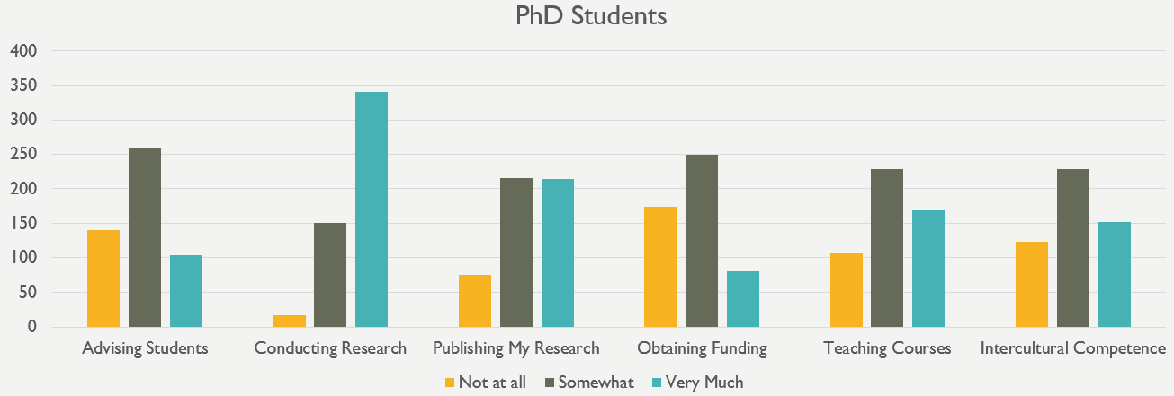
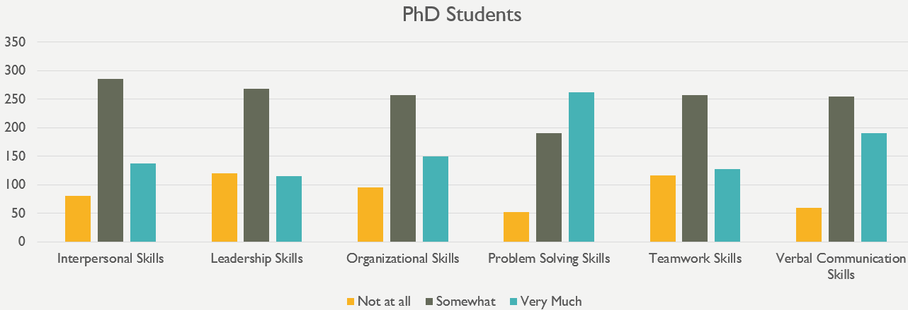
Breakdowns by school and degree are provided below.

Agriculture and Natural Resources

Faculty
24 respondents are obtaining their PhDs and eleven are obtaining their master’s degrees. Overall, students feel that faculty have high ethical standards and care about their teaching and scholarship. The majority of students also reported that Agriculture and Natural Resources faculty care about their students and discuss research strategies with them. While the Agriculture and Natural Resources faculty is highly praised by respondents, the faculty may consider looking into why students may feel that some faculty allow personal disagreements with each other to negatively impact students and why PhD respondents may feel that some faculty appear to give most of the attention and resources to a select group of students. It may also be worthwhile to look into why some PhD respondents have reported experiencing tense/hostile interactions with members of the faculty. It is important to keep in mind that the number of respondents for Agriculture and Natural Resources is quite small, especially for master’s degree respondents – 20% is equal to two respondents. Detailed information for each question is provided below.
Care about students: The majority of graduate student respondents feel that faculty care about students (79.2% of PhD respondents and 60% of master’s degree respondents). 20.8% of PhD respondents and 20% of master’s respondents did not feel this way.
Care about their scholarship: The vast majority of respondents said that faculty care about their scholarship (91.7% of PhD and 80% of master’s degree respondents). Only 8.3% of PhD respondents and 10% of master’s respondents feel that faculty do not care about scholarship.
Care about their teaching: 66.7% of PhD respondents and 70% of master’s respondents reported that faculty care about their teaching. 20.8% of PhD respondents and 10% of master’s respondents disagreed with this statement.
Have high ethical standards: The majority of PhD respondents (91.7%) and master’s degree respondents (80%) consider faculty to have high ethical standards. Only 8.3% of PhD respondents and 10% of master’s degree respondents feel that faculty do not.
Are explicit in their expectations of students: 62.5% of PhD students and 60% of master’s students responded with “Strongly Agree” or “Somewhat Agree”. 16.6% of PhD students and 30% of master’s students felt that faculty were not explicit in their expectations. The remaining respondents either responded with “Neither Agree nor Disagree” or “Not Applicable” to this question.
Help students grow as scholars: 70.8% of the PhD respondents and 70% of master’s degree respondents feel that faculty help students grow as scholars. 20.8% of PhD respondents and 10% of master’s degree respondents did not feel this way.
Treat students with respect: The majority of PhD (78.3%) and master’s degree (90%) respondents feel that faculty treat students with respect. Only 17.4% of PhD respondents and 10% of master’s degree respondents said they did not feel faculty treat them with respect.
Discuss career options with me: 54.2% of the PhD students surveyed and 40% of master’s degree respondents indicated that faculty discuss career options with them. 25% of PhD respondents and 40% of master’s degree respondents said that faculty did not discuss career options.
Discuss funding opportunities with me: 58.3% of PhD respondents and 50% of master’s degree respondents indicated that faculty discuss funding opportunities, while 20.8% of PhD respondents and 30% of master’s degree respondents said faculty did not.
Discuss personal matters with me: PhD and master’s degree students responded to this question differently. 50% of PhD respondents agreed with this statement, while only 20% of master’s degree respondents did. 16.7% of PhD respondents reported that they did not discuss personal matters with faculty, while 40% of master’s degree respondents said they did not discuss personal matters.
Discuss research strategies with me: 75% of PhD respondents and 70% of master’s degree respondents stated that faculty discuss research strategies with them. 16.7% of PhD respondents and 20% of master’s degree respondents said faculty did not do so.
Include me in projects that align with my professional interests: 79.2% of PhD respondents and 60% of master’s degree respondents felt that faculty include them in projects aligned with their professional interests. 12.5% of PhD respondents and 30% of master’s degree respondents did not feel they were included in these types of projects.
Value my professional interests: 73.9% of PhD respondents and 50% of master’s degree respondents said that faculty value their professional interests. Only 13% of PhD respondents and 20% of master’s degree respondents felt that faculty did not value their professional interests.
Interact with me outside of class: 66.7% of PhD respondents and 60% of master’s degree respondents said that faculty interact with them outside of class. Only 12.5% of PhD respondents and 20% of master’s degree respondents said that faculty did not interact with them outside of class.
Seem more concerned with furthering their own careers than with the well-being of the program as a whole: PhD respondents appear to be mixed in their responses. 41.7% of PhD respondents did not feel that faculty are more concerned with furthering their own careers than with the well-being of the program, but 54.2% of PhD respondents felt otherwise. 50% of master’s degree respondents disagreed with the statement, while 20% of master’s degree respondents felt that faculty are more concerned with furthering their own careers.
Carefully guard results and new ideas from others in the field: 45.8% of PhD respondents said that this question was either not applicable or they provided a neutral response. Of those who answered this question, responses were mixed. 37.5% of PhD respondents and 20% of master’s respondents feel that faculty guard results and new ideas from others in the field. 16.7% of PhD respondents and 30% of master’s respondents say that faculty do not guard results and new ideas.
Allow personal disagreements with each other to negatively impact students: PhD and master’s degree respondents answered this question differently from each other. The majority of PhD students (54.2%) strongly or somewhat agreed with this statement, while 12.5% of PhD respondents strongly or somewhat disagreed. 45.5% of master’s students, on the other hand, responded with “Strongly Disagree” or “Somewhat Disagree” and 27.3% responded with “Strongly Agree” or “Somewhat Agree”. The remaining respondents either responded with “Neither Agree nor Disagree” or “Not Applicable” to this question.
Appear to give most of the attention and resources to a select group of students: PhD and master’s degree respondents answered this question differently from each other. The PhD respondents were mixed in their responses, with 45.8% of PhD respondents saying that faculty do appear to give most of the attention and resources to a select group of students, while 33.3% did not feel this way. Most master’s degree respondents did not feel that faculty gave most attention and resources to a select group (60%), while 20% of master’s degree students felt they do.
Use their position to request work/assistance from me in ways in which I am not comfortable saying no: PhD students were mixed in their responses. 39.1% felt faculty use their position to request work/assistance while 33.3% felt that faculty did not do this. 60% of master’s respondents do not believe that faculty use their position to request work/assistance, while 30% felt that faculty have used their position to request work/assistance.
Have tense/hostile interactions with me: 41.7% of PhD respondents and 70% of master’s respondents have not had tense/hostile interactions with faculty. 33.3% of PhD respondents and 20% of master’s degree respondents indicated that they have experienced tense/hostile interactions with faculty. 25% of PhD respondents gave a neutral response.
Discriminate against me: 50% of PhD respondents and 80% of master’s respondents do not feel discriminated against, while 29.2% of PhD respondents and 10% of master’s respondents have indicated feeling that faculty discriminate against them.

Department
A total of 34 Agriculture and Natural Resources master’s and PhD degree seeking students indicated at least one area in which their respective department excels. 23 of these students are obtaining their PhDs and 11 are obtaining their master’s degrees. Note that each student could indicate more than one area of excellence, so the numbers will not add up.
As indicated by the table and graphs below, students in Agriculture and Natural Resources feel their respective departments excel in classroom instruction, providing information about job opportunities, and their scholarly research reputation. Doctoral students also feel that their respective departments do a good job at integrating graduate students into department life. Master’s degree students feel that their departments do a good job of advising.
Area of Excellence | # of PhD endorsements | # of master’s degree endorsements
Advising | 5 | 4
Building Community | 3 | 2
Career Preparation | 1 | 3
Classroom Instruction | 10 | 4
Communicating about opportunities for growth | 3 | 2
Communicating with students about progress | 5 | 2
Integrating graduate students into program/department life | 10 | 1
Outstanding faculty | 6 | 3
Providing alumni networking opportunities | 2 | 0
Providing dissertation guidance | 3 | 3
Providing information about job opportunities | 8 | 5
Providing internship/networking opportunities | 5 | 3
Providing suitable work/study space | 5 | 3
Providing workshops and seminars | 5 | 2
Real world applications | 4 | 1
Scholarly research reputation | 7 | 4
Securing adequate funding | 5 | 3
None of the above | 1 | 0

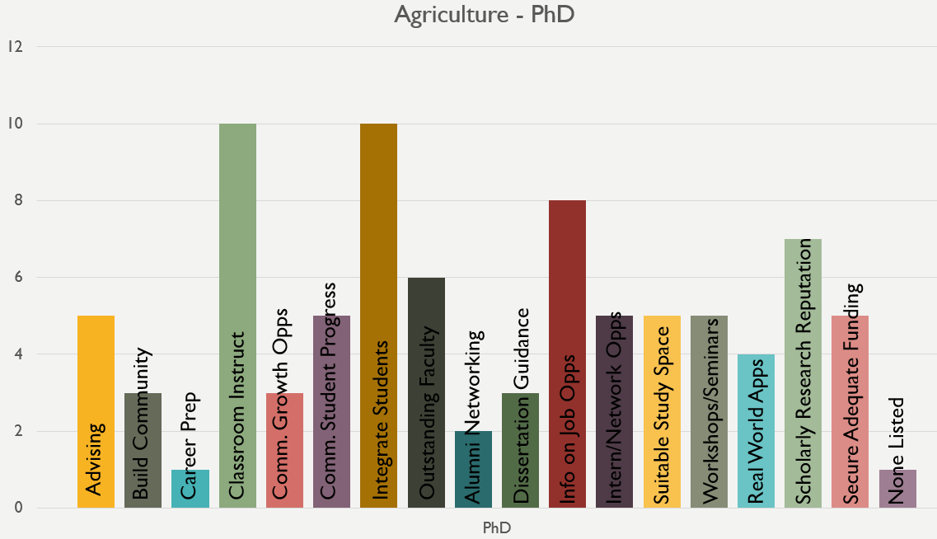 | 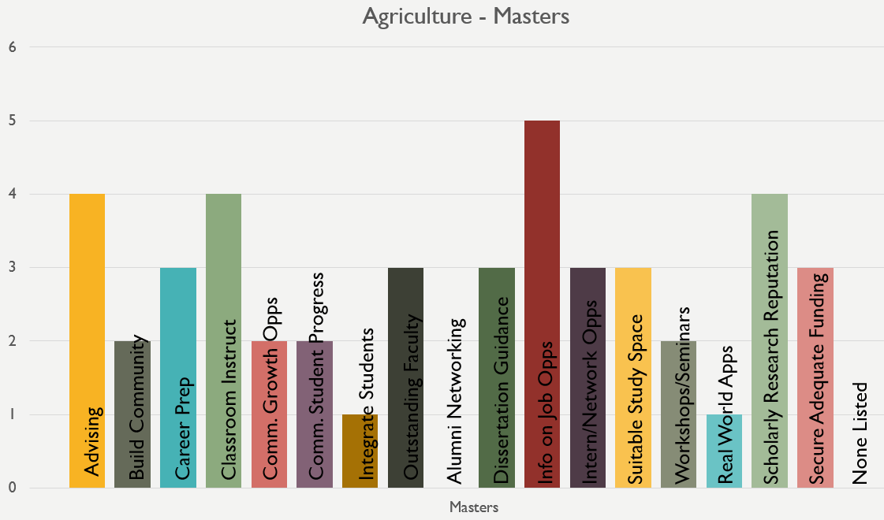

Program Preparation
Overall, the 24 PhD respondents from Agriculture and Natural Resources feel that their program does a good job of teaching them how to conduct research, teach courses, and publish research. Students also feel their problem solving skills are honed in their programs. Further work to help students learn to obtain funding and to attain intercultural competence is recommended.
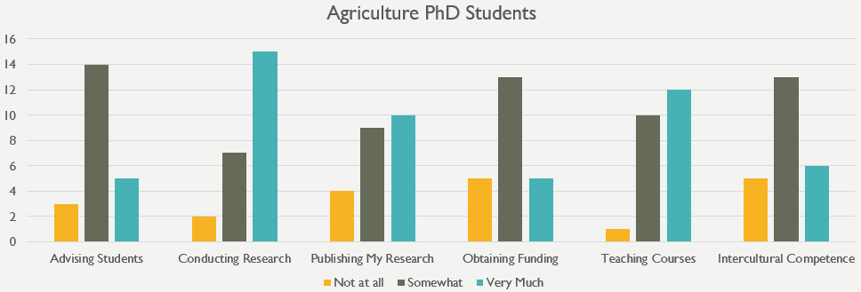
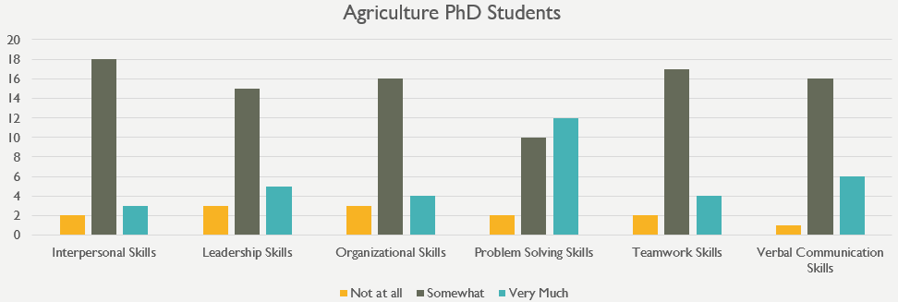

Architecture, Planning, and Preservation

Faculty
1 respondent is obtaining his/her PhD and 17 respondents are obtaining their master’s degrees. Due to the fact that there is only one PhD student, the data is aggregated over all respondents. Overall, students feel that faculty care about their students and their teaching, have high ethical standards, and help students to grow as scholars. The majority of students also reported that Architecture, Planning, and Preservation faculty treat students with respect and value their professional interests. The Architecture, Planning, and Preservation faculty received a lot of praise, but may want to look into why some students did not feel faculty discussed career options or personal matters with them. It is important to keep in mind that the number of respondents for Architecture, Planning, and Preservation is quite small – 11.1% is equal to two respondents. Detailed information for each question is provided below.
Care about students: The majority of graduate student respondents (77.8%) feel that faculty care about students, while 11.1% of respondents did not feel this way.
Care about their scholarship: The majority of respondents (55.6%) said that faculty care about their scholarship. Only 5.6% of respondents feel that faculty do not care about scholarship.
Care about their teaching: 83.3% of respondents reported that faculty care about their teaching, while the remaining respondents were neutral about this statement.
Have high ethical standards: The majority of respondents (72.2%) consider faculty to have high ethical standards. Only 5.6% of respondents feel that faculty do not.
Are explicit in their expectations of students: 66.7% of students responded with “Strongly Agree” or “Somewhat Agree” and only 11.1% of students felt that faculty were not explicit in their expectations. The remaining 22.2% of respondents responded with “Neither Agree nor Disagree” to this question.
Help students grow as scholars: 77.8% of respondents feel that faculty help students grow as scholars. 16.7% of respondents did not feel this way and 5.6% of respondents gave a neutral response.
Treat students with respect: 94.4% of respondents feel that faculty treat students with respect. No respondents disagreed with this statement and the remaining 5.6% responded neutrally.
Discuss career options with me: 66.7% of the students surveyed indicated that faculty discuss career options with them, 16.7% of respondents said that faculty did not, and 16.7% provided a neutral response.
Discuss funding opportunities with me: 33.3% of the students surveyed indicated that faculty discuss funding opportunities with them, 44.4% of respondents said that faculty did not, and 22.2% provided a neutral response.
Discuss personal matters with me: 16.7% of the students surveyed indicated that faculty discuss personal matters with them, 22.2% of respondents said that faculty did not, and 61.1% provided a neutral response.
Discuss research strategies with me: 44.4% of the students surveyed indicated that faculty discuss research strategies with them, 22.2% of respondents said that faculty did not, and 33.3% provided a neutral response.
Include me in projects that align with my professional interests: 50% of respondents felt that faculty include them in projects aligned with their professional interests. 11.1% of respondents did not feel they were included in these types of projects. 38.9% of respondents provided a neutral response.
Value my professional interests: 83.3% of respondents said that faculty value their professional interests. Only 5.6% of respondents felt that faculty did not value their professional interests.
Interact with me outside of class: 61.1% of respondents said that faculty interact with them outside of class. 16.7% of respondents said that faculty did not interact with them outside of class. 22.2% of respondents provided a neutral response.
Seem more concerned with furthering their own careers than with the well-being of the program as a whole: 72.2% of respondents did not feel that faculty are more concerned with furthering their own careers than with the well-being of the program. 16.7% of respondents felt otherwise. 11.1% of students were neutral.
Carefully guard results and new ideas from others in the field: 44.4% of respondents do not feel that faculty guard results and new ideas from others in the field and 11.1% feel that they do guard results and new ideas. 44.4% of respondents said that this statement was either not applicable or they provided a neutral response.
Allow personal disagreements with each other to negatively impact students: 44.4% of respondents strongly or somewhat disagreed with this statement, 16.7% strongly or somewhat agreed, and the remaining respondents (38.9%) either responded with “Neither Agree nor Disagree” or “Not Applicable” to this question.
Appear to give most of the attention and resources to a select group of students: 66.7% of respondents felt that faculty do not appear to give most of the attention and resources to a select group of students and 11.1% feel that they do, while 22.2% provided a neutral response.
Use their position to request work/assistance from me in ways in which I am not comfortable saying no: The majority of respondents (72.2%) do not feel that faculty use their position to request work/assistance. Only 11.1% of respondents felt that faculty have used their position to request work/assistance.
Have tense/hostile interactions with me: 72.2% of respondents have not had tense/hostile interactions with faculty, while 5.6% of respondents indicated that they have experienced tense/hostile interactions with faculty.
Discriminate against me: 77.8% of respondents do not feel discriminated against. 5.6% of respondents have indicated feeling that faculty discriminate against them.

Department
A total of 16 Architecture, Planning, and Preservation master’s and PhD degree seeking students indicated at least one area in which their respective department excels. 1 of these students is obtaining a PhD and 15 are obtaining their master’s degrees. Due to the small number of PhD responses, data are aggregated. Note that each student could indicate more than one area of excellence, so the numbers will not add up.
As indicated by the table and graphs below, students in Architecture, Planning, and Preservation feel their respective departments excel in providing information about job opportunities and internship/networking opportunities, real world applications, classroom instruction, and providing suitable work/study space.
Area of Excellence | # of endorsements
Advising | 4
Building Community | 6
Career Preparation | 6
Classroom Instruction | 7
Communicating about opportunities for growth | 2
Communicating with students about progress | 3
Integrating graduate students into program/department life | 5
Outstanding faculty | 5
Providing alumni networking opportunities | 5
Providing dissertation guidance | 1
Providing information about job opportunities | 10
Providing internship/networking opportunities | 8
Providing suitable work/study space | 7
Providing workshops and seminars | 4
Real world applications | 8
Scholarly research reputation | 2
Securing adequate funding | 1
None of the above | 1

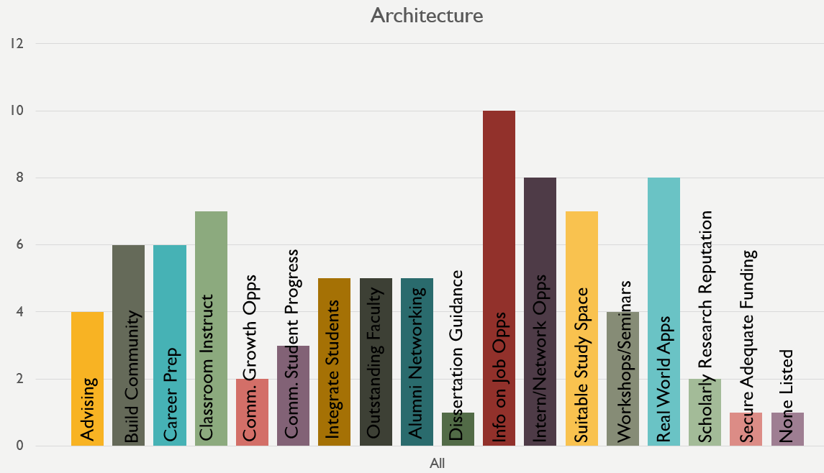

Program Preparation
There were too few respondents in Architecture, Planning, and Preservation to be able to provide detailed information.

Arts and Humanities

Faculty
72 respondents are obtaining their PhDs and 39 are obtaining their master’s degrees. Overall, students feel that faculty care about their scholarship, care about their students, and help students grow as scholars. The majority of students also reported that Arts and Humanities faculty discuss research strategies with them. While the Arts and Humanities faculty is highly praised by respondents, the faculty may consider looking into why students may feel that some faculty appear to give most of the attention and resources to a select group of students. Detailed information for each question is provided below.
Care about students: The majority of graduate student respondents feel that faculty care about students (72.2% of PhD respondents and 71.8% of master’s degree respondents). Only 12.5% of PhD respondents and 15.4% of master’s respondents did not feel this way.
Care about their scholarship: The vast majority of respondents said that faculty care about their scholarship (86.1% of PhD and 71.8% of master’s degree respondents). Only 4.2% of PhD respondents and 5.1% of master’s respondents feel that faculty do not care about scholarship.
Care about their teaching: 62.5% of PhD respondents and 71.8% of master’s respondents reported that faculty care about their teaching. Only 18.1% of PhD respondents and 17.9% of master’s respondents disagreed with this statement.
Have high ethical standards: The majority of PhD respondents (80.3%) and master’s degree respondents (76.3%) consider faculty to have high ethical standards. Only 5.6% of PhD respondents and 13.2% of master’s degree respondents feel that faculty do not.
Are explicit in their expectations of students: 51.4% of PhD students and 60.5% of master’s students responded with “Strongly Agree” or “Somewhat Agree”. 31.9% of PhD students and 28.9% of master’s students felt that faculty were not explicit in their expectations. The remaining respondents either responded with “Neither Agree nor Disagree” or “Not Applicable” to this question.
Help students grow as scholars: 71.8% of the PhD respondents and 68.4% of master’s degree respondents feel that faculty help students grow as scholars. Only 11.3% of PhD respondents and 7.9% of master’s degree respondents did not feel this way.
Treat students with respect: The majority of PhD (76.1%) and master’s degree (69.2%) respondents feel that faculty treat students with respect. Only 16.9% of PhD respondents and 12.8% of master’s degree respondents said they did not feel faculty treat them with respect.
Discuss career options with me: 63.4% of the PhD students surveyed and 33.3% of master’s degree respondents indicated that faculty discuss career options with them. 19.7% of PhD respondents and 33.3% of master’s degree respondents said that faculty did not discuss career options. 33.3% of master’s degree respondents provided a neutral response.
Discuss funding opportunities with me: 52.1% of PhD respondents indicated that faculty discuss funding opportunities with them, while 26.8% of PhD respondents said faculty did not. 18.4% of master’s degree respondents indicated that faculty discuss funding opportunities, while 39.5% of master’s degree respondents said faculty did not and 42.1% of master’s degree students responded neutrally.
Discuss personal matters with me: 32.4% of PhD respondents agreed with this statement and 32.4% disagreed, while the remaining 35.2% remained neutral. 38.5% of master’s degree respondents agreed with this statement, 23.1% said they did not discuss personal matters, and 38.5% remained neutral.
Discuss research strategies with me: 73.2% of PhD respondents and 61.5% of master’s degree respondents stated that faculty discuss research strategies with them. Only 11.3% of PhD respondents and 12.8% of master’s degree respondents said faculty did not do so.
Include me in projects that align with my professional interests: 53.5% of PhD respondents and 44.7% of master’s degree respondents felt that faculty include them in projects aligned with their professional interests. 29.6% of PhD respondents and 21.1% of master’s degree respondents did not feel they were included in these types of projects. 34.2% of master’s degree respondents provided a neutral response.
Value my professional interests: 73.2% of PhD respondents and 66.7% of master’s degree respondents said that faculty value their professional interests. Only 14.1% of PhD respondents and 17.9% of master’s degree respondents felt that faculty did not value their professional interests.
Interact with me outside of class: 67.6% of PhD respondents and 63.2% of master’s degree respondents said that faculty interact with them outside of class. Only 16.9% of PhD respondents and 21.1% of master’s degree respondents said that faculty did not interact with them outside of class.
Seem more concerned with furthering their own careers than with the well-being of the program as a whole: Students appear to be mixed in their responses. 45.1% of PhD respondents did not feel that faculty are more concerned with furthering their own careers than with the well-being of the program, but 35.2% of PhD respondents felt otherwise and 19.7% were neutral. 50% of master’s degree respondents disagreed with the statement, while 36.8% of master’s degree respondents felt that faculty are more concerned with furthering their own careers.
Carefully guard results and new ideas from others in the field: Only a small number of students felt that this statement was true (6.9% of PhD respondents and 25.6% of master’s degree students agreed with this statement). The majority of PhD respondents (56.9%) and 30.8% of master’s degree respondents do not feel that faculty guard results and new ideas from others in the field. It is important to note that 43.6% of master’s degree respondents and 36.1% of PhD respondents said that this question was either not applicable or they provided a neutral response.
Allow personal disagreements with each other to negatively impact students: Respondents were mixed on this question. 43.1% of PhD respondents strongly or somewhat agreed with this statement, while 40.3% of PhD respondents strongly or somewhat disagreed. 43.6% of master’s students, on the other hand, responded with “Strongly Disagree” or “Somewhat Disagree” and 33.3% responded with “Strongly Agree” or “Somewhat Agree”. The remaining respondents either responded with “Neither Agree nor Disagree” or “Not Applicable” to this question. Overall, PhD students had very different opinions about this statement, while master’s degree respondents tended to disagree with the statement.
Appear to give most of the attention and resources to a select group of students: 50% of PhD respondents felt that faculty appear to give most of the attention and resources to a select group of students, while 30.6% did not feel this way. Master’s degree respondents were more mixed in their responses. 35.9% did not feel that faculty gave most attention and resources to a select group, while 46.2% of master’s degree students feel they do.
Use their position to request work/assistance from me in ways in which I am not comfortable saying no: 60.6% of PhD respondents and 56.4% of master’s degree respondents felt faculty do not use their position to request work/assistance. 21.1% of PhD respondents and 23.1% of master’s degree respondents felt that faculty have used their position to request work/assistance.
Have tense/hostile interactions with me: 71.8% of PhD respondents and 65.8% of master’s respondents have not had tense/hostile interactions with faculty. 16.9% of PhD respondents and 21.1% of master’s degree respondents indicated that they have experienced tense/hostile interactions with faculty.
Discriminate against me: 77.5% of PhD respondents and 76.9% of master’s respondents do not feel discriminated against. Only 5.6% of PhD respondents and 12.8% of master’s respondents have indicated feeling that faculty discriminate against them.

Department
A total of 111 Arts and Humanities master’s and PhD degree seeking students indicated at least one area in which their respective department excels. 72 of these students are obtaining their PhDs and 39 are obtaining their master’s degrees. Note that each student could indicate more than one area of excellence, so the numbers will not add up.
As indicated by the table and graphs below, students in the Arts and Humanities feel their respective departments excel in their outstanding faculty, classroom instruction, and providing suitable work/study space. Doctoral students also feel that their respective departments have a scholarly research reputation. Master’s degree students feel that their departments do a good job of providing information about job opportunities.
Area of Excellence | # of PhD endorsements | # of master’s degree endorsements
Advising | 20 | 9
Building Community | 15 | 11
Career Preparation | 14 | 9
Classroom Instruction | 25 | 16
Communicating about opportunities for growth | 12 | 9
Communicating with students about progress | 15 | 9
Integrating graduate students into program/department life | 21 | 11
Outstanding faculty | 37 | 18
Providing alumni networking opportunities | 4 | 6
Providing dissertation guidance | 20 | 5
Providing information about job opportunities | 15 | 17
Providing internship/networking opportunities | 4 | 11
Providing suitable work/study space | 25 | 15
Providing workshops and seminars | 22 | 10
Real world applications | 5 | 10
Scholarly research reputation | 42 | 14
Securing adequate funding | 11 | 3
None of the above | 7 | 3

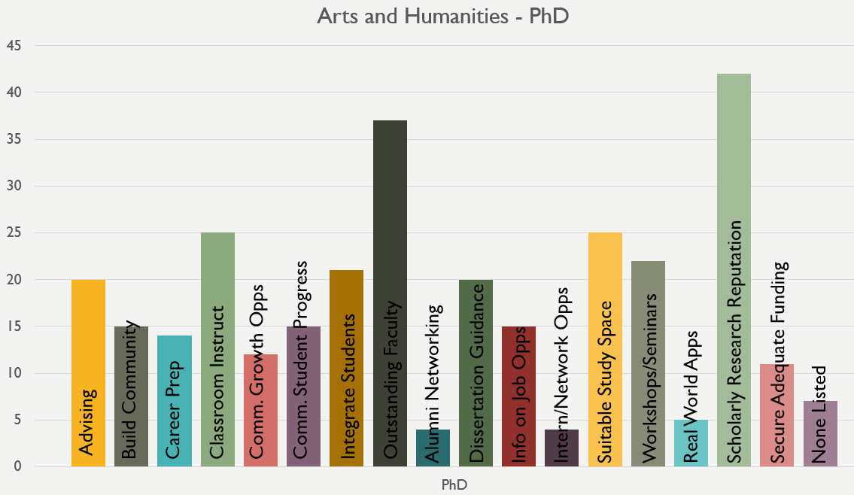 | 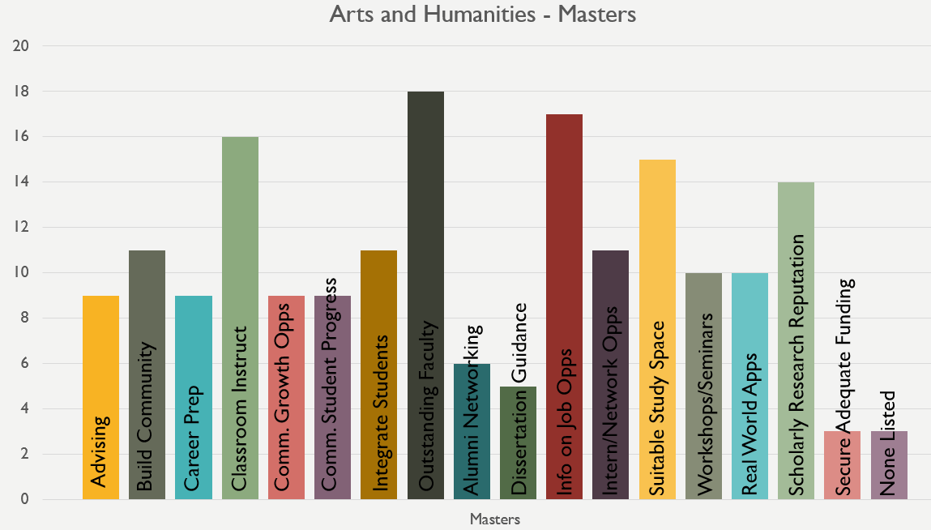

Program Preparation
Overall, the 72 PhD respondents from Arts and Humanities feel that their program does a good job of teaching them how to conduct research and teach courses. Students also feel their verbal communication and problem solving skills are honed in their programs and that they gain intercultural competence. Further work to help students learn to obtain funding and to attain teamwork skills is recommended.
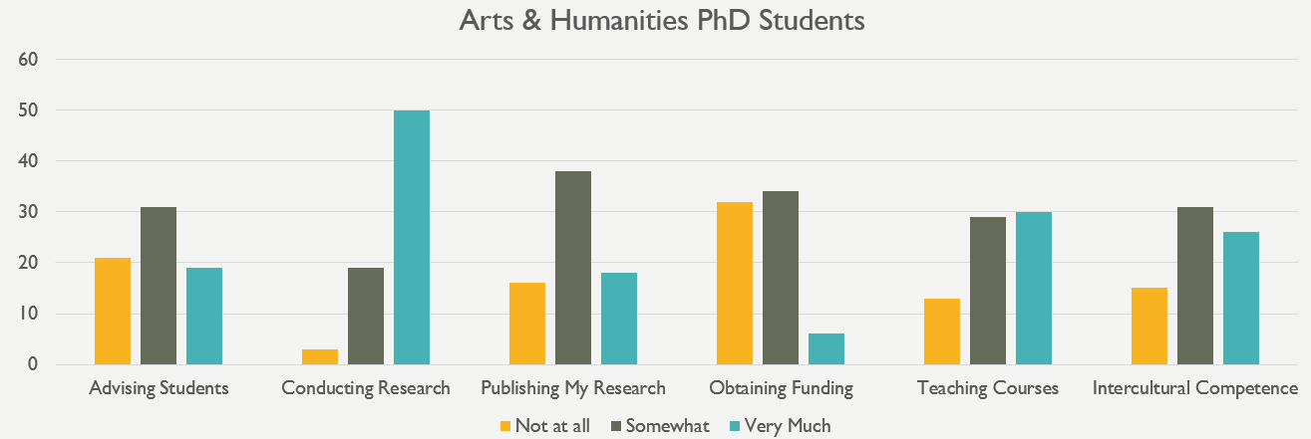
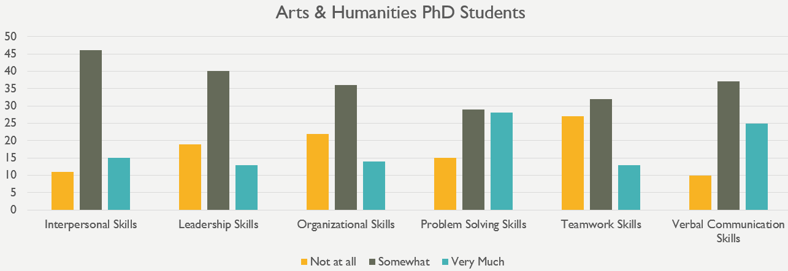

Behavioral and Social Sciences

Faculty
70 respondents are obtaining their PhDs and 42 are obtaining their master’s degrees. Overall, students feel that faculty care about their scholarship, care about their students, and treat students with respect. The majority of students also reported that Behavioral and Social Sciences faculty are explicit in their expectations of students and discuss research strategies with them. The Behavioral and Social Sciences faculty is highly praised by respondents. Detailed information for each question is provided below.
Care about students: The majority of graduate student respondents feel that faculty care about students (87.1% of PhD respondents and 88.1% of master’s degree respondents). Only 4.3% of PhD respondents and 7.1% of master’s respondents did not feel this way.
Care about their scholarship: The vast majority of respondents said that faculty care about their scholarship (88.6% of PhD and 66.7% of master’s degree respondents). Only 1.4% of PhD respondents and 4.8% of master’s respondents feel that faculty do not care about scholarship.
Care about their teaching: 58.6% of PhD respondents and 85.7% of master’s respondents reported that faculty care about their teaching. 22.9% of PhD respondents and 11.9% of master’s respondents disagreed with this statement.
Have high ethical standards: The majority of PhD respondents (81.4%) and master’s degree respondents (92.9%) consider faculty to have high ethical standards. Only 1.4% of PhD respondents and 2.4% of master’s degree respondents feel that faculty do not.
Are explicit in their expectations of students: 62.9% of PhD students and 76.2% of master’s students responded with “Strongly Agree” or “Somewhat Agree”. 27.1% of PhD students and only 9.5% of master’s students felt that faculty were not explicit in their expectations. The remaining respondents either responded with “Neither Agree nor Disagree” or “Not Applicable” to this question.
Help students grow as scholars: 84.1% of the PhD respondents and 85.4% of master’s degree respondents feel that faculty help students grow as scholars. Only 4.3% of PhD respondents and 4.9% of master’s degree respondents did not feel this way.
Treat students with respect: The majority of PhD (91.4%) and master’s degree (85.4%) respondents feel that faculty treat students with respect. Only 2.9% of PhD respondents and 4.9% of master’s degree respondents said they did not feel faculty treat them with respect.
Discuss career options with me: 64.3% of the PhD students surveyed and 61.9% of master’s degree respondents indicated that faculty discuss career options with them. 21.4% of PhD respondents and 21.4% of master’s degree respondents said that faculty did not discuss career options.
Discuss funding opportunities with me: 71.4% of PhD respondents indicated that faculty discuss funding opportunities with them, while 17.1% of PhD respondents said faculty did not. 38.1% of master’s degree respondents indicated that faculty discuss funding opportunities, while 21.4% of master’s degree respondents said faculty did not and 40.5% of master’s degree students responded neutrally.
Discuss personal matters with me: 40.6% of PhD respondents agreed with this statement and 36.2% disagreed, while the remaining 23.2% remained neutral. 38.5% of master’s degree respondents agreed with this statement, 23.1% said they did not discuss personal matters, and 38.5% remained neutral.
Discuss research strategies with me: 78.6% of PhD respondents and 71.4% of master’s degree respondents stated that faculty discuss research strategies with them. Only 11.4% of PhD respondents and 14.3% of master’s degree respondents said faculty did not do so.
Include me in projects that align with my professional interests: 72.5% of PhD respondents and 52.4% of master’s degree respondents felt that faculty include them in projects aligned with their professional interests. 14.5% of PhD respondents and 11.9% of master’s degree respondents did not feel they were included in these types of projects. 35.7% of master’s degree respondents provided a neutral response.
Value my professional interests: 82.9% of PhD respondents and 80.5% of master’s degree respondents said that faculty value their professional interests. Only 4.3% of PhD respondents and 4.9% of master’s degree respondents felt that faculty did not value their professional interests.
Interact with me outside of class: 68.1% of PhD respondents and 73.2% of master’s degree respondents said that faculty interact with them outside of class. Only 18.8% of PhD respondents and 14.6% of master’s degree respondents said that faculty did not interact with them outside of class.
Seem more concerned with furthering their own careers than with the well-being of the program as a whole: 49.3% of PhD respondents did not feel that faculty are more concerned with furthering their own careers than with the well-being of the program, 27.5% of PhD respondents felt otherwise and 23.2% were neutral. 65.9% of master’s degree respondents disagreed with the statement, while 19.5% of master’s degree respondents felt that faculty are more concerned with furthering their own careers.
Carefully guard results and new ideas from others in the field: Only a small number of students agreed with this statement (15.7% of PhD respondents and 9.5% of master’s degree students). The majority of PhD respondents (58.6%) and 40.5% of master’s degree respondents do not feel that faculty guard results and new ideas from others in the field. 50% of master’s degree respondents and 25.7% of PhD respondents said that this question was either not applicable or they provided a neutral response.
Allow personal disagreements with each other to negatively impact students: 51.4% of PhD respondents and 59.5% of master’s degree respondents strongly or somewhat disagreed with this statement, while 28.6% of PhD respondents and 14.3% of master’s students responded with “Strongly Agree” or “Somewhat Agree”. The remaining respondents either responded with “Neither Agree nor Disagree” or “Not Applicable” to this question.
Appear to give most of the attention and resources to a select group of students: 52.9% of PhD respondents felt that faculty do not appear to give most of the attention and resources to a select group of students, while 32.9% feel that they do. 59.5% of master’s degree respondents did not feel that faculty gave most attention and resources to a select group, while 16.7% of master’s degree students feel they do.
Use their position to request work/assistance from me in ways in which I am not comfortable saying no: The majority of respondents (68.6% of PhD respondents and 73.2% of master’s degree respondents) do not feel that faculty use their position to request work/assistance. Only 12.9% of PhD respondents and 12.2% of master’s degree respondents felt that faculty have used their position to request work/assistance.
Have tense/hostile interactions with me: 73.9% of PhD respondents and 71.4% of master’s respondents have not had tense/hostile interactions with faculty. 11.4% of PhD respondents and 14.3% of master’s degree respondents indicated that they have experienced tense/hostile interactions with faculty.
Discriminate against me: 85.7% of PhD respondents and 83.3% of master’s respondents do not feel discriminated against. Only 5.7% of PhD respondents and 4.8% of master’s respondents have indicated feeling that faculty discriminate against them.

Department
A total of 110 Behavioral and Social Sciences master’s and PhD degree seeking students indicated at least one area in which their respective department excels. 69 of these students are obtaining their PhDs and 41 are obtaining their master’s degrees. Note that each student could indicate more than one area of excellence, so the numbers will not add up.
As indicated by the table and graphs below, students in the Behavioral and Social Sciences feel their respective departments excel in their outstanding faculty and providing information about job opportunities. Doctoral students also feel that their respective departments have a scholarly research reputation and do a good job of providing workshops and seminars. Master’s degree students feel that their departments do a good job of providing instruction in the classroom, providing real world applications, and preparing students for their careers.
Area of Excellence | # of PhD endorsements | # of master’s degree endorsements
Advising | 24 | 16
Building Community | 11 | 10
Career Preparation | 20 | 21
Classroom Instruction | 17 | 25
Communicating about opportunities for growth | 11 | 14
Communicating with students about progress | 20 | 14
Integrating graduate students into program/department life | 23 | 8
Outstanding faculty | 40 | 22
Providing alumni networking opportunities | 7 | 6
Providing dissertation guidance | 18 | 1
Providing information about job opportunities | 27 | 21
Providing internship/networking opportunities | 18 | 18
Providing suitable work/study space | 21 | 12
Providing workshops and seminars | 27 | 10
Real world applications | 18 | 24
Scholarly research reputation | 50 | 14
Securing adequate funding | 26 | 3
None of the above | 3 | 2

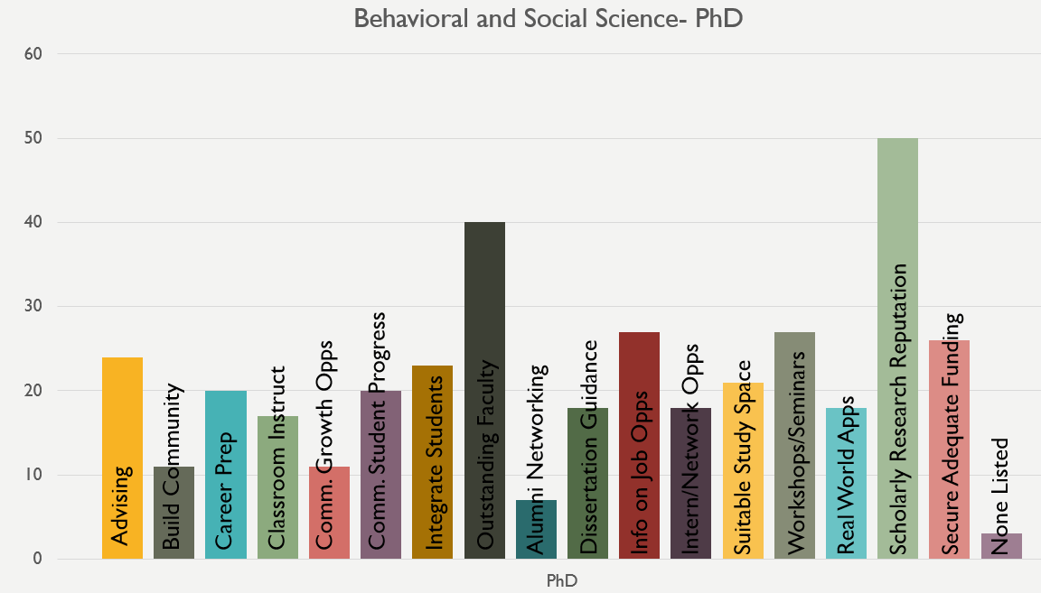 | 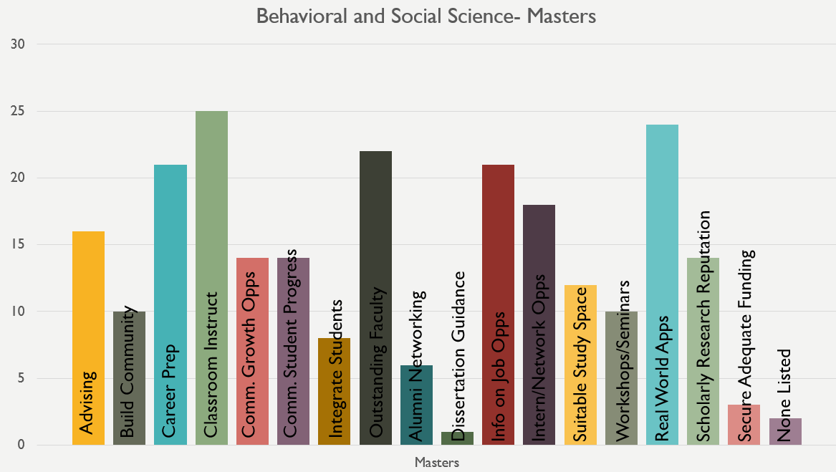

Program Preparation
Overall, the 70 PhD respondents from Behavioral and Social Sciences feel that their program does a good job of teaching them how to conduct and publish research. Students also feel their problem solving skills are honed in their programs. Further work to help students learn to attain teamwork skills and intercultural competence, as well as more experience teaching courses is recommended.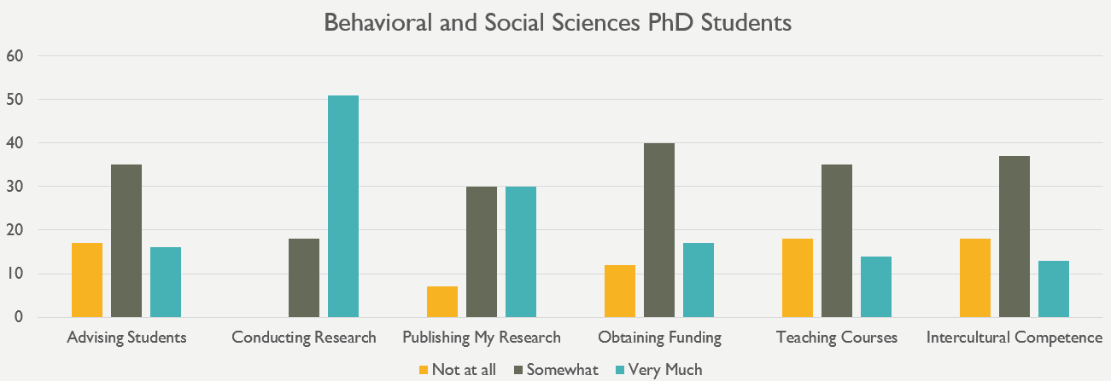
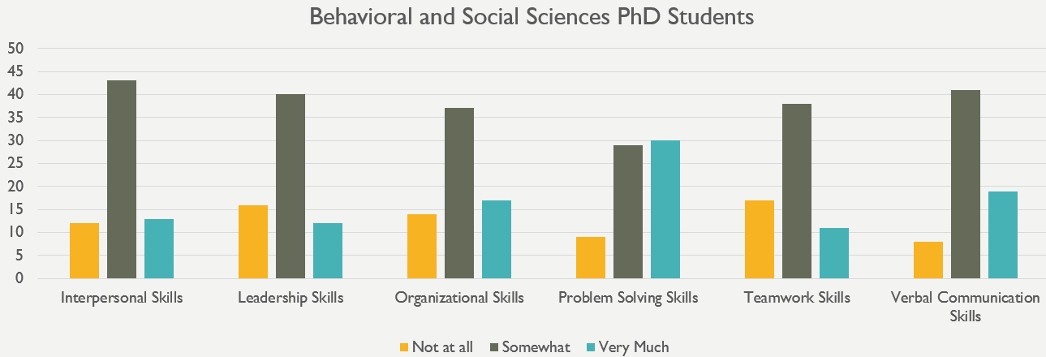

Business

Faculty
8 respondents are obtaining their PhDs and 84 are obtaining their master’s degrees. Due to the fact that there are such a small number of PhDs, the data is aggregated over all respondents. Overall, students feel that faculty care about their students and their teaching, have high ethical standards, and are explicit in their expectations of students. The majority of students also reported that Business faculty treat students with respect and value their professional interests. The Business faculty received a lot of praise, but may want to look into why some students did not feel faculty discussed personal matters with them. Detailed information for each question is provided below.
Care about students: The majority of graduate student respondents (83.7%) feel that faculty care about students, while only 2.2% of respondents did not feel this way.
Care about their scholarship: The majority of respondents (55.4%) said that faculty care about their scholarship. Only 9.8% of respondents feel that faculty do not care about scholarship.
Care about their teaching: 87% of respondents reported that faculty care about their teaching, while only 4.3% of respondents disagreed with this statement.
Have high ethical standards: The majority of respondents (92.4%) consider faculty to have high ethical standards. Only 1.1% of respondents feel that faculty do not.
Are explicit in their expectations of students: 73.9% of students responded with “Strongly Agree” or “Somewhat Agree” and only 8.7% of students felt that faculty were not explicit in their expectations. The remaining 17.4% of respondents either responded with “Neither Agree nor Disagree” or “Not Applicable” to this question.
Help students grow as scholars: 67% of respondents feel that faculty help students grow as scholars. Only 7.7% of respondents did not feel this way. 25.3% of respondents gave a neutral response.
Treat students with respect: 95.7% of respondents feel that faculty treat students with respect. Only 1.1% of respondents said they did not feel faculty treat them with respect.
Discuss career options with me: 38% of the students surveyed indicated that faculty discuss career options with them, 23.9% of respondents said that faculty did not, and 38% provided a neutral response.
Discuss funding opportunities with me: 24.2% of the students surveyed indicated that faculty discuss funding opportunities with them, 35.2% of respondents said that faculty did not, and 40.7% provided a neutral response.
Discuss personal matters with me: 27.2% of the students surveyed indicated that faculty discuss personal matters with them, 30.4% of respondents said that faculty did not, and 42.4% provided a neutral response.
Discuss research strategies with me: 35.9% of the students surveyed indicated that faculty discuss research strategies with them, 21.7% of respondents said that faculty did not, and 42.4% provided a neutral response.
Include me in projects that align with my professional interests: 43.5% of respondents felt that faculty include them in projects aligned with their professional interests. 17.4% of respondents did not feel they were included in these types of projects. 39.1% of respondents provided a neutral response.
Value my professional interests: 65.2% of respondents said that faculty value their professional interests. Only 4.3% of respondents felt that faculty did not value their professional interests.
Interact with me outside of class: 46.7% of respondents said that faculty interact with them outside of class. 19.6% of respondents said that faculty did not interact with them outside of class. 33.7% of respondents provided a neutral response.
Seem more concerned with furthering their own careers than with the well-being of the program as a whole: 50% of respondents did not feel that faculty are more concerned with furthering their own careers than with the well-being of the program. 22.8% of respondents felt otherwise. 27.2% of students were neutral.
Carefully guard results and new ideas from others in the field: 28.6% of respondents do not feel that faculty guard results and new ideas from others in the field and 20.9% feel that they do guard results and new ideas. 50.5% of respondents said that this statement was either not applicable or they provided a neutral response.
Allow personal disagreements with each other to negatively impact students: 54.3% of respondents strongly or somewhat disagreed with this statement, 20.7% strongly or somewhat agreed, and the remaining respondents (25%) either responded with “Neither Agree nor Disagree” or “Not Applicable” to this question.
Appear to give most of the attention and resources to a select group of students: 53.8% of respondents felt that faculty do not appear to give most of the attention and resources to a select group of students and 27.5% feel that they do, while 18.7% provided a neutral response.
Use their position to request work/assistance from me in ways in which I am not comfortable saying no: The majority of respondents (62%) do not feel that faculty use their position to request work/assistance. Only 13% of respondents felt that faculty have used their position to request work/assistance.
Have tense/hostile interactions with me: 73.9% of respondents have not had tense/hostile interactions with faculty, while 12% of respondents indicated that they have experienced tense/hostile interactions with faculty.
Discriminate against me: 67.4% of respondents do not feel discriminated against. 14.1% of respondents have indicated feeling that faculty discriminate against them.

Department
A total of 91 Business master’s and PhD degree seeking students indicated at least one area in which their respective department excels. 8 of these students are obtaining their PhDs and 83 are obtaining their master’s degrees. Due to the small number of PhD responses, data are aggregated. Note that each student could indicate more than one area of excellence, so the numbers will not add up.
As indicated by the table and graphs below, students in Business feel their respective departments excel in providing information about job opportunities and alumni networking opportunities, having real world application, advising, and building community.
Area of Excellence | # of endorsements
Advising | 28
Building Community | 26
Career Preparation | 37
Classroom Instruction | 40
Communicating about opportunities for growth | 10
Communicating with students about progress | 12
Integrating graduate students into program/department life | 9
Outstanding faculty | 35
Providing alumni networking opportunities | 26
Providing dissertation guidance | 1
Providing information about job opportunities | 31
Providing internship/networking opportunities | 19
Providing suitable work/study space | 18
Providing workshops and seminars | 22
Real world applications | 30
Scholarly research reputation | 17
Securing adequate funding | 1
None of the above | 4

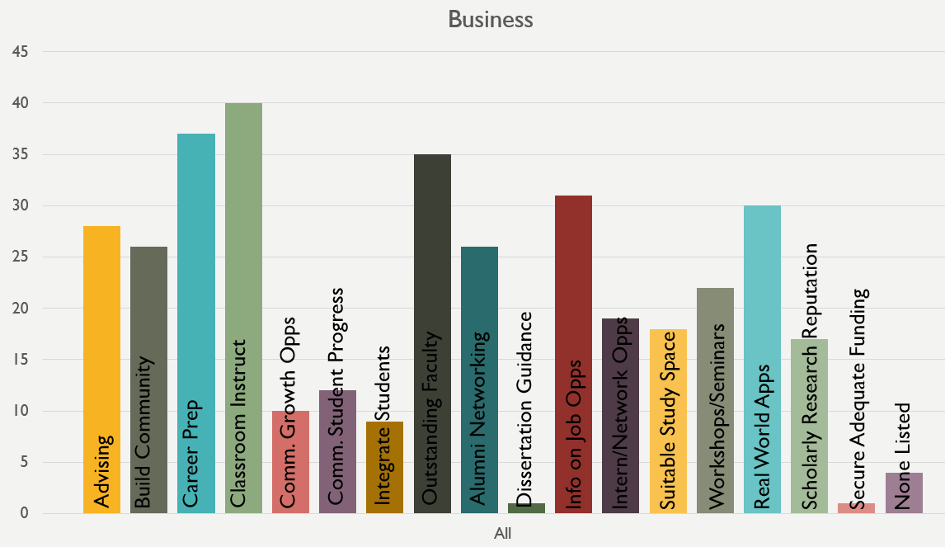

Program Preparation
Only 8 PhD students responded from the Business school, so it is important to keep in mind the minimal amount of information that can be gleaned from these results. However, those who responded feel that their program does a good job of teaching them how to conduct and publish research, how to advise students, and they feel that they have strengthened their verbal communication skills.
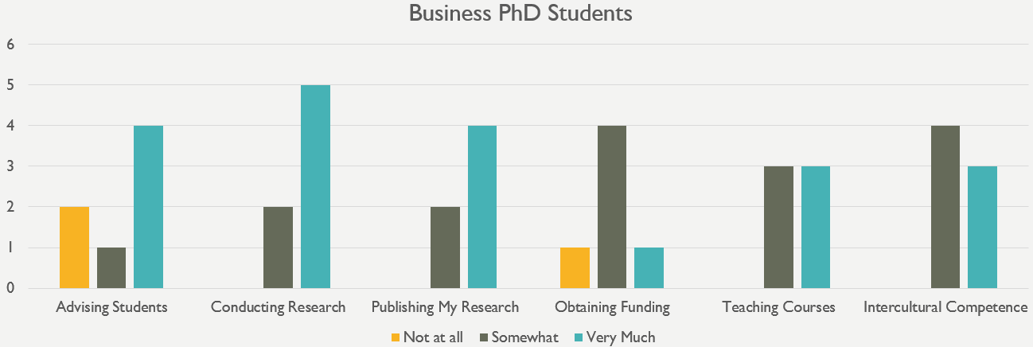
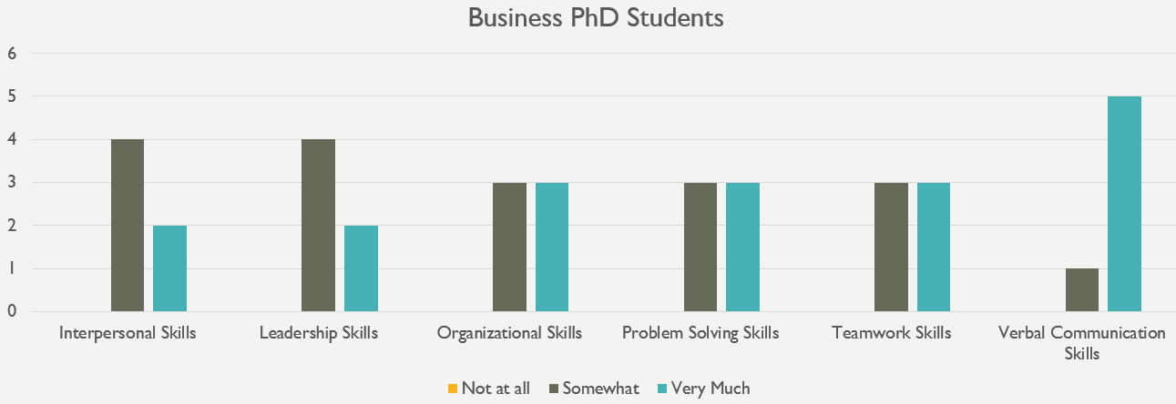

Computer, Mathematical, and Natural Sciences

Faculty
144 respondents are obtaining their PhDs and 15 are obtaining their master’s degrees. Overall, students feel that faculty care about their scholarship, care about their students, and have high ethical standards. The majority of students also reported that Computer, Mathematical, and Natural Sciences faculty treat students with respect and discuss research strategies with them. The Computer, Mathematical, and Natural Sciences faculty received a lot of positive feedback overall, but may want to look into why students did not feel faculty discussed personal matters with them and why some feel that faculty carefully guard results and new ideas from others in the field. Detailed information for each question is provided below.
Care about students: The majority of graduate student respondents feel that faculty care about students (71.3% of PhD respondents and 60% of master’s degree respondents). 14.7% of PhD respondents and 20% of master’s respondents did not feel this way.
Care about their scholarship: The vast majority of respondents said that faculty care about their scholarship (75.7% of PhD and 73.3% of master’s degree respondents). Only 3.5% of PhD respondents and no master’s respondents feel that faculty do not care about scholarship.
Care about their teaching: 52.8% of PhD respondents and 60% of master’s respondents reported that faculty care about their teaching. 21.5% of PhD respondents and 20% of master’s respondents disagreed with this statement. 25.7% of PhD students and 20% of master’s degree students were neutral in their responses.
Have high ethical standards: The majority of PhD respondents (78%) and master’s degree respondents (80%) consider faculty to have high ethical standards. Only 5.7% of PhD respondents and 13.3% of master’s degree respondents feel that faculty do not.
Are explicit in their expectations of students: PhD students were mixed in their responses. Although 48.6% of PhD students responded with “Strongly Agree” or “Somewhat Agree”, 32.6% of PhD students felt that faculty were not explicit in their expectations. 60% of master’s students felt faculty are explicit and 33.3% of master’s students did not. The remaining respondents either responded with “Neither Agree nor Disagree” or “Not Applicable” to this question.
Help students grow as scholars: 76.8% of the PhD respondents and 66.7% of master’s degree respondents feel that faculty help students grow as scholars. 9.2% of PhD respondents and 13.3% of master’s degree respondents did not feel this way.
Treat students with respect: The majority of PhD (82.5%) and master’s degree (73.3%) respondents feel that faculty treat students with respect. 6.3% of PhD respondents and 20% of master’s degree respondents said they did not feel faculty treat them with respect.
Discuss career options with me: 50.7% of the PhD students surveyed and 40% of master’s degree respondents indicated that faculty discuss career options with them. 23.9% of PhD respondents and 26.7% of master’s degree respondents said that faculty did not discuss career options. 25.4% of PhD respondents and 33.3% of master’s degree respondents responded neutrally.
Discuss funding opportunities with me: 57% of PhD respondents indicated that faculty discuss funding opportunities with them, 21.8% of PhD respondents said faculty did not, and 21.1% provided a neutral response. 33.3% of master’s degree respondents indicated that faculty discuss funding opportunities, while 20% of master’s degree respondents said faculty did not and 46.7% of master’s degree students responded neutrally.
Discuss personal matters with me: PhD respondents were mixed in their responses. 31% of PhD respondents agreed with this statement and 37.3% disagreed, while the remaining 31.7% remained neutral. 20% of master’s degree respondents agreed with this statement, 40% said they did not discuss personal matters, and 40% remained neutral.
Discuss research strategies with me: 81.1% of PhD respondents and 60% of master’s degree respondents stated that faculty discuss research strategies with them. Only 7.7% of PhD respondents and 13.3% of master’s degree respondents said faculty did not do so.
Include me in projects that align with my professional interests: 73.9% of PhD respondents and 46.7% of master’s degree respondents felt that faculty include them in projects aligned with their professional interests. 10.6% of PhD respondents and 13.3% of master’s degree respondents did not feel they were included in these types of projects. 40% of master’s degree respondents provided a neutral response.
Value my professional interests: 77.5% of PhD respondents and 53.3% of master’s degree respondents said that faculty value their professional interests. 10.6% of PhD respondents and 13.3% of master’s degree respondents felt that faculty did not value their professional interests.
Interact with me outside of class: 63.4% of PhD respondents and 46.7% of master’s degree respondents said that faculty interact with them outside of class. 16.9% of PhD respondents and 26.7% of master’s degree respondents said that faculty did not interact with them outside of class.
Seem more concerned with furthering their own careers than with the well-being of the program as a whole: 47.9% of PhD respondents did not feel that faculty are more concerned with furthering their own careers than with the well-being of the program, 23.9% of PhD respondents felt otherwise and 28.2% were neutral. 53.3% of master’s degree respondents disagreed with the statement, while 26.7% of master’s degree respondents felt that faculty are more concerned with furthering their own careers.
Carefully guard results and new ideas from others in the field: PhD students provided mixed responses to this question. While 39.2% of PhD respondents do not feel that faculty guard results and new ideas from others in the field, 29.2% feel that they do. 31.5% of PhD respondents were neutral on this statement. 46.7% of master’s degree respondents do not feel that faculty guard results and new ideas from others in the field and 20% feel that they do guard results and new ideas. 33.3% of master’s degree respondents said that this statement was either not applicable or they provided a neutral response.
Allow personal disagreements with each other to negatively impact students: 50.7% of PhD respondents and 60% of master’s degree respondents strongly or somewhat disagreed with this statement, while 26.4% of PhD respondents and 26.7% of master’s students responded with “Strongly Agree” or “Somewhat Agree”. The remaining respondents (22.9% of PhD students and 13.3% of master’s degree students) either responded with “Neither Agree nor Disagree” or “Not Applicable” to this question.
Appear to give most of the attention and resources to a select group of students: PhD respondents were mixed. 50.7% of PhD respondents felt that faculty do not appear to give most of the attention and resources to a select group of students, while 31.9% feel that they do. 60% of master’s degree respondents did not feel that faculty gave most attention and resources to a select group, while 26.7% of master’s degree students feel they do.
Use their position to request work/assistance from me in ways in which I am not comfortable saying no: The majority of respondents (73.9% of PhD respondents and 73.3% of master’s degree respondents) do not feel that faculty use their position to request work/assistance. Only 13.4% of PhD respondents and 13.3% of master’s degree respondents felt that faculty have used their position to request work/assistance.
Have tense/hostile interactions with me: 78.9% of PhD respondents and 73.3% of master’s respondents have not had tense/hostile interactions with faculty. 10.6% of PhD respondents and 6.7% of master’s degree respondents indicated that they have experienced tense/hostile interactions with faculty.
Discriminate against me: 83.2% of PhD respondents and 80% of master’s respondents do not feel discriminated against. Only 5.6% of PhD respondents and none of the master’s respondents have indicated feeling that faculty discriminate against them. 11.2% of PhD respondents and 20% of master’s degree respondents provided neutral responses.

Department
A total of 156 Computer, Mathematical, and Natural Sciences master’s and PhD degree seeking students indicated at least one area in which their respective department excels. 143 of these students are obtaining their PhDs and 13 are obtaining their master’s degrees. Note that each student could indicate more than one area of excellence, so the numbers will not add up.
As indicated by the table and graphs below, students in the Computer, Mathematical, and Natural Sciences feel their respective departments excel in their scholarly research reputation and outstanding faculty. Doctoral students also feel that their respective departments do a good job of securing adequate funding and providing suitable work/study space. Master’s degree students feel that their departments do a good job of advising, providing instruction in the classroom, and providing real world applications.
Area of Excellence | # of PhD endorsements | # of master’s degree endorsements
Advising | 47 | 5
Building Community | 25 | 3
Career Preparation | 25 | 3
Classroom Instruction | 39 | 5
Communicating about opportunities for growth | 20 | 2
Communicating with students about progress | 29 | 4
Integrating graduate students into program/department life | 43 | 2
Outstanding faculty | 76 | 6
Providing alumni networking opportunities | 11 | 1
Providing dissertation guidance | 22 | 2
Providing information about job opportunities | 39 | 3
Providing internship/networking opportunities | 31 | 3
Providing suitable work/study space | 69 | 4
Providing workshops and seminars | 52 | 4
Real world applications | 27 | 5
Scholarly research reputation | 99 | 5
Securing adequate funding | 71 | 4
None of the above | 6 | 2

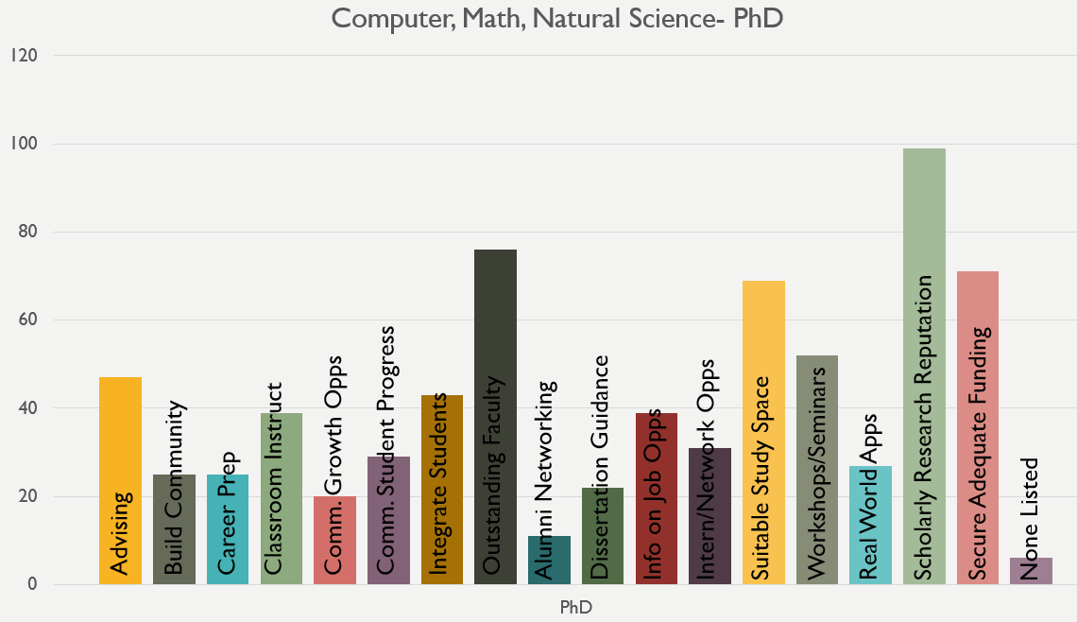 | 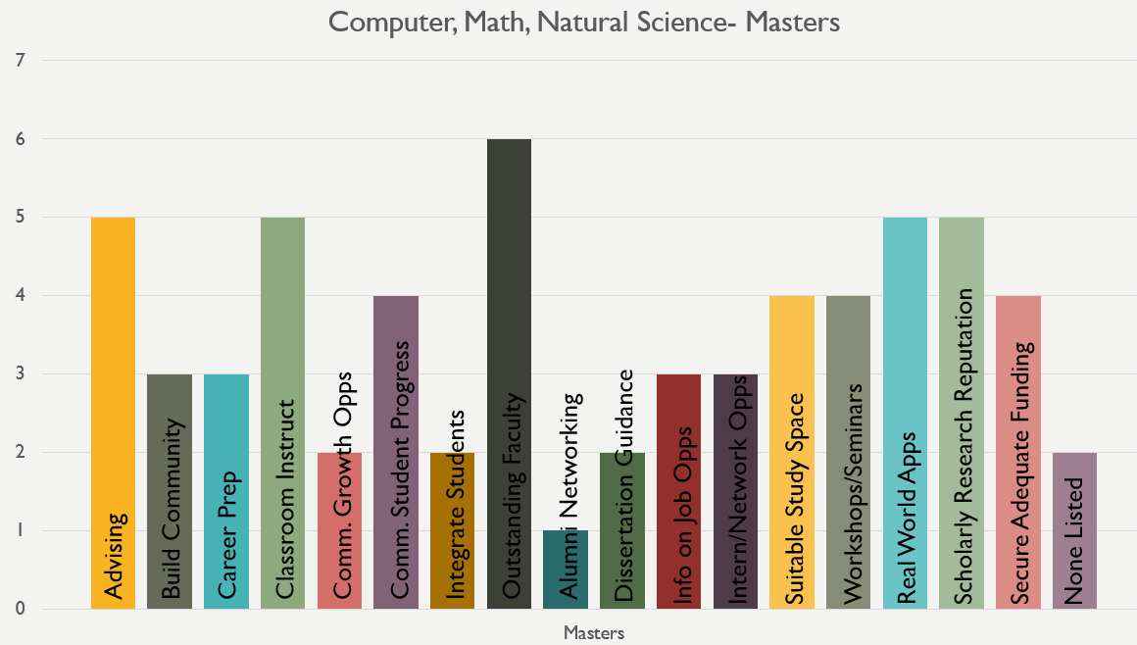

Program Preparation
Overall, the 144 PhD respondents from Computer, Mathematical, and Natural Sciences feel that their program does a good job of teaching them how to conduct and publish research. Students also feel their problem solving and verbal communication skills are honed in their programs. Further work to help students learn to attain leadership skills and intercultural competence is recommended.
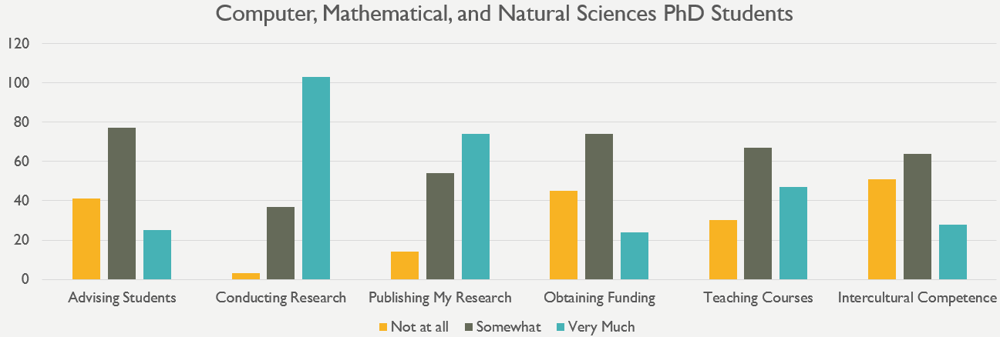
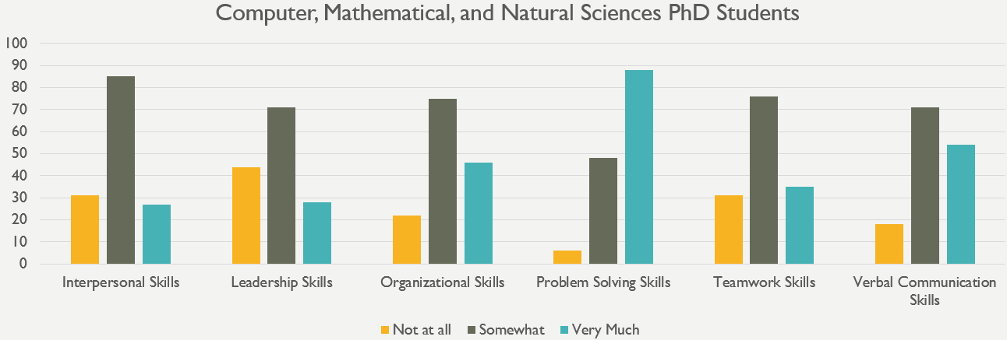

Education

Faculty
54 respondents are obtaining their PhDs and 39 are obtaining their master’s degrees. Overall, students feel that faculty care about their scholarship and teaching, care about their students, and have high ethical standards. The majority of students also reported that Education faculty treat students with respect and value their professional interests. The Education faculty received a lot of positive feedback overall, but may want to look into why some students did not feel faculty discussed career options with them, why some feel that faculty allow personal disagreements with each other to negatively impact students, and appear to give most of the attention and resources to a select group of students. Detailed information for each question is provided below.
Care about students: The majority of graduate student respondents feel that faculty care about students (83.3% of PhD respondents and 82.1% of master’s degree respondents). 7.4% of PhD respondents and 17.9% of master’s respondents did not feel this way.
Care about their scholarship: The vast majority of respondents said that faculty care about their scholarship (94.4% of PhD and 82.1% of master’s degree respondents). Only 1.9% of PhD respondents and 2.6% of master’s degree respondents feel that faculty do not care about scholarship.
Care about their teaching: 83.3% of PhD respondents and 82.1% of master’s respondents reported that faculty care about their teaching. 11.1% of PhD respondents and 7.7% of master’s respondents disagreed with this statement.
Have high ethical standards: The majority of PhD respondents (90.7%) and master’s degree respondents (89.7%) consider faculty to have high ethical standards. Only 3.7% of PhD respondents and 5.1% of master’s degree respondents feel that faculty do not.
Are explicit in their expectations of students: PhD students were mixed in their responses. Although 48.6% of PhD students responded with “Strongly Agree” or “Somewhat Agree”, 32.6% of PhD students felt that faculty were not explicit in their expectations. 60% of master’s students felt faculty are explicit and 33.3% of master’s students did not. The remaining respondents either responded with “Neither Agree nor Disagree” or “Not Applicable” to this question.
Help students grow as scholars: 77.8% of the PhD respondents and 84.6% of master’s degree respondents feel that faculty help students grow as scholars. 7.4% of PhD respondents and 12.8% of master’s degree respondents did not feel this way.
Treat students with respect: The majority of PhD (87%) and master’s degree (84.6%) respondents feel that faculty treat students with respect. 9.3% of PhD respondents and 15.4% of master’s degree respondents said they did not feel faculty treat them with respect.
Discuss career options with me: PhD students were mixed in their responses. Although 49.1% of the PhD students surveyed indicated that faculty discuss career options with them, 37.7% did not. 61.5% of master’s degree respondents indicated that faculty discuss career options with them and 23.1% of master’s degree respondents said that faculty did not.
Discuss funding opportunities with me: 54.7% of PhD respondents indicated that faculty discuss funding opportunities with them, 30.2% of PhD respondents said faculty did not, and 15.1% provided a neutral response. Master’s degree students were more mixed in their responses. 33.3% of master’s degree respondents indicated that faculty discuss funding opportunities, while 38.5% of master’s degree respondents said faculty did not and 28.2% of master’s degree students responded neutrally.
Discuss personal matters with me: 58.5% of PhD respondents and 59% of master’s degree students indicated that they discuss personal matters with faculty. 30.2% of PhD respondents and 25.6% of master’s degree students disagreed.
Discuss research strategies with me: 69.8% of PhD respondents and 60.5% of master’s degree respondents stated that faculty discuss research strategies with them. 17% of PhD respondents and 13.2% of master’s degree respondents said faculty did not do so.
Include me in projects that align with my professional interests: 59.3% of PhD respondents and 51.3% of master’s degree respondents felt that faculty include them in projects aligned with their professional interests. 25.9% of PhD respondents and 15.4% of master’s degree respondents did not feel they were included in these types of projects. 33.3% of master’s degree respondents provided a neutral response.
Value my professional interests: 79.6% of PhD respondents and 74.4% of master’s degree respondents said that faculty value their professional interests. 9.3% of PhD respondents and 10.3% of master’s degree respondents felt that faculty did not value their professional interests.
Interact with me outside of class: 74.1% of PhD respondents and 61.5% of master’s degree respondents said that faculty interact with them outside of class. 16.7% of PhD respondents and 20.5% of master’s degree respondents said that faculty did not interact with them outside of class.
Seem more concerned with furthering their own careers than with the well-being of the program as a whole: 55.6% of PhD respondents did not feel that faculty are more concerned with furthering their own careers than with the well-being of the program, 27.8% of PhD respondents felt otherwise and 16.7% were neutral. 56.4% of master’s degree respondents disagreed with the statement, 28.2% of master’s degree respondents felt that faculty are more concerned with furthering their own careers, and 15.4% were neutral.
Carefully guard results and new ideas from others in the field: 67.9% of PhD respondents do not feel that faculty guard results and new ideas from others in the field, 13.2% feel that they do, and 18.9% of PhD respondents were neutral on this statement. 44.7% of master’s degree respondents do not feel that faculty guard results and new ideas from others in the field and 13.2% feel that they do guard results and new ideas. 42.1% of master’s degree respondents said that this statement was either not applicable or they provided a neutral response.
Allow personal disagreements with each other to negatively impact students: PhD respondents are mixed in their responses. While 46.3% of PhD respondents strongly or somewhat disagreed with this statement, 40.7% strongly or somewhat agreed. The majority of master’s students (66.7%), on the other hand, did not feel faculty allowed personal disagreements with each other to negatively impact students. 10.3% of master’s students responded with “Strongly Agree” or “Somewhat Agree”. The remaining respondents (13% of PhD students and 23.1% of master’s degree students) either responded with “Neither Agree nor Disagree” or “Not Applicable” to this question.
Appear to give most of the attention and resources to a select group of students: PhD respondents were mixed. 42.6% of PhD respondents felt that faculty do not appear to give most of the attention and resources to a select group of students, while 40.7% feel that they do. 56.4% of master’s degree respondents did not feel that faculty gave most attention and resources to a select group, while 28.2% of master’s degree students feel they do.
Use their position to request work/assistance from me in ways in which I am not comfortable saying no: The majority of respondents (74.1% of PhD respondents and 79.5% of master’s degree respondents) do not feel that faculty use their position to request work/assistance. 18.5% of PhD respondents and only 5.1% of master’s degree respondents felt that faculty have used their position to request work/assistance.
Have tense/hostile interactions with me: 79.6% of PhD respondents and 87.2% of master’s respondents have not had tense/hostile interactions with faculty. 11.1% of PhD respondents and 10.3% of master’s degree respondents indicated that they have experienced tense/hostile interactions with faculty.
Discriminate against me: 83% of PhD respondents and 87.2% of master’s respondents do not feel discriminated against. Only 7.5% of PhD respondents and 5.1% of the master’s respondents have indicated feeling that faculty discriminate against them.

Department
A total of 94 Education master’s and PhD degree seeking students indicated at least one area in which their respective department excels. 54 of these students are obtaining their PhDs and 40 are obtaining their master’s degrees. Note that each student could indicate more than one area of excellence, so the numbers will not add up.
As indicated by the table and graphs below, students in Education feel their respective departments excel in their outstanding faculty, building community, and providing classroom instruction. Doctoral students also feel that their respective departments have a good scholarly research reputation and do a good job of communicating with students about progress. Master’s degree students feel that their departments do a good job of building community, preparing students for careers, and providing information about job and internship/networking opportunities.
Area of Excellence | # of PhD endorsements | # of master’s degree endorsements
Advising | 16 | 17
Building Community | 20 | 18
Career Preparation | 11 | 18
Classroom Instruction | 19 | 20
Communicating about opportunities for growth | 11 | 10
Communicating with students about progress | 19 | 15
Integrating graduate students into program/department life | 17 | 10
Outstanding faculty | 29 | 24
Providing alumni networking opportunities | 7 | 11
Providing dissertation guidance | 11 | 2
Providing information about job opportunities | 7 | 18
Providing internship/networking opportunities | 13 | 18
Providing suitable work/study space | 8 | 1
Providing workshops and seminars | 12 | 6
Real world applications | 13 | 14
Scholarly research reputation | 33 | 17
Securing adequate funding | 17 | 7
None of the above | 2 | 3

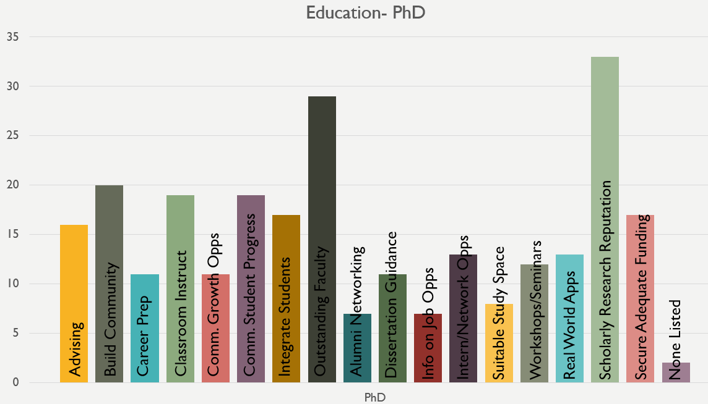 | 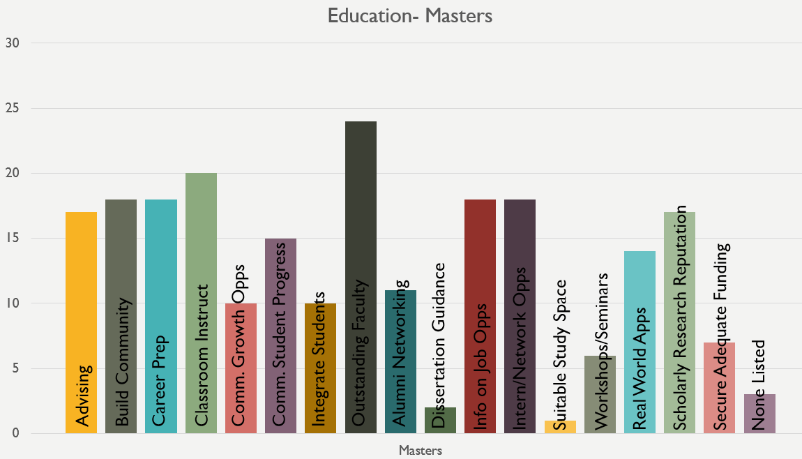

Program Preparation
Overall, the 54 PhD respondents from Education feel that their program does a good job of teaching them how to conduct research and teach courses. Students also feel their verbal, interpersonal, and problem solving skills are honed in their programs and that they gain intercultural competence. Further work to help students learn to obtain funding and advise students is recommended.
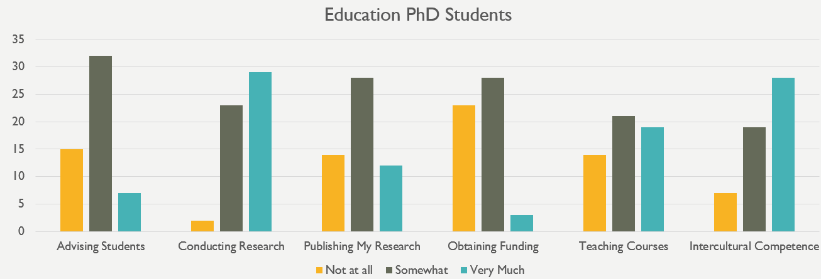
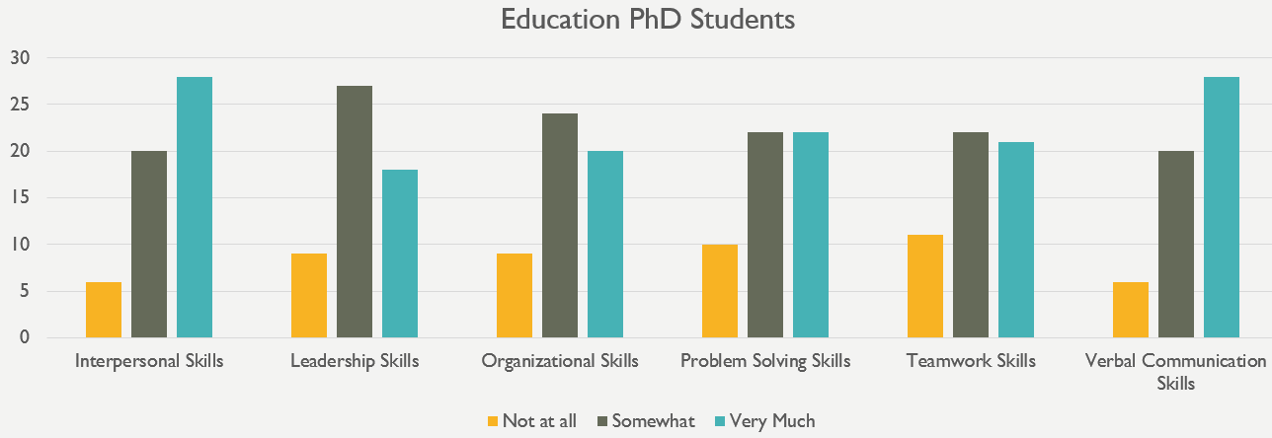

Engineering

Faculty
111 respondents are obtaining their PhDs and 115 are obtaining their master’s degrees. Overall, students feel that faculty treat them with respect and that they care about their students, scholarship, and teaching. The majority of students also reported that Engineering faculty have high ethical standards. While the Engineering faculty is highly praised by respondents, the faculty may consider looking into why students may feel that some faculty guard results and new ideas from others in the field. Detailed information for each question is provided below.
Care about students: The majority of engineering graduate student respondents feel that faculty care about students (76.6% of PhD respondents and 78.3% of master’s degree respondents). Very few students did not feel this way (10.8% of PhD respondents and 6% of master’s respondents).
Care about their scholarship: 76.6% of PhD students indicated that faculty care about their scholarship. Only 6.3% of PhD respondents feel that faculty do not care about scholarship. 46% of master’s students provided a neutral response to this question, while 39.1% indicated that faculty care about scholarship.
Care about their teaching: 72.7% of PhD respondents and 78.9% of master’s respondents reported that faculty care about their teaching. Only 11.8% of PhD respondents and 7% of master’s respondents disagreed with this statement.
Have high ethical standards: The majority of PhD respondents (76.6%) and master’s degree respondents (83.3%) consider faculty to have high ethical standards. Only 9.9% of PhD respondents and 3.5% of master’s degree respondents feel that faculty do not.
Are explicit in their expectations of students: 56.3% of PhD students and 62.2% of master’s students responded with “Strongly Agree” or “Somewhat Agree”. Only 21.8% of PhD students and 15.8% of master’s students felt that faculty were not explicit in their expectations. The remaining respondents either responded with “Neither Agree nor Disagree” or “Not Applicable” to this question.
Help students grow as scholars: 71.2% of the PhD respondents and 57.3% of master’s degree respondents feel that faculty help students grow as scholars. Only 8.1% of PhD respondents and 9.6% of master’s degree respondents did not feel this way.
Treat students with respect: The majority of PhD (88.2%) and master’s degree (91.3%) respondents feel that faculty treat students with respect. Only 5.5% of PhD respondents and less than 1% of master’s degree respondents said they did not feel faculty treat them with respect.
Discuss career options with me: 47.7% of the PhD students surveyed and 44.3% of master’s degree respondents indicated that faculty discuss career options with them. 26.1% of PhD respondents and 23.5% of master’s degree respondents said that faculty did not discuss career options.
Discuss funding opportunities with me: 59.4% of PhD respondents indicated that faculty discuss funding opportunities, while 19.8% of PhD respondents said faculty did not. 33.9% of master’s degree respondents did not feel faculty discussed funding and 23.5% said that they did discuss funding opportunities with faculty.
Discuss personal matters with me: 26.4% of PhD respondents and 18.6% of master’s degree respondents said that faculty discuss personal matters with them. 37.2% of PhD respondents and 41.6% of master’s degree respondents did not discuss personal matters with faculty.
Discuss research strategies with me: 78.4% of PhD respondents stated that faculty discuss research strategies with them and only 11.7% of PhD respondents said faculty did not do so. Master’s degree students were more mixed in their feelings, with 38.2% of master’s respondents indicating that faculty discussed research strategies with them and 24.3% saying they did not discuss research strategies with faculty.
Include me in projects that align with my professional interests: 63% of PhD respondents and 41.7% of master’s degree respondents felt that faculty include them in projects aligned with their professional interests. 18% of PhD respondents and 20.9% of master’s degree respondents did not feel they were included in these types of projects.
Value my professional interests: 73.9% of PhD respondents and 60% of master’s degree respondents said that faculty value their professional interests. Only 16.2% of PhD respondents and 10.4% of master’s degree respondents felt that faculty did not value their professional interests.
Interact with me outside of class: 60.4% of PhD respondents and 46.1% of master’s degree respondents said that faculty interact with them outside of class. 18% of PhD respondents and 20% of master’s degree respondents said that faculty did not interact with them outside of class.
Seem more concerned with furthering their own careers than with the well-being of the program as a whole: 52.2% of PhD respondents and 45.1% of master’s degree respondents did not feel that faculty are more concerned with furthering their own careers than with the well-being of the program. 29.7% of PhD respondents and 28.3% of master’s degree respondents felt that faculty are more concerned with furthering their own careers.
Carefully guard results and new ideas from others in the field: 40.9% of PhD respondents and 35.6% of master’s respondents feel that faculty guard results and new ideas from others in the field. 25.4% of PhD respondents and 20.9% of master’s respondents say that faculty do not guard results and new ideas.
Allow personal disagreements with each other to negatively impact students: The majority of PhD students (50.5%) responded with “Strongly Disagree” or “Somewhat Disagree” to this question, while 25.2% of PhD respondents strongly or somewhat agreed with this statement. 33.9% of master’s students responded with “Strongly Disagree” or “Somewhat Disagree” and 24.3% responded with “Strongly Agree” or “Somewhat Agree”. The remaining respondents either responded with “Neither Agree nor Disagree” or “Not Applicable” to this question.
Appear to give most of the attention and resources to a select group of students: The majority of PhD students (50.5%) responded with “Strongly Disagree” or “Somewhat Disagree” to this question, while 24.3% of PhD respondents strongly or somewhat agreed with this statement. 47.8% of master’s students responded with “Strongly Disagree” or “Somewhat Disagree” and 27.8% responded with “Strongly Agree” or “Somewhat Agree”. The remaining respondents either responded with “Neither Agree nor Disagree” or “Not Applicable” to this question.
Use their position to request work/assistance from me in ways in which I am not comfortable saying no: 64.5% of PhD respondents and 49.1% of master’s respondents do not believe that faculty use their position to request work/assistance. 17.2% of PhD respondents and 16.7% of master’s respondents felt that faculty have used their position to request work/assistance.
Have tense/hostile interactions with me: 74.8% of PhD respondents and 62.3% of master’s respondents have not had tense/hostile interactions with faculty. 13.5% of PhD respondents and 14.9% of master’s degree respondents indicated that they have experienced tense/hostile interactions with faculty.
Discriminate against me: 75.4% of PhD respondents and 60.5% of master’s respondents do not feel discriminated against, while 11.8% of PhD respondents and 12.3% of master’s respondents have indicated feeling that faculty discriminate against them.

Department
A total of 222 Engineering master’s and PhD degree seeking students indicated at least one area in which their respective department excels. 112 of these students are obtaining their PhDs and 110 are obtaining their master’s degrees. Note that each student could indicate more than one area of excellence, so the numbers will not add up.
As indicated by the table and graphs below, students in Engineering feel their respective departments excel in having outstanding faculty, providing information about job opportunities, and providing advising. Doctoral students also feel that their respective departments have a scholarly research reputation. Master’s degree students feel that their departments do a good job in providing instruction in the classroom.
Area of Excellence | # of PhD endorsements | # of master’s degree endorsements
Advising | 39 | 35
Building Community | 19 | 8
Career Preparation | 16 | 25
Classroom Instruction | 28 | 43
Communicating about opportunities for growth | 16 | 10
Communicating with students about progress | 20 | 18
Integrating graduate students into program/department life | 28 | 21
Outstanding faculty | 48 | 28
Providing alumni networking opportunities | 11 | 22
Providing dissertation guidance | 15 | 5
Providing information about job opportunities | 46 | 27
Providing internship/networking opportunities | 27 | 25
Providing suitable work/study space | 33 | 22
Providing workshops and seminars | 35 | 20
Real world applications | 28 | 16
Scholarly research reputation | 48 | 16
Securing adequate funding | 35 | 11
None of the above | 10 | 20

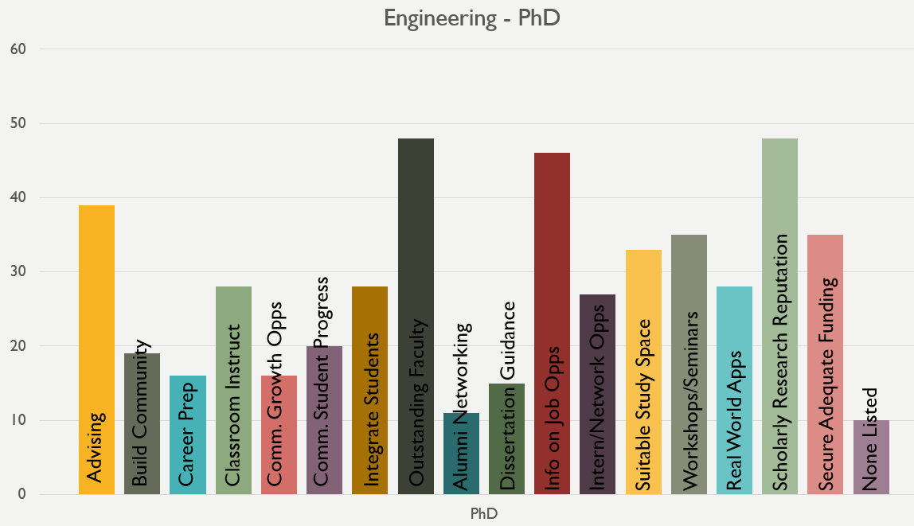 | 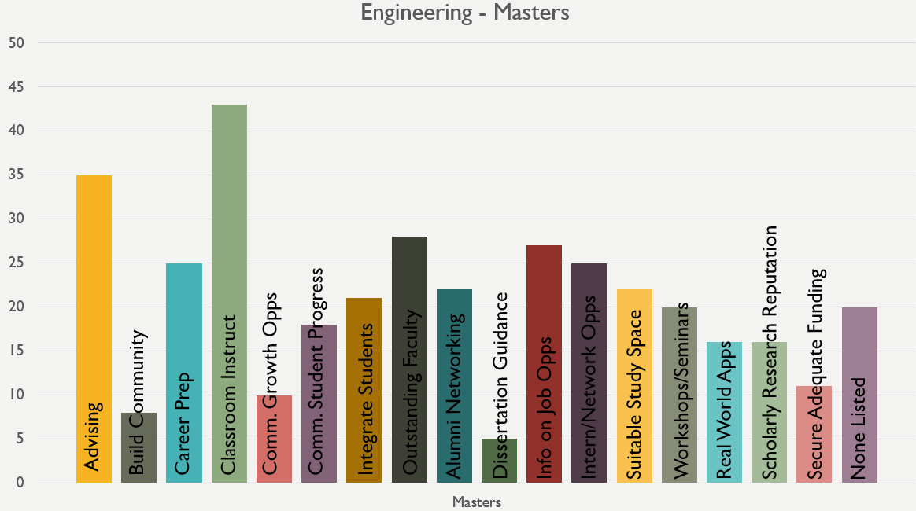

Program Preparation
Overall, the 111 PhD respondents from Engineering feel that their program does a good job of teaching them how to conduct and publish research. Students also feel their problem solving, verbal communication, and interpersonal skills are honed in their programs. Further work to help students learn to obtain funding and advise students is recommended.
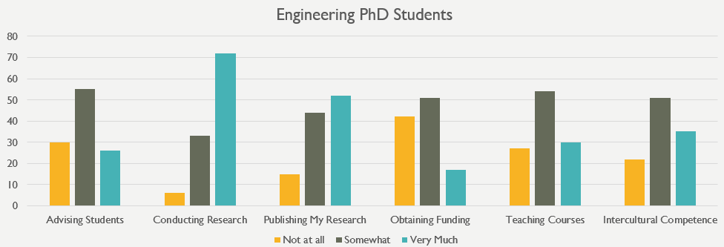
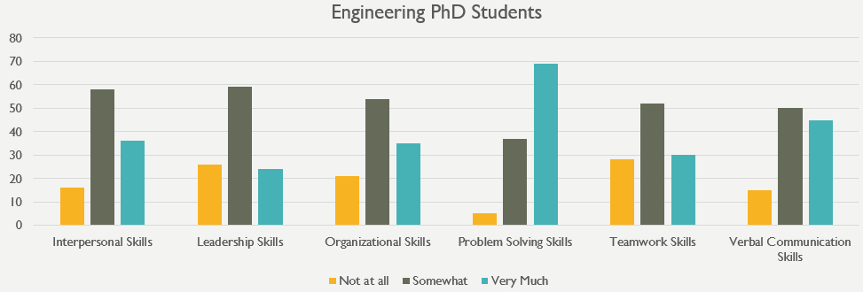

Information Studies

Faculty
12 respondents are obtaining their PhDs and 76 are obtaining their master’s degrees. Overall, students feel that faculty care about their scholarship and their students, have high ethical standards, and are open about their research results and new ideas in the Information Studies field. The majority of students also reported that Information Studies faculty treat students with respect and help students to grow as scholars. The Information Studies faculty received a lot of praise, but may want to look into why some students did not feel faculty discussed personal matters with them. It is important to keep in mind that the number of PhD respondents for Information Studies is quite small – 25% is equal to three respondents. Detailed information for each question is provided below.
Care about students: The majority of graduate student respondents feel that faculty care about students (100% of PhD respondents and 88% of master’s degree respondents). Only 4% of master’s respondents did not feel this way.
Care about their scholarship: The vast majority of respondents said that faculty care about their scholarship (91.7% of PhD and 74.7% of master’s degree respondents). Only 2.7% of master’s degree respondents feel that faculty do not care about scholarship.
Care about their teaching: 75% of PhD respondents and 80% of master’s respondents reported that faculty care about their teaching. 8.3% of PhD respondents and 9.3% of master’s respondents disagreed with this statement.
Have high ethical standards: The majority of PhD respondents (83.3%) and master’s degree respondents (86.5%) consider faculty to have high ethical standards. Only 8.3% of PhD respondents and 2.7% of master’s degree respondents feel that faculty do not.
Are explicit in their expectations of students: 66.7% of PhD students responded with “Strongly Agree” or “Somewhat Agree” and 16.7% of PhD students felt that faculty were not explicit in their expectations. 75% of master’s students felt faculty are explicit and only 6.6% of master’s students did not. The remaining respondents either responded with “Neither Agree nor Disagree” or “Not Applicable” to this question.
Help students grow as scholars: 83.3% of the PhD respondents and 72% of master’s degree respondents feel that faculty help students grow as scholars. Only 6.7% of master’s degree respondents did not feel this way. 16.7% of PhD respondents and 21.3% of master’s degree respondents gave a neutral response.
Treat students with respect: All PhD respondents and 92% of master’s degree respondents feel that faculty treat students with respect. Only 2.7% of master’s degree respondents said they did not feel faculty treat them with respect.
Discuss career options with me: 58.3% of the PhD students surveyed indicated that faculty discuss career options with them, 16.7% said that faculty do not. Master’s degree students were mixed in their responses. 39.2% of master’s degree respondents indicated that faculty discuss career options with them, 32.4% of master’s degree respondents said that faculty did not, and 28.4% provided a neutral response.
Discuss funding opportunities with me: 58.3% of PhD respondents indicated that faculty discuss funding opportunities with them, 25% of PhD respondents said faculty did not, and 16.7% provided a neutral response. 17.3% of master’s degree respondents indicated that faculty discuss funding opportunities, while 42.7% of master’s degree respondents said faculty did not and 40% of master’s degree students responded neutrally.
Discuss personal matters with me: 8.3% of PhD respondents and 13.5% of master’s degree students indicated that they discuss personal matters with faculty. 33.3% of PhD respondents and 39.2% of master’s degree students disagreed. A large number of respondents (58.3% of PhD respondents and 47.3% of master’s degree respondents) remained neutral.
Discuss research strategies with me: 83.3% of PhD respondents and 45.9% of master’s degree respondents stated that faculty discuss research strategies with them. 8.3% of PhD respondents and 21.6% of master’s degree respondents said faculty did not do so. A large number of master’s degree respondents remained neutral (32.4%).
Include me in projects that align with my professional interests: 58.3% of PhD respondents and 45.3% of master’s degree respondents felt that faculty include them in projects aligned with their professional interests. 25% of PhD respondents and 18.7% of master’s degree respondents did not feel they were included in these types of projects. 36% of master’s degree respondents provided a neutral response.
Value my professional interests: 83.3% of PhD respondents and 70.3% of master’s degree respondents said that faculty value their professional interests. 8.3% of PhD respondents and 8.1% of master’s degree respondents felt that faculty did not value their professional interests.
Interact with me outside of class: 58.3% of PhD respondents and 42.7% of master’s degree respondents said that faculty interact with them outside of class. 18.7% of master’s degree respondents said that faculty did not interact with them outside of class. 41.7% of PhD respondents and 38.7% of master’s degree respondents provided a neutral response.
Seem more concerned with furthering their own careers than with the well-being of the program as a whole: 75% of PhD respondents and 66.7% of master’s degree respondents did not feel that faculty are more concerned with furthering their own careers than with the well-being of the program. 16.7% of PhD respondents and 17.3% of master’s degree respondents felt otherwise. 16% of master’s degree students were neutral.
Carefully guard results and new ideas from others in the field: No PhD respondents feel that faculty guard results and new ideas from others in the field. 50.7% of master’s degree respondents do not feel that faculty guard results and new ideas from others in the field and only 4% feel that they do guard results and new ideas. 45.3% of master’s degree respondents said that this statement was either not applicable or they provided a neutral response.
Allow personal disagreements with each other to negatively impact students: 66.7% of PhD respondents strongly or somewhat disagreed with this statement, 16.7% strongly or somewhat agreed. 48.7% of master’s degree students did not feel faculty allowed personal disagreements with each other to negatively impact students. 7.9% of master’s students responded with “Strongly Agree” or “Somewhat Agree”. The remaining respondents (16.7% of PhD students and 43.4% of master’s degree students) either responded with “Neither Agree nor Disagree” or “Not Applicable” to this question.
Appear to give most of the attention and resources to a select group of students: 58.3% of PhD respondents felt that faculty do not appear to give most of the attention and resources to a select group of students and 16.7% feel that they do, while 25% provided a neutral response. 51.3% of master’s degree respondents did not feel that faculty gave most attention and resources to a select group, while 25% of master’s degree students feel they do, and 23.7% responded in a neutral way.
Use their position to request work/assistance from me in ways in which I am not comfortable saying no: The majority of respondents (58.3% of PhD respondents and 69.3% of master’s degree respondents) do not feel that faculty use their position to request work/assistance. Only 8.3% of PhD respondents and 4% of master’s degree respondents felt that faculty have used their position to request work/assistance.
Have tense/hostile interactions with me: 91.7% of PhD respondents and 86.5% of master’s respondents have not had tense/hostile interactions with faculty. Only 5.4% of master’s degree respondents indicated that they have experienced tense/hostile interactions with faculty.
Discriminate against me: 91.7% of PhD respondents and 82.7% of master’s respondents do not feel discriminated against. Only 8.3% of PhD respondents and 4% of the master’s respondents have indicated feeling that faculty discriminate against them.

Department
A total of 85 Information studies master’s and PhD degree seeking students indicated at least one area in which their respective department excels. 12 of these students are obtaining their PhDs and 73 are obtaining their master’s degrees. Note that each student could indicate more than one area of excellence, so the numbers will not add up.
As indicated by the table and graphs below, students in Information Studies feel their respective departments excel in having outstanding faculty and providing classroom instruction. Doctoral students also feel that their respective departments have a scholarly research reputation, excel in securing adequate funding, and provide real world applications. Master’s degree students feel that their departments do a good job in providing information about job and internship/networking opportunities.
Area of Excellence | # of PhD endorsements | # of master’s degree endorsements
Advising | 3 | 19
Building Community | 3 | 10
Career Preparation | 2 | 19
Classroom Instruction | 6 | 29
Communicating about opportunities for growth | 1 | 15
Communicating with students about progress | 3 | 6
Integrating graduate students into program/department life | 3 | 15
Outstanding faculty | 7 | 28
Providing alumni networking opportunities | 0 | 9
Providing dissertation guidance | 5 | 3
Providing information about job opportunities | 3 | 38
Providing internship/networking opportunities | 0 | 38
Providing suitable work/study space | 2 | 13
Providing workshops and seminars | 2 | 13
Real world applications | 6 | 23
Scholarly research reputation | 6 | 22
Securing adequate funding | 6 | 2
None of the above | 0 | 6

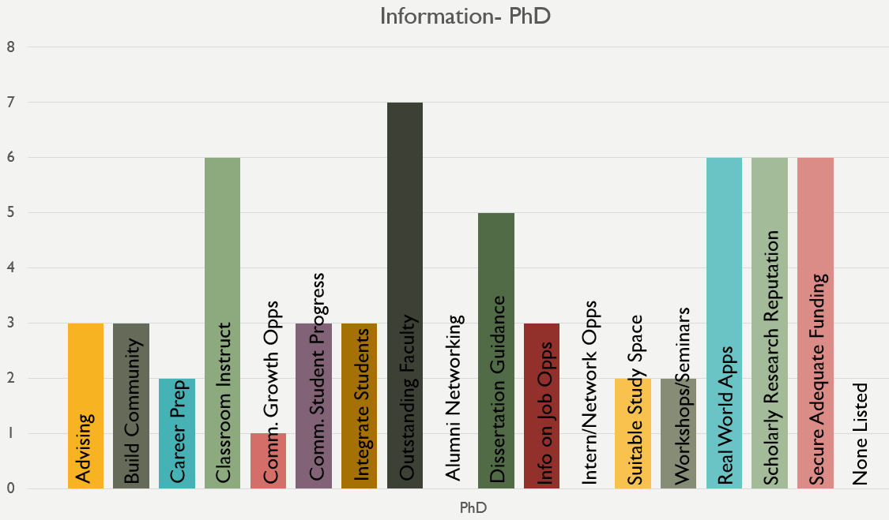 | 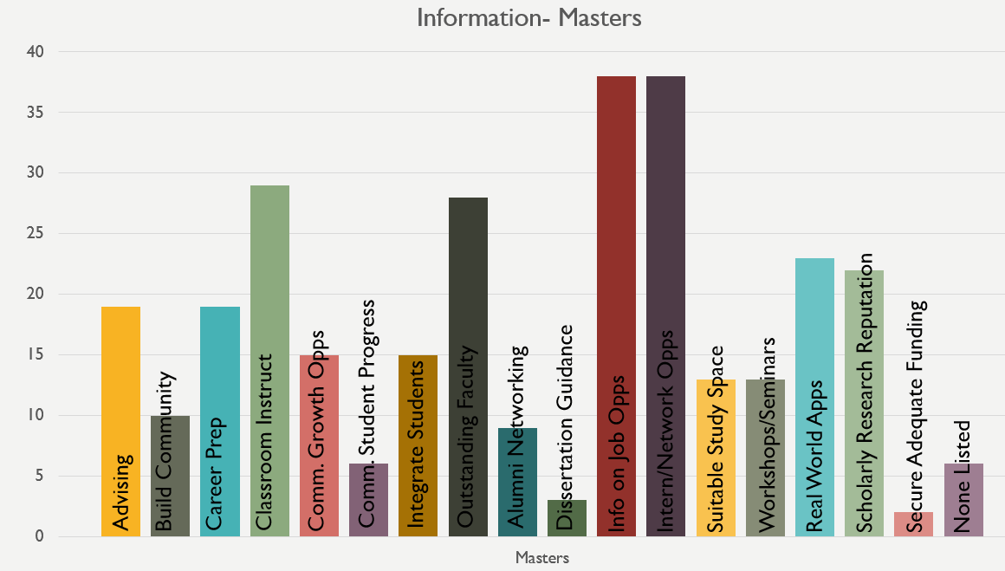

Program Preparation
Only 12 PhD students responded from Information Studies, so it is important to keep in mind the minimal amount of information that can be gleaned from these results. However, those who responded feel that their program does a good job of teaching them how to conduct and publish research. They also feel that their program has helped them to improve their problem solving and teamwork skills. Further work to help students learn to advise students, obtain funding, and to teach courses is recommended.
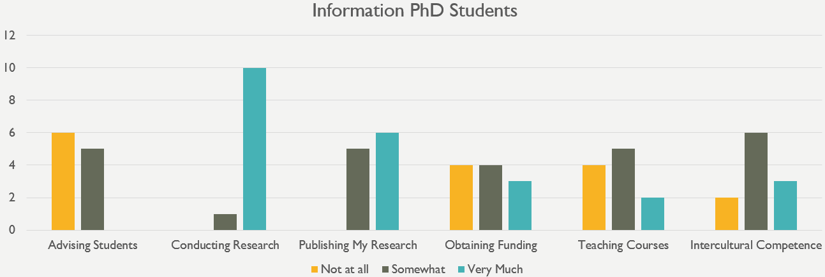
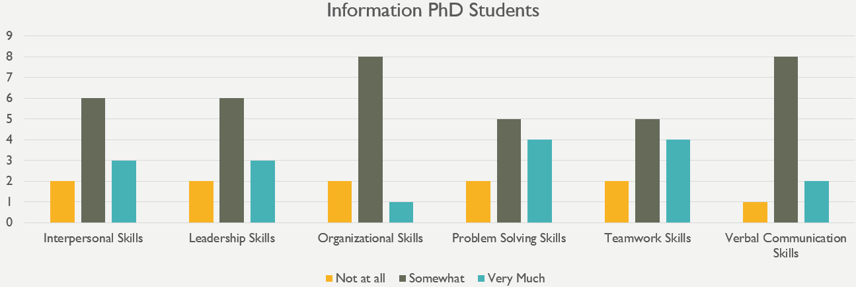

Journalism

Faculty
There were too few respondents in Journalism to be able to provide detailed information.

Department
A total of 3 Journalism PhD degree seeking students indicated at least one area in which their respective department excels. Due to such a small number of students, data are not provided as such a small amount of information does not necessarily reflect trends of the larger Journalism student population.

Program Preparation
There were too few respondents in Journalism to be able to provide detailed information.

Public Health

Faculty
27 respondents are obtaining their PhDs and 36 are obtaining their master’s degrees. Overall, students feel that faculty care about their scholarship, care about their students, and help students grow as scholars. The majority of students also reported that Public Health faculty value their professional interests and treat students with respect. While the Public Health faculty is highly praised by respondents, the faculty may consider looking into why students may feel that some faculty do not discuss personal matters or interact with them outside of class. Detailed information for each question is provided below.
Care about students: The majority of graduate student respondents feel that faculty care about students (92.6% of PhD respondents and 80.6% of master’s degree respondents). Only 8.3% of master’s respondents did not feel this way. The remainder of respondents were neutral.
Care about their scholarship: The vast majority of respondents said that faculty care about their scholarship (88.9% of PhD and 72.2% of master’s degree respondents). Only 7.4% of PhD respondents and 8.3% of master’s respondents feel that faculty do not care about scholarship.
Care about their teaching: 77.8% of PhD respondents and 75% of master’s respondents reported that faculty care about their teaching. 22.2% of PhD respondents and 11.1% of master’s respondents disagreed with this statement.
Have high ethical standards: The majority of PhD respondents (77.8%) and master’s degree respondents (80.6%) consider faculty to have high ethical standards. Only 14.8% of PhD respondents feel that faculty do not. The remainder of students were neutral in their response.
Are explicit in their expectations of students: 66.7% of PhD students and 63.9% of master’s students responded with “Strongly Agree” or “Somewhat Agree”. 22.2% of PhD students and 27.8% of master’s students felt that faculty were not explicit in their expectations. The remaining respondents either responded with “Neither Agree nor Disagree” or “Not Applicable” to this question.
Help students grow as scholars: 88.9% of the PhD respondents and 77.8% of master’s degree respondents feel that faculty help students grow as scholars. Only 3.7% of PhD respondents and 13.9% of master’s degree respondents did not feel this way.
Treat students with respect: The majority of PhD (85.2%) and master’s degree (91.7%) respondents feel that faculty treat students with respect. Only 11.1% of PhD respondents said they did not feel faculty treat them with respect. The remainder of respondents either responded with “Neither Agree nor Disagree” or “Not Applicable” to this question
Discuss career options with me: 77.8% of the PhD students surveyed and 36.1% of master’s degree respondents indicated that faculty discuss career options with them. 22.2% of PhD respondents and 47.2% of master’s degree respondents said that faculty did not discuss career options.
Discuss funding opportunities with me: 66.7% of PhD respondents indicated that faculty discuss funding opportunities with them, while 22.2% of PhD respondents said faculty did not. 16.7% of master’s degree respondents indicated that faculty discuss funding opportunities, while 55.6% of master’s degree respondents said faculty did not and 27.8% of master’s degree students responded neutrally.
Discuss personal matters with me: PhD respondents were mixed in their responses. 48.1% of PhD respondents agreed with this statement and 37% disagreed. 19.4% of master’s degree respondents agreed with this statement, 52.8% said they did not discuss personal matters, and 27.8% remained neutral.
Discuss research strategies with me: 85.2% of PhD respondents stated that faculty discuss research strategies with them and 11.1% said faculty did not do so. Master’s degree respondents were mixed in their responses. 41.7% of master’s degree respondents did not discuss research strategies with faculty, while 30.6% did discuss research strategies and 27.8% were neutral in their responses.
Include me in projects that align with my professional interests: 70.4% of PhD respondents felt that faculty included them in projects that align with their professional interests, while 22.2% did not. Master’s degree students were mixed in their responses. 38.9% of master’s degree respondents did not feel they were included in these types of projects, while 33.3% felt they were. 27.8% of master’s degree respondents provided a neutral response.
Value my professional interests: 92.6% of PhD respondents and 62.9% of master’s degree respondents said that faculty value their professional interests. Only 3.7% of PhD respondents and 20% of master’s degree respondents felt that faculty did not value their professional interests.
Interact with me outside of class: 70.4% of PhD respondents said that faculty interact with them outside of class, while 14.8% said faculty did not. Master’s degree respondents were more mixed in their responses. 47.2% of master’s degree respondents said that faculty interact with them outside of class, while 30.6% of master’s degree respondents said that faculty did not interact with them outside of class.
Seem more concerned with furthering their own careers than with the well-being of the program as a whole: 59.3% of PhD respondents did not feel that faculty are more concerned with furthering their own careers than with the well-being of the program, while 29.6% of PhD respondents felt otherwise and 11.1% were neutral. 55.6% of master’s degree respondents disagreed with the statement, while 27.8% of master’s degree respondents felt that faculty are more concerned with furthering their own careers, and 16.7% were neutral.
Carefully guard results and new ideas from others in the field: Only a small number of students felt that this statement was true (7.4% of PhD respondents and 8.3% of master’s degree students agreed with this statement). The majority of PhD respondents (55.6%) and 33.3% of master’s degree respondents do not feel that faculty guard results and new ideas from others in the field. It is important to note that 37% of PhD respondents and 58.3% of master’s degree respondents said that this question was either not applicable or they provided a neutral response.
Allow personal disagreements with each other to negatively impact students: Respondents were mixed on this question. 48.1% of PhD respondents strongly or somewhat disagreed with this statement, while 44.4% of PhD respondents strongly or somewhat agreed. 44.4% of master’s students responded with “Strongly Disagree” or “Somewhat Disagree” and 16.7% responded with “Strongly Agree” or “Somewhat Agree”. The remaining respondents (7.4% of PhD respondents and 38.9% of master’s degree respondents) either responded with “Neither Agree nor Disagree” or “Not Applicable” to this question.
Appear to give most of the attention and resources to a select group of students: 59.3% of PhD respondents do not feel that faculty appear to give most of the attention and resources to a select group of students, while 29.6% did feel this way. Master’s degree respondents were more mixed in their responses. 42.9% did not feel that faculty gave most attention and resources to a select group, while 40% of master’s degree students feel they do.
Use their position to request work/assistance from me in ways in which I am not comfortable saying no: 66.7% of PhD respondents and 83.3% of master’s degree respondents felt faculty do not use their position to request work/assistance. 22.2% of PhD respondents feel that faculty have used their position to request work/assistance.
Have tense/hostile interactions with me: 74.1% of PhD respondents and 77.8% of master’s respondents have not had tense/hostile interactions with faculty. 22.2% of PhD respondents and 5.6% of master’s degree respondents indicated that they have experienced tense/hostile interactions with faculty.
Discriminate against me: 85.2% of PhD respondents and 72.2% of master’s respondents do not feel discriminated against. Only 7.4% of PhD respondents and 8.3% of master’s respondents have indicated feeling that faculty discriminate against them.

Department
A total of 63 Public Health master’s and PhD degree seeking students indicated at least one area in which their respective department excels. 27 of these students are obtaining their PhDs and 36 are obtaining their master’s degrees. Note that each student could indicate more than one area of excellence, so the numbers will not add up.
As indicated by the table and graphs below, students in Public Health feel their respective departments excel in providing real world applications. Doctoral students also feel that their respective departments do a good job in communicating with students about progress, having outstanding faculty, and securing adequate funding. Master’s degree students feel that their departments do a good job in providing instruction in the classroom, providing information about job and internship/networking opportunities, and advising.
Area of Excellence | # of PhD endorsements | # of master’s degree endorsements
Advising | 7 | 10
Building Community | 6 | 6
Career Preparation | 6 | 5
Classroom Instruction | 5 | 11
Communicating about opportunities for growth | 9 | 5
Communicating with students about progress | 11 | 3
Integrating graduate students into program/department life | 9 | 4
Outstanding faculty | 10 | 9
Providing alumni networking opportunities | 2 | 3
Providing dissertation guidance | 8 | 2
Providing information about job opportunities | 5 | 10
Providing internship/networking opportunities | 5 | 15
Providing suitable work/study space | 8 | 9
Providing workshops and seminars | 5 | 5
Real world applications | 11 | 10
Scholarly research reputation | 9 | 8
Securing adequate funding | 10 | 2
None of the above | 1 | 5

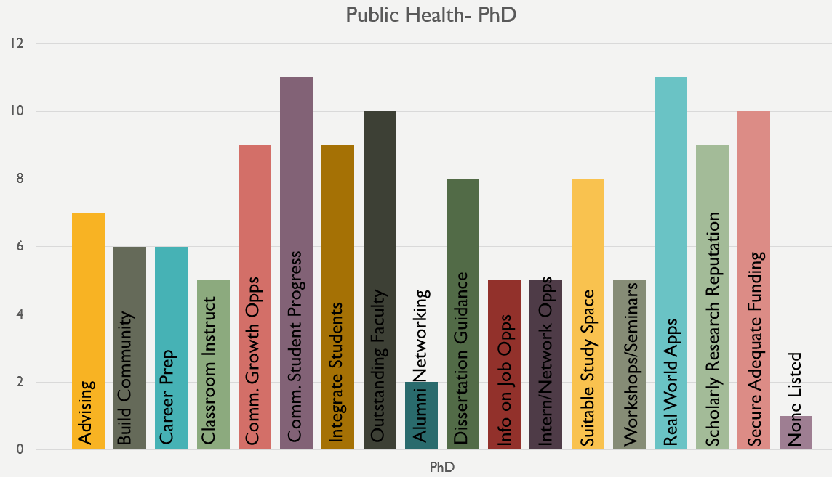 | 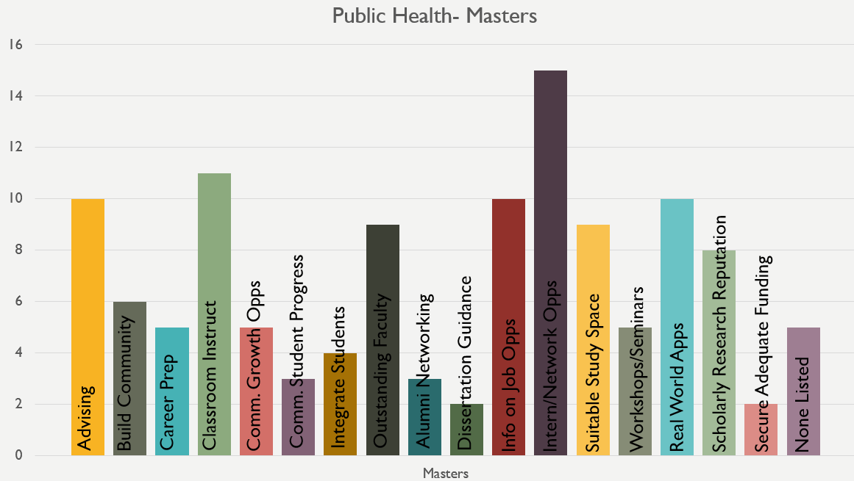

Program Preparation
Overall, the 27 PhD respondents from Public Health feel that their program does a good job of teaching them how to conduct and publish research and teach courses. Students also feel their problem solving, verbal communication, and leadership skills are honed in their programs and they feel that they have gained intercultural competence. Further work to help students learn to obtain funding and advise students is recommended.
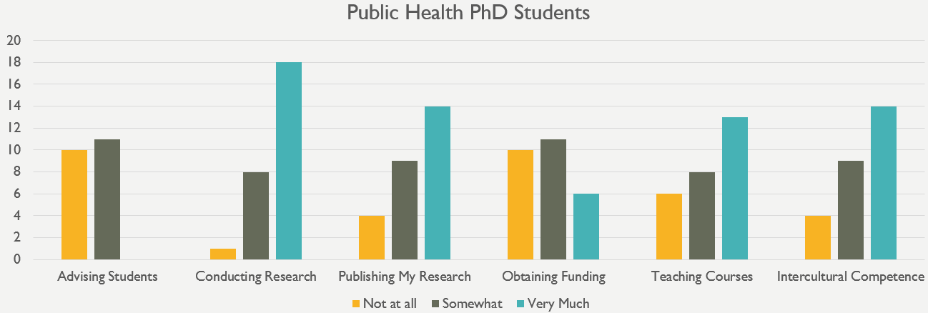
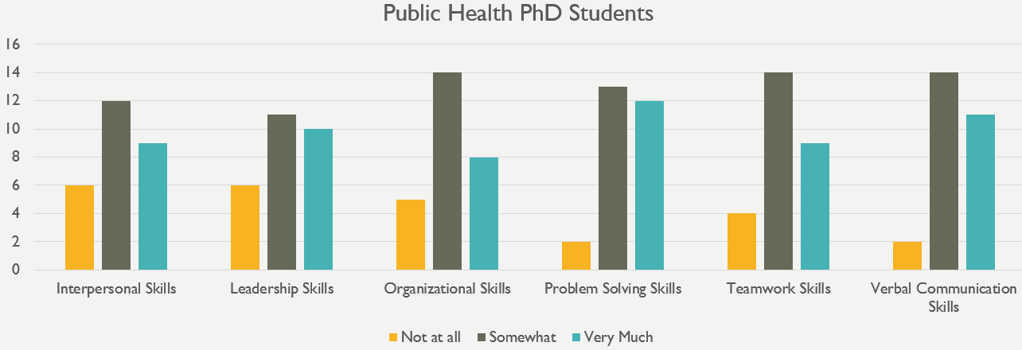

Public Policy

Faculty
8 respondents are obtaining their PhDs and 31 are obtaining their master’s degrees. Due to the fact that there are such a small number of PhDs, the data is aggregated over all respondents. Overall, students feel that faculty care about their students and their teaching and have high ethical standards. The majority of students also reported that Public Policy faculty treat students with respect and value their professional interests. The Public Policy faculty received a lot of praise, but may want to look into why some students did not feel faculty discussed personal matters or career options with them. Detailed information for each question is provided below.
Care about students: The majority of graduate student respondents (87.2%) feel that faculty care about students. The remaining 12.8% of respondents provided a neutral response.
Care about their scholarship: The majority of respondents (69.2%) said that faculty care about their scholarship. Only 7.7% of respondents feel that faculty do not care about scholarship and 23.1% of students were neutral.
Care about their teaching: 79.5% of respondents reported that faculty care about their teaching, while only 5.1% of respondents disagreed with this statement and the remaining 15.4% were neutral.
Have high ethical standards: The majority of respondents (87.2%) consider faculty to have high ethical standards. Only 5.1% of respondents feel that faculty do not.
Are explicit in their expectations of students: 64.1% of students responded with “Strongly Agree” or “Somewhat Agree” and only 15.4% of students felt that faculty were not explicit in their expectations. The remaining 20.5% of respondents responded with “Neither Agree nor Disagree” to this question.
Help students grow as scholars: 70.3% of respondents feel that faculty help students grow as scholars. Only 16.2% of respondents did not feel this way. 12.8% of respondents gave a neutral response.
Treat students with respect: 92.3% of respondents feel that faculty treat students with respect. The remaining students surveyed (7.7%) provided neutral responses.
Discuss career options with me: 41% of the students surveyed indicated that faculty discuss career options with them, 38.5% of respondents said that faculty did not, and 20.5% provided a neutral response.
Discuss funding opportunities with me: 23.1% of the students surveyed indicated that faculty discuss funding opportunities with them, 43.6% of respondents said that faculty did not, and 33.3% provided a neutral response.
Discuss personal matters with me: 25.6% of the students surveyed indicated that faculty discuss personal matters with them, 38.5% of respondents said that faculty did not, and 35.9% provided a neutral response.
Discuss research strategies with me: 48.7% of the students surveyed indicated that faculty discuss research strategies with them, 25.6% of respondents said that faculty did not, and 25.6% provided a neutral response.
Include me in projects that align with my professional interests: 42.1% of respondents felt that faculty include them in projects aligned with their professional interests. 31.6% of respondents did not feel they were included in these types of projects. 26.3% of respondents provided a neutral response.
Value my professional interests: 71.8% of respondents said that faculty value their professional interests. Only 7.7% of respondents felt that faculty did not value their professional interests.
Interact with me outside of class: 52.6% of respondents said that faculty interact with them outside of class. 21.1% of respondents said that faculty did not interact with them outside of class. 26.3% of respondents provided a neutral response.
Seem more concerned with furthering their own careers than with the well-being of the program as a whole: 55.3% of respondents did not feel that faculty are more concerned with furthering their own careers than with the well-being of the program. 21.1% of respondents felt otherwise. 23.7% of students were neutral.
Carefully guard results and new ideas from others in the field: 33.3% of respondents do not feel that faculty guard results and new ideas from others in the field and 12.8% feel that they do guard results and new ideas. 53.8% of respondents said that this statement was either not applicable or they provided a neutral response.
Allow personal disagreements with each other to negatively impact students: 64.1% of respondents strongly or somewhat disagreed with this statement, 7.7% strongly or somewhat agreed, and the remaining respondents (28.2%) either responded with “Neither Agree nor Disagree” or “Not Applicable” to this question.
Appear to give most of the attention and resources to a select group of students: 48.7% of respondents felt that faculty do not appear to give most of the attention and resources to a select group of students and 33.3% feel that they do, while 17.9% provided a neutral response.
Use their position to request work/assistance from me in ways in which I am not comfortable saying no: The majority of respondents (74.4%) do not feel that faculty use their position to request work/assistance. Only 2.6% of respondents felt that faculty have used their position to request work/assistance.
Have tense/hostile interactions with me: 75.7% of respondents have not had tense/hostile interactions with faculty, while 8.1% of respondents indicated that they have experienced tense/hostile interactions with faculty.
Discriminate against me: 76.9% of respondents do not feel discriminated against. 7.7% of respondents have indicated feeling that faculty discriminate against them.

Department
A total of 39 Public Policy master’s and PhD degree seeking students indicated at least one area in which their respective department excels. 8 of these students is obtaining a PhD and 31 are obtaining their master’s degrees. Due to the small number of PhD responses, data are aggregated. Note that each student could indicate more than one area of excellence, so the numbers will not add up.
As indicated by the table and graphs below, students in Public Policy feel their respective departments excel in providing information about job and internship/networking opportunities, providing alumni networking opportunities, providing classroom instruction, and providing career preparation.
Area of Excellence | # of endorsements
Advising | 14
Building Community | 6
Career Preparation | 15
Classroom Instruction | 18
Communicating about opportunities for growth | 3
Communicating with students about progress | 5
Integrating graduate students into program/department life | 8
Outstanding faculty | 14
Providing alumni networking opportunities | 15
Providing dissertation guidance | 1
Providing information about job opportunities | 18
Providing internship/networking opportunities | 17
Providing suitable work/study space | 8
Providing workshops and seminars | 11
Real world applications | 13
Scholarly research reputation | 6
Securing adequate funding | 6
None of the above | 3

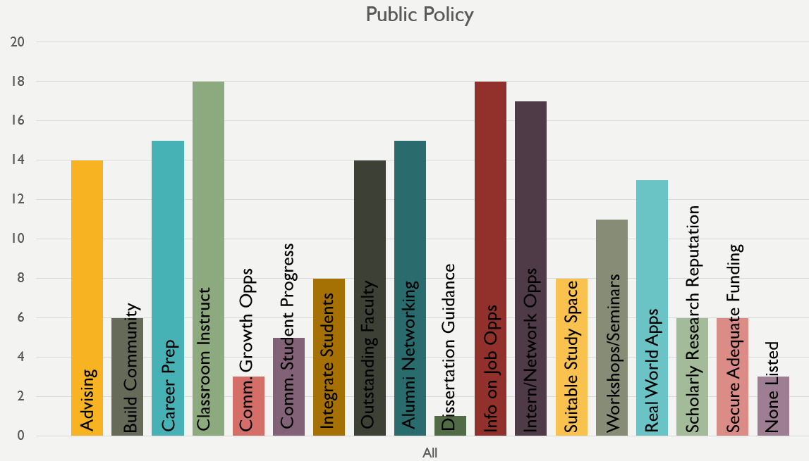

Program Preparation
Only 8 PhD students responded from Public Policy, so it is important to keep in mind the minimal amount of information that can be gleaned from these results. However, those who responded feel that their program does a good job of teaching them how to conduct research. Further work to help students learn to obtain funding, publish research, and gain organizational and leadership skills is recommended.
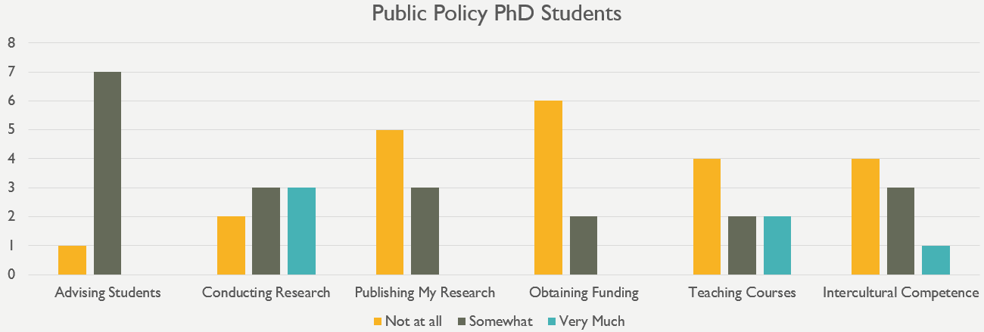
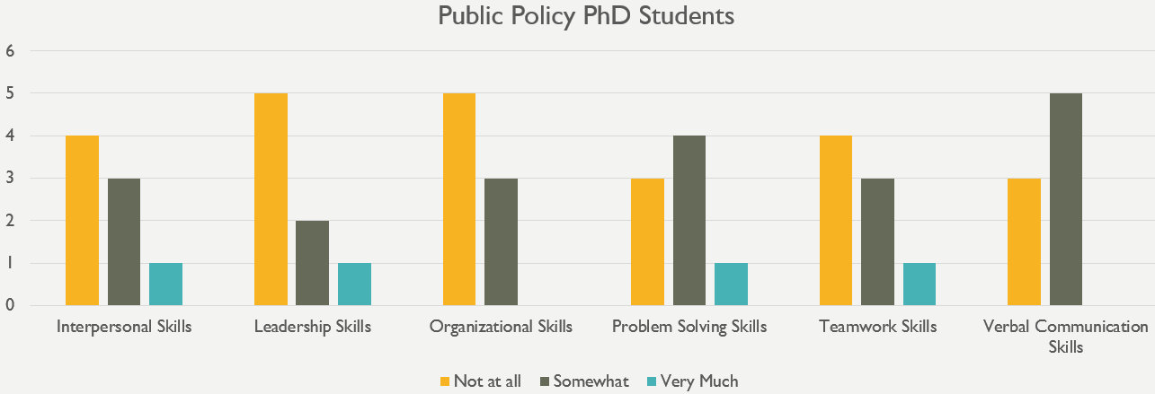

Appendix

(Note: this section may be removed depending on the needs of The Graduate School)
[Q30 / Q30_8] In which of the following kinds of organizations are you already involved?
Students were asked about the frequency with which they participated in 7 kinds of organizations: Campus governance organization (e.g., University Senate, Graduate Student Government, Departmental Governance Unit, President’s Commissions); Community service group; Intramural sports team; Student organization; Regional/national organization related to my field of study; Religious or ministry group; Transfer and Off Campus Student Life; and “Other”. The 41 students who wrote in their responses under “Other” shared organizations that fell into 16 categories shown in the table below:
Category
Employment (9) | Entrepreneurship (1)
Program-based student group (7) | Identity-based organization (1)
Community service / volunteering (6) | Public speaking (1)
Academic organization (3) | Recreational activities (1)
Arts/music/dance/theater performance (2) | Technology club (1)
Graduate assistant advisory committee (2) | Support group (1)
Off-campus miscellaneous organization (2) | Social group (1)
Athletic (1) | Research organization (1)

The most common organizational category listed was “employment” where students noted that they were involved with their full- or part-time jobs. The next most common category was “program-based student group”, examples of which included: iSchool Assembly, Public Health without Borders, MBA Energy & Veterans club, and meetup group with a professor. The third most common organizational category was “community service / volunteering”, examples of which included: volunteer for refugees of Kashmir in India and regional/national organization unaffiliated with school which does community service.
[Q28 / Q28_18] In which of the following community building activities/programs for graduate students would you be most interested? (Select all that apply)
Students were asked to select from the following 17 categories of activities/programs in which they would be most interested:

- Arts and Crafts
- Bowling/billiards tournaments for graduate students
- Campus-wide social events for all graduate students
- Film screenings for graduate students
- Health or wellness programs
- Holiday themed events (ice skating, pumpkin picking, etc.)
- Local activities like trivia nights, tours, or trips to Washington, D.C.
- Managing relationship or finding life balance workshop
- One-time community service events (e.g. Habitat for Humanity)
- On-going community service (e.g. weekly tutoring)
- Outdoor activities (hiking, rock climbing, etc.)
- Performances (dance, theater, etc.)
- Social events within my academic program/department
- Social events within my school or college
- Tailgating at football games or other sporting events
- Wine or beer tasting
- Family-friendly activities

Students were also given the opportunity to select “None” and write in activities/programs under “Other.” The 29 responses to “Other” fell into the following 13 categories:
Category
Entertainment (6) | Collective bargaining (1)
Programs for specific student types (4) | Financial literacy (1)
Athletic (4) | Travel (1)
Intellectual / skill-based (4) | Spouse / Partner (1)
Food (2) | Online events (1)
Networking (2) | Support group (1)
Community outreach (1)

The most mentioned category was entertainment and included trivia nights, film screenings, fashion shows, board games, puppy day, and others. Another popular category was programs for specific student types, including those for part-time students, doctoral students, minorities, and those in off campus graduate programs. Athletic and intellectual/skill-based activities such as short soccer or volleyball tournaments, cycling, hackathons, coding/data analysis workshops, and others were also mentioned.

[Q20a1a, Q20a1b, Q20a1c, Q20a2, Q20a3a, Q20a3b, Q20a3c] Which of the following best describes your intended position at a (4-year R1 research intensive university; 4-year R2 or non-research intensive university; 2-year university or junior college; preschool, elementary, middle, secondary school or school system; U.S. federal government; U.S. State or local government; non-U.S. government)? Response: Other position

Students were asked to select from a list of career positions in various settings and had the opportunity to write in their responses under “other positions.” The tables below show the responses to this question depending on setting:
Other positions of interest at a 4-yr r-1 University (15 responses):
Type of position | Examples
Administrative (9) | - Library/archives  - Staff psychologist  - Student affairs professional  - Education abroad director  - Counselor
Faculty / Student (4) | - Doctoral student  - Post-doc
Other (2) | - Consultant  - Hybrid role with admin & teaching responsibilities

Other positions of interest at a 4-yr r-2 University (12 responses):
Type of position | Examples
Staff / Administrative (10) | - Librarian / archivist  - Staff psychologist  - Student affairs professional  - Sexual assault prevention coordinator  - Counselor
Faculty (2) | - Adjunct professor  - Lecturer

Other positions of interest at a 4-yr r-2 University (12 responses):
Type of position | Examples
Staff / Administrative (10) | - Librarian / archivist  - Staff psychologist  - Student affairs professional  - Sexual assault prevention coordinator  - Counselor
Faculty (2) | - Adjunct professor  - Lecturer

Other positions of interest at a 2-yr University or junior college (2 responses):
Type of position | Examples
Staff / Administrative (1) | - Librarian
Faculty (1) | - Adjunct

Other positions of interest at a preschool, elementary, middle, secondary, or school system (28 responses):
Type of position | Examples
Staff / Administrative (25) | - Speech language pathologist  - Librarian  - Therapist  - School counselor  - Support staff / special education and psychological services  - Policy analyst  - Information management/technology
Teacher (3) | - Dance teacher  - Teacher  - Special education teacher

Other positions of interest in the U.S. Federal government (3 responses):
Type of position | Examples
Staff / Administrative (1) | - Smithsonian employee
Research (2) | - Research scientist  - Government research lab

Other positions of interest in the U.S. state or local government (4 responses):
Type of position | Examples
Staff / Administrative (4) | - Librarian  - Educator  - City government employee

Other positions of interest in a non-U.S. government (2responses):
Type of position | Examples
Staff / Administrative (2) | - Consultant  - Advisor

The label for the subscale is one created by those analyzing the data based on what the combination of questions seems to be measuring. It is possible that “Connection” may not be the best name for this subscale.

